Why A Gas Mask Should Be Part of Your Preps
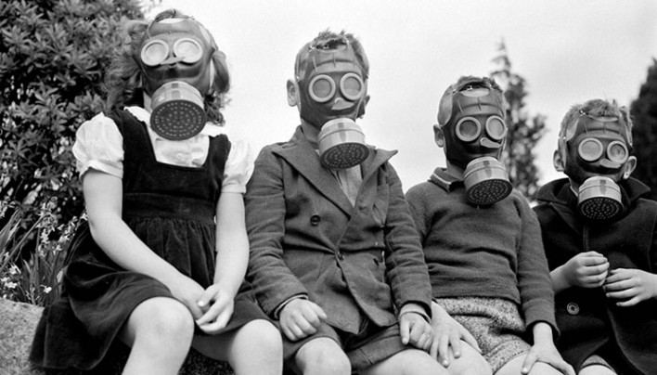

You know the survival maxim about how you can live 3 minutes without air, right? I always looked at this as just basic life type of scenarios. If you couldn’t breathe for three minutes you would die. I would envision someone who had been knocked out and people had stopped to stare at the person lying on the ground slowly turning blue. Other times I would imagine someone suffocating in a horrible paracord accident or other nonsense. It struck me the other day that I had been looking at this all wrong.
Three minutes without air could just as easily mean three minutes without clean, breathable air. What if the air you were breathing would kill you, not the act of not breathing at all? What if with each breath you were bringing some organism into your lungs that would poison you or make you sick to the point that you died or became incapacitated. Three minutes without clean, clear, safe air would be an eternity for some. How long can you hold your breath?

Threats
Egypt Riots
There are many valid reasons for having a gas mask as part of your preps that have nothing to do with a global pandemic or outbreak of some deadly virus, but they all revolve around protecting the air that you and your family are breathing. Remember the riots in Egypt and Syria where police fired tear gas into the crowds as they protested against their government? Have you personally ever been exposed to tear gas? I have, and it isn’t fun at all. In the Army each soldier has to go through the “gas chamber” for a couple of reasons. The first is to test your NBC mask and make you feel comfortable with how it will protect you. For this little trick, we all lined up, put on our masks and walked into a very smoky room. All of the other young guys with me were standing around the edge of a big room. You could see the smoke in the air but it wasn’t so intense that you couldn’t see everyone around you. We did some jumping jacks as I recall to get our heart rate up and our breathing faster. Then our drill sergeant told us to take our masks off.
Everyone held their breath for as long as they could, but your eyes started burning first. I happened to the unlucky guy who was at the front of the line and everyone started pushing me from behind to get out the door. Some guys started coughing and several were stamping their feet. My drill sergeant who must have loved me (and who still had his mask on) yelled at me to “stand still or I’ll make you all do this again!” About now, our eyes and noses were running like crazy and we had to take a breath in. This burned like fire and the coughing fits came next. Eyes watering, snot running down our face and coughing like mad, we were finally given the go ahead to walk out the door.
That was tear gas, and after a few minutes in the clean air, we were fine. Imagine if that had been nerve agent or some deadly virus. A few minutes outside of the building could very well kill you.

Options
In searching for a gas mask or respirator for my family I came across several options depending on what your personal threat assessment is. You can start with your basic N95 particulate masks but these have limited use and some say they are useless at protecting you from airborne viruses. I prefer a solution that can give you protection from multiple threats and that requires you spend a little more money unfortunately.
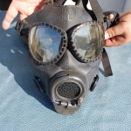
Vintage US Military gas mask
Mil surplus – Again if you stick with military surplus, you aren’t going to find too much more out there that was specifically designed to counter threats from NBC (Nuclear, Biological, and Chemical) than your average soldier could face. Used NBC masks can be found on Ebay or my personal favorite, the local Army Navy store. You may have to dig a little more to find a good mask with hood and case that is in great condition, but the prices would be very reasonable. These may be the older style of masks also with the cartridges that are installed inside the mask opening instead of screwed on. The good thing about used military surplus is they have the bells and whistles that other masks may not have at the base model. You will get a drinking straw (for use with standard army canteen cap) and a built in speaker so people you are yelling at will hear you. Of course you will still sound a little like Darth Vader but that is a bonus.
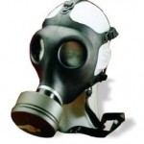
Israeli Civilian Gas Mask
Israeli – The infamous Israeli Civilian Gas masks are everywhere out there. You can find these at Army Navy stores, Ebay and Amazon as well as camping sites if you can believe that. This is the gas mask supposedly issued to Israeli civilians when threatened with chemical attack by Saddam’s Iraq. It has full NBC protection, and come with one sealed filter.
The price on these is around $25 and that is an insane deal if you ask me. Additional filters are around $10. Now, the million dollar question is do they work? That I am not sure of but at this price it is hard to pass up. In the Army we would have to check our masks out every year and our NBC specialist would have us mask up and then they would swipe a pen around the openings of our mask and ask us if we could smell anything. I never could, thankfully but he said I would have smelled banana. You can even buy these kits today to test your masks I would definitely recommend that. At least you will know that if they throw rotten fruit at you it will be alright.
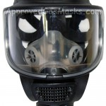
Tactical Gas Mask from AGM
Consumer models – There are several companies I found that sell masks to be used for a variety of environments that could be used to keep you safe also. These masks are going to run you a lot more than a used military gas mask or the Israeli Civilian mask, but if you want a little more peace of mind they might be a better fit for you. A company called Approved Gas Masks has something called the Tactical Domestic Preparedness Mask that will fit NBC filters that they also sell. It looks like the masks themselves run about $170 but there are small discounts on some models if you purchase more. The masks supposedly fit the standard NATO filters which you may be able to pick up online somewhere else, or AGM has these for you also at about $45 each.

Considerations
Communication – You want a mask that you will be able to talk in. More specifically you want a mask that your family can hear what you say. Make sure that what you purchase for your family or group is going to allow you to communicate.
Drinking – This would be a major issue if the threat lasted for a long time or you were outdoors in a hot climate for an extended duration. The older military gas masks have straws that plug into your canteen cap. The cap was special and I am sure you can order these from Ebay, but something to consider.
Visibility – Clear visibility in your mask is crucial. More so if you are planning to be able to shoot a weapon accurately. If you haven’t purchased your first defensive firearm, you can read this post. If you are using a shotgun, aiming isn’t such a big issue. The two main things that affect visibility are your filters and your face mask. In the older military style you have two eye holes. The newer masks offer one faceplate. The filter will either be positioned on the side or at your mouth. Practice aiming and shooting your rifle with the gas mask on to see if you have to adjust anything. Make sure you do this before you are in the situation where you need to fire accurately.
Filters – Replacement filters are something you should consider now. Buy enough to last because you won’t be able to run out to Wal-Mart for a resupply. Also, the mounting position of the filters could influence whether or not they will work good for you. The best option is to purchase a mask that allows you to mount filters on the left or right side. This will free up your cheek for a good stock/cheek weld when sighting.

