When the Neighbors Ask For Help
I hear it all the time – “The SHTF and a neighbor knocks on my door I’m putting a bullet in their head and feeding them to the pigs.” Right. When John and Susan drop over with little 6-year old Lisa asking if there is any food to spare these keyboard warriors are going to just kill them? Tough talk when those who you had a few beers with and babysat their kids aren’t standing right in front of you.
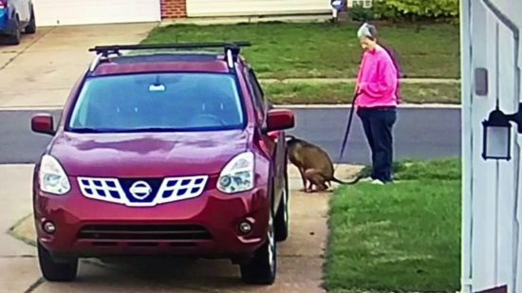
This neighbor lets her dog crap on my driveway?
“No soup for you!!”
This topic came up at a Survival & Preparedness Convention I spoke at a few years ago. Several of the guest speakers were standing around talking about different things and someone mentioned what if cousin Bob showed up knowing you had some extra food put back – asking for help. As you can imagine opinions varied based on numerous factors. What was the relationship with those knocking on the door? How desperate is the situation? Does the person have any skills that would provide benefit to having them stay? Are kids involved?
The truth of the matter is the vast majority of us do not know how we will react should something like this occur. To flat out state that you will help absolutely no one could result in a situation where it could be beneficial to assist someone – and you send them away. To create shoe boxes full of supplies specifically for this situation and start handing them out to every desperate soul that passes by could prove disastrous.
So – not to burst your bubble here but there is no solid, guaranteed right answer.

