What Should a Serious Prepper Wear?
By Chris Taylor
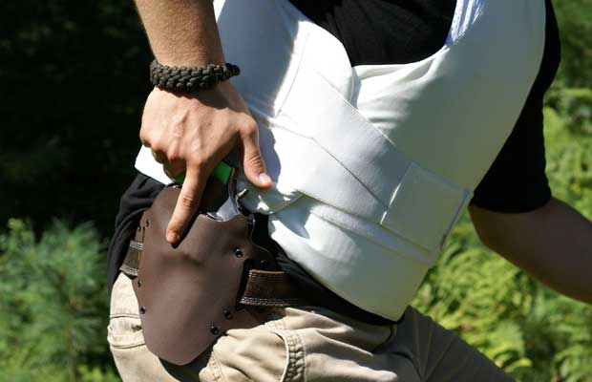

The need for body armor is one that has seen increasing popularity amongst preppers. With the majority of situations that require beforehand preparation, the threat of guns and knives are things that aren’t overlooked. Many preppers see the need to stock up on weapons themselves and also acknowledge the fact that the likelihood of perpetrators also carrying weapons is quite high.
However what is often unclear, is the level of protection as well as the protective gear that is necessary in specific situations. The ideal vest for a prepper, therefore, depends on the potential threats being prepared for. It’s important that the vest chosen is one that will suffice in offering the degree of protection necessary in a particular event. This not only means that the level of the vest is of dire importance but also that the type of vest as well as the fit of the vest should not be undermined.
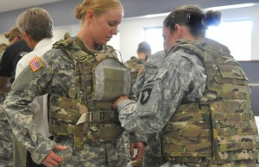
Overt Body Armor Vest as used in the Military

When is an overt vest better?
Overt vests are best for preppers who are preparing for situations where combat like scenarios may come into play. These are the vests that are commonly seen worn by military personnel.
Worn over clothing, overt bullet proof vests are generally thicker, heavier, and also, more hard wearing that covert protective gear. This is partially due to the fact that they aren’t offered additional protection from wear and tear by means of the wearer’s clothing. The reason that overt vests tend to be heavier is because of the higher levels of protection offered.

Levels:
The highest possible level of body armor is attainable through overt gear. Because combat-like situations involving rifles require an overt vest, these are the ideal vests for those prepping for such occurrences. An NIJ Level IIIa overt vest equipped with Level III or IV hard armor plates would therefore be the ideal choice. It is important to remember that higher level body armor is more weight bearing and therefore for situations where high levels of flexibility and movement are required, an overt vest may not be the right choice.

When is a covert vest better?
Unlike overt vests, covert vests are worn underneath clothing and with the incorporation of cotton, can be worn directly against the skin. Situations where movement and flexibility are essential require a covert vest.

Concealability:
One of the main points for covert vests is the concealability factor. As a prepper, there may be cases where staying under the radar is important. Especially when in need of deterring potential threats by not showing that you’re adequately prepared, covert vests will prove to be more beneficial than overt vests. Another important feature of covert vests is that the wearer is able to achieve the added protection needed without being subjected to high levels of discomfort. Covert vests are lightweight and thus, can be worn as Everyday Carry. This means that regardless of the area that a prepper may find him/herself in and also, regardless of the number of hours a prepper will be in continuous need of body armor, covert gear will provide both comfort and protection.

Coolmax:
The Coolmax fabric, incorporated in many covert vests, means that whether high temperatures or low, the wearer will have a higher degree of comfort. This is because Coolmax is designed to draw moisture away from the body, spreading it across a greater surface area and thus, keeping the wearer dry. This is highly beneficial in warmer climates where the amount of perspiration will be high, especially when carrying out strenuous activities. This same feature of breathability and the pulling away of moisture from the body, helps to keep those wearing covert vests, warmer. Moisture on the body that has been subjected to lower temperatures will make the wearer colder, something that is eliminated by the Coolmax fabric.

Levels:
Covert gear is available in the lowest NIJ Level, Level I as well as in Levels II a, II, and Level IIIa. For preppers who are in search of a vest that will protect against threats such as hand guns and knives whilst still having high flexibility, a Level II a or Level II vest should be chosen.

How important is a vest that fits well?
The way in which body armor fits directly correlates with the level of protection that will be provided. The purpose of body armor is to provide protection against potentially harmful attacks and the way this is achieved is through protecting the body’s vital organs. As a result, it is imperative that the body armor purchased is one that offers the necessary protection to the vital organs.
As a rule of thumb, body armor should stop slightly above the navel. This prevents the vest from being restricting and allows the wearer to move more freely in the face of a threat. In order to prevent protective gear from being counterproductive, it should not be restricting to any part of the body and should also, not fit too loosely. Body armor that is restricting will restrict movement and inhibit the wearer from acting quickly. On the other hand, loose fitting covert body armor will get in the way, and once again, hinder the movement of the wearer.
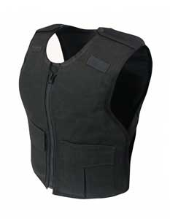
Female Body Armor

Female Preppers:
Female preppers need to be aware of the fact that there is body armor available that has been designed with their body types in mind. In order to receive optimum protection from protective gear, female preppers should decide on a vest that is specific to their body type.
It is therefore, essential, that prior to choosing body armor, both men and women preppers have proper measurements taken. Body armor is an investment and one that should not be taken lightly. Know the threats that are being prepared for and ensure that the vest chosen is one that will offer the needed protection when a threat is faced. Remember, an overt vest may prove beneficial in some scenarios but can pose as a threat in others. The same is true for covert vests and thus, the first decision that you will need to make is whether the right vest for you, is an overt or covert bullet proof vest.

