What Makes a Good Bug-Out Location?

by CTD Blogger
I’m going to tell you a true story, but to protect my friend’s privacy and OPSEC—as all good preppers should do—I’m going to remain as anonymous as possible. I’m telling you because I believe in helping people and I like to imagine a world after SHTF where we help each other rather than hinder each other, so here it goes…
I recently had the opportunity to visit a friend’s bug-out property. What started out as a dream for land outside of the city for a nice get-away to keep animals and a shooting range turned into the perfect place to start a bug-out plan in motion.
In my opinion, any piece of land outside of the city has the potential for a good bug-out location. Any deer lease, lake property, land, or farm—with time, patience and a little manpower—converts into a secure location to keep you and yours safe during an economic collapse, chaos and violence in the city, major natural disaster, or flu outbreak.
My friend lucked out on their purchase. It was a full-time homestead for a large family, so all the comforts of home are already there. With a few additions and tweaks, this bug-out location not only provides safety and security, but comfort as well for months if need be to ride out a SHTF storm.
As silly as the National Geographic show Doomsday Preppers can get, there is something to say for the ratings it gives each prepper at the end of each segment. Based on the same rating system on how well each prepper has planned for water, food, shelter, security, and X-Factor, I’ve rated my friend’s place for each category as an example for what makes a good bug-out location, as well as tips for how to improve it.
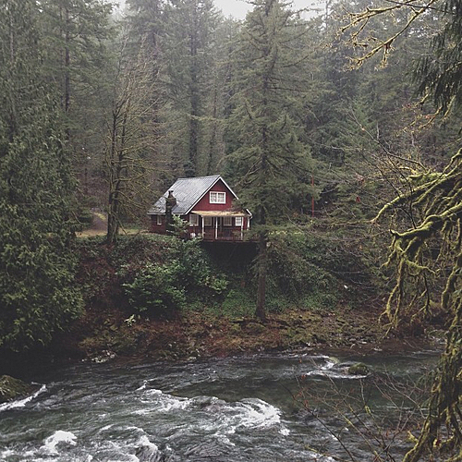
Is there a fresh water supply nearby?

Water
The recommended amount of water per person per day is one gallon for drinking, basic personal hygiene and basic food prep. My friend fairs very well in this department. There are two full ponds, a swimming pool, city water, and well water on the property. In the kitchen pantry I found collapsible water containers, a small water filtration system and emergency water treatment tablets. Though there is plenty of accessible water on-site, I would add the AquaPodKit, cases of bottled water and a larger filtration system in case the ponds dry up.
Score: 19.5

Food
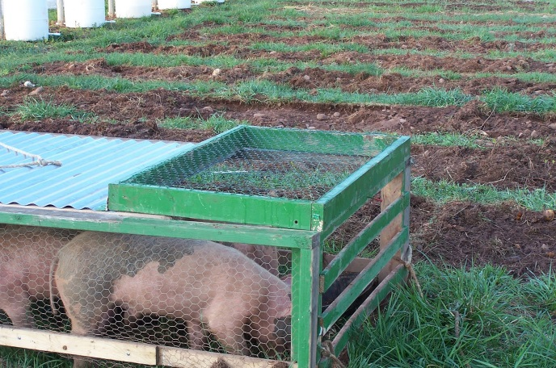
Can your property be self-sustaining?
A regular supply of non-perishable food items are stored at the property year round; however, there is not much variety or enough. I found no cans of food, only boxed non-perishables that require hot water, milk and butter to prepare.
This is the area I found my friend was lacking in most. The property has more than enough room where they could hold at least a year’s supply of food storage. However, they have started a small garden and my friend is researching the best livestock to keep on the property. Further, if push came to shove deer, squirrels and rabbits spotted on game cameras roam the property in abundance.
Score: 13

Shelter
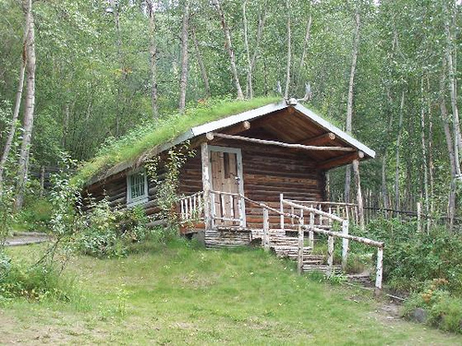
Is your shelter visible from any road?
Very few people know the actual location to the property and it is not visible from any road. The property is fairly difficult to get to—I had to be lead in. There are no markers, signs or address numbers at the gated entrance. The non-descript gate can be closed and locked.
The property sits less than a full gas tank away from the city—close enough to get out quickly, but far enough to survive the a nuclear bomb blast in the middle of the city. There is little traffic getting out there and alternative routes exist in case roads became congested. If you had to, you could walk to the property in less than two days.
With less than 3,000 people, the nearest town is not densely populated. Most live on their land. Small towns can be nosy, however, so my friend never shops in town for supplies.
I give my friend bonus points for finding a place with plenty of shelter. The main house has three bedrooms and two full baths. Additionally, there is a bunkhouse with a kitchen, bathroom, and large bedroom and one more building with a bedroom, sink and toilet. All together, there are five bedrooms, four toilets, three showers, two bathtubs, and six sinks. That is plenty of room for extended family members, friends or partners to all bug-out together comfortably. If need be, the property could serve as a survivor compound where everyone helps out.
For extra storage space, there are two fully enclosed and lockable garages, and three covered storage buildings for equipment.
A propane tank heats the water and lights the stove, but the heat and air conditioner are electricity-powered. There is no alternative to heat food. I suggest adding a charcoal grill, propane stove and emergency stoves to the property. A wood burning stove would provide heat for the winter and as an alternative for cooking. In my friend’s defense, they do plan to add solar panels to the roof of the main house—eventually having the capability to go completely off grid.
I found an old non-working generator in one of the out buildings that if working would be an excellent back-up power source before the installation of solar panels. I would work on getting it fixed and storing up gasoline. My friend could also benefit from a windmill.
Score: 18
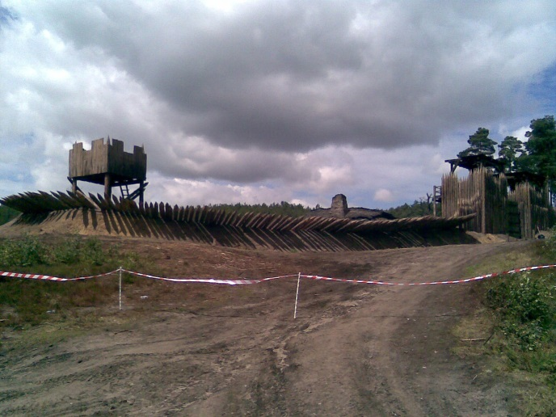
Are you able to secure the perimeter?

Security
For firearms and ammunition, my friend is doing just fine and that is all I have to say about that.
As far as other security goes, my friend needs to add just a few extra measures for some added protection. The property has no complete perimeter fence, nor do I really expect one. However, with the right tools, the right volunteers and promise of plenty of free beer—building a perimeter fence close to the house wouldn’t take much.
The house sits up on a hill and with binoculars you can see in most all directions. I would add a hidden security camera at the gate’s entrance as a precaution.
The main house’s design allows for a lot of natural light to come into every room. There are plenty of floor to ceiling double windows and doors.
When the weather is perfect this makes for a cool, breezy and comfortable dwelling, however also easy to break into. My friend should work on storing wood or other fortifiable material, hammer and nails so they can quickly reinforce windows and doors.
Score: 17.5
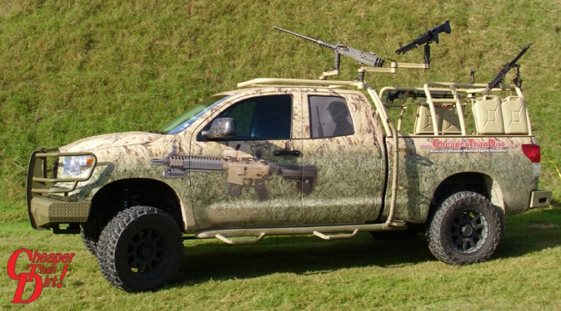
Do you have any extras that put you ahead of other preppers?

X-Factor
My friend has no legal dependents. This means that if they have to get out of dodge, they are only taking people they want. They already know who gets to go and who has to stay. These chosen ones know the plan and are dedicated to helping.
The last owners of the property left furniture, old tools and equipment. This saves money for necessary and needed items and many of the old farm tools would work as makeshift weapons.
My friend has an ample supply of liquor on the property. I also spotted a carton of cigarettes and chocolate. We all know the uses of such vices, but they also make excellent bartering collateral. Since my friend isn’t a coffee drinker, there was enough for one cup of morning Joe for myself, but not many others. This may be a personal preference, but since coffee stores, I’d keep a large can in the kitchen.
Score: 18

Overall
Overall, my friend’s bug-out location is ideal. It is easy to defend, has the ability to become self-sufficient and has ample storage to stock supplies. As with anything, it needs a few improvements, but as it is, I wouldn’t complain if I have to bug out there.
Total score: 86
When I took the Doomsday Preppers quiz on the National Geographic website on my friends behalf, based on only the observations I made, the property as it is right now has the chance for those staying there to survive for four to eight months. Not bad, I say. How long will you survive?

