What Knot To do
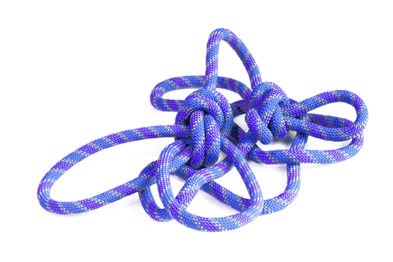
Knot tying has always been one of those key outdoor skills that even the most experienced survivalist’s often take for granted. Any time outdoors can often show you just how much your success or failure can depend on your ability to tie a decent knot
A good knot can save lives when you’re dealing with a survival situation, performing first aid, and when working over heights or water. But, you have to know how to tie it correctly. Below I have listed a few very basic knots that are extremely helpful to know regardless of if you are in a life or death survival situation or simply pitching a tent on a family camping trip.
Square (Reef) Knot
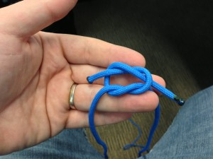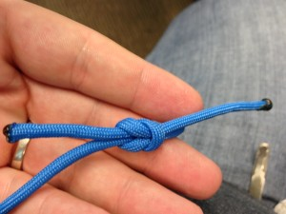
This Knot is a classic for connecting lines and tying knots and is often the first knot taught in cub scouts or boy scouts. Whether you are tying two ropes together to make a longer rope, or you are securing up a bundle of firewood to carry, the Square Knot is a timeless and easy knot for the job.
While this knot is as ancient as they come, it was coined as the reef knot in the late 1700’s by sailors and used in the reefing and furling of sails.
When made with cloth the knot lies very flat and for this reason it has been used in the tying of bandages for millennia. As a binding knot it was known to ancient Greeks as the Hercules knot and is still used extensively in medicine.
It has also been used since ancient times to tie belts and sashes. A modern use in this manner includes tying the obi (or belt) of a martial arts keikogi(uniform).
How to Tie: Square knots are extremely simple to tie. You can tie a solid square knot by lapping right over left, and then tying again in the reverse direction (you will essentially create two entwined loops) See the example below:
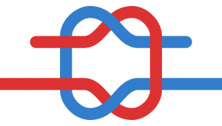
Bowline
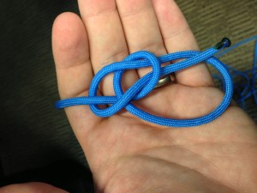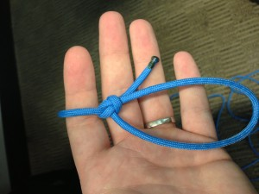
The Bowline creates a loop at the end of a rope that cannot shrink or expand. The bowline is well known as a rescue knot for such purposes as rescuing people who might have fallen down a hole, or off a cliff onto a ledge. They would put it around themselves and sit on the loop. This makes it easy to heft them up away from danger. This knot is often taught using the story of the rabbit coming out of the hole, in front of the tree, going behind the tree, and back down his original hole.
How to Tie: Form a loop on top of the long end of the line. Pass the free end of the line through the loop and around behind the line. Bring the free end down in the original loop, while maintaining the secondary loop which becomes your Bowline loop. Once the “rabbit” is back down his hole, pull the “tree” up and the Bowline is tightened.
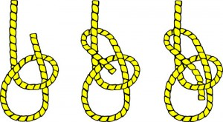
Figure 8
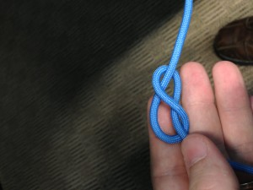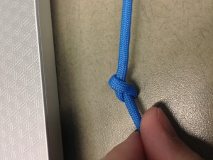
The Figure 8 makes a stopper knot at the end of a line, and it’s necessary to use this knot in order to tie several other more complex knots. This knot is crucial for keeping a line from slipping completely away and even though it may jam when pulled tight, it is typically quick and easy to untie.
How to Tie: To tie a Figure 8 simply pass the free end of a line over itself to form a loop. Continue under and around the line’s end, and finish the knot by passing the free end down through the loop
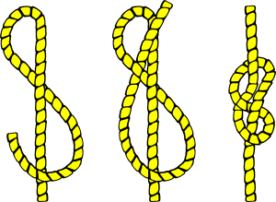
Sheet Bend
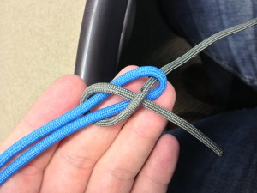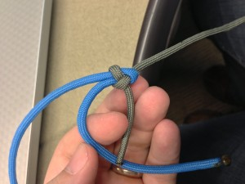
Nothing works better for tying different types of material together and joining different thicknesses of rope. This knot even joins together lines or materials that normally couldn’t be joined together.
This is a crucial knot in a survival situation as you often will not have enough of one length of rope and may need to tie multiple lengths together.
With enough time and material this knot can also be used to create nets for catching fish. It is so essential that the Ashley Book of Knots lists the sheet bend as knot # 1.
How to Tie: With the sheet bend, you bend the thicker or more slippery rope into a “j” shape (like a fish hook). You then pass the other rope through the fish hook from behind, wrap around the entire fishhook once and then tuck the smaller line under itself.
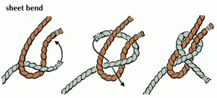
Taut Line Hitch
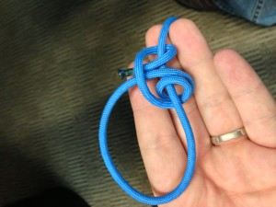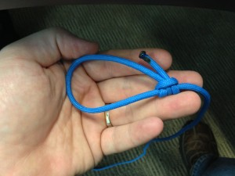
The Taut Line Hitch takes the place of a slide to tension or loosen a loop in a line (like a tent guy line). This knot grips well, as long as there is tension on the “taut” side of the loop. If the tension is released from the line the knot can quickly slip. Once snug and set, the hitch can be adjusted as needed.
To tighten the line with respect to a load attached to the standing part, grasp the standing part with one hand inside of the loop and pull towards the anchor object. Grasp the hitch with the other hand and as slack develops within the loop slide the hitch away from the anchor object, taking up the slack and enlarging the loop. To loosen, slide the hitch toward the anchor object, making the loop smaller and lengthening the standing portion.
How to Tie: Create a loop by wrapping around something like a tree or tent stake. With the free end of the rope, wrap towards the stake twice. Then wrap the free end of the rope over everything, towards you one time around the rope and cinch these wraps down tight. Pull on the standing line and the Taut Line Hitch should grip the loaded line.
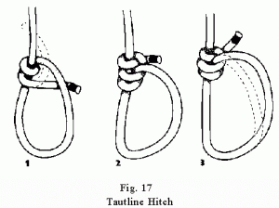
These are just five knots that I find essential. I know I left many knots out and there are literally thousands of knots, each having different variations and uses.

