Using the Shadow Method of Finding Directions
by admin
If you are lost during daylight hours one of the easiest ways to find the four points of the compass is the shadow method. The down side to this method is that it only works when the sun is out.
Simply stand a 3-foot stick on end and place a small rock where the tip of the shadow falls. Wait ten to fifteen minutes and place a second rock at the point where the tip of the shadow has moved too. Draw a line between the two points. This is an east-west line. Place the toe of your left foot at the first rock and the toe of your right foot at the second rock; you will now be facing north.
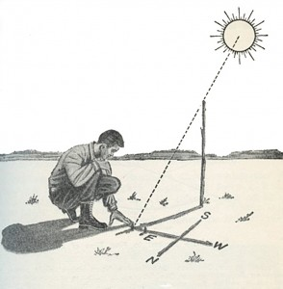
The shadow method of finding directions
If you are ever uncertain which direction the lines runs, remember that anywhere on earth, the first shadow mark will always be west, the second east.
Once you know these four directions, determine the route that you need to travel. Look in the direction you wish to go and pick out an object to be your goal. When you arrive at your goal you will know that you have traveled a straight line and have not wondered off course.

