Using a map and compass
by John B
It’s so easy to pull out your smart phone and use a map app or GPS app to navigate to your chosen destination. What if GPS ceases to function, or if you want to avoid being tracked by your cell phone carrier? Using a map and compass is a fool proof system to find your way.

Items you’ll need:
- Map of your immediate area
- Compass
I picked 2 random cities on a page of a Delorme Atlas (Virginia) for our example.
Today we’re going from point A (Red Circle) to point B (Blue Circle). Red Circle is the spot you need to bug out from, and Blue Circle is your safe haven.
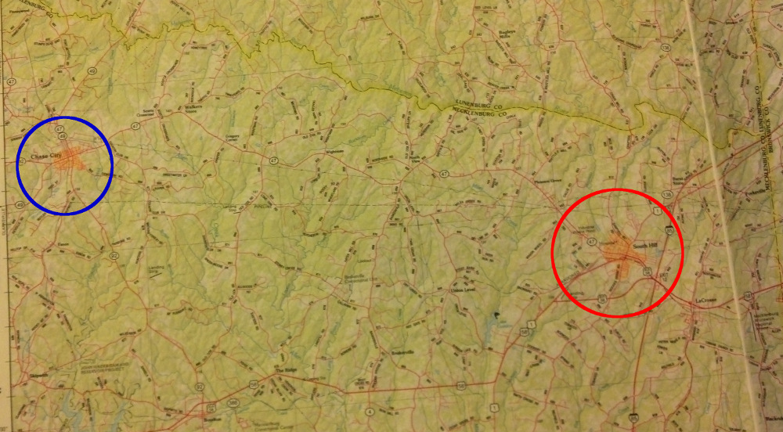
Use a straight edge to determine the desired line of travel.
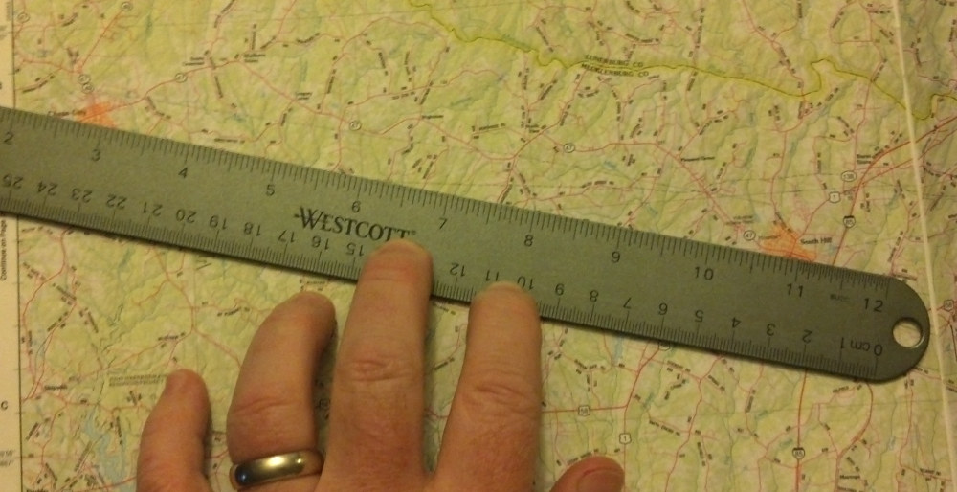
Place the long edge of your compass along the straight edge, following the path of the straight edge
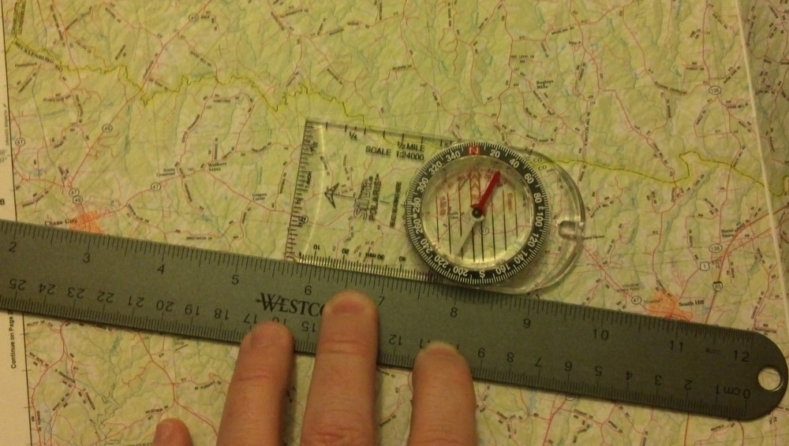
Rotate the direction dial housing on your compass so that it’s N (North) points to magnetic north on the map.
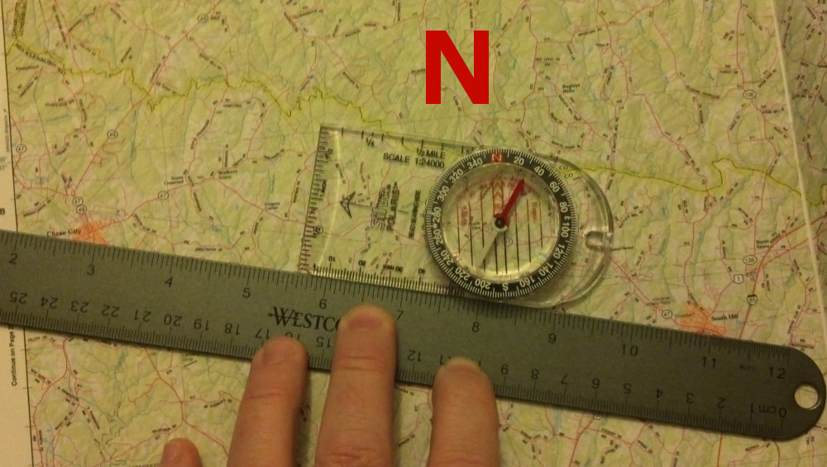
Hold your compass and turn in place until the red compass needle points to North on the compass dial’s housing (it’s the red N)
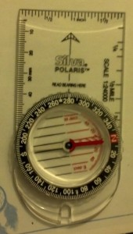
Now your “Direction of Travel” arrow points to the heading for your desired line of travel. Try to find a landmark along that line in the distance and head towards it.
After you reach that landmark use your compass to locate another landmark along the same path and repeat this process until you arrive at your desired destination.
Sometimes the old way is the right way. Make sure you are familiar with using a map and compass so you know how to navigate without technology.

