Urban Altoids Kit
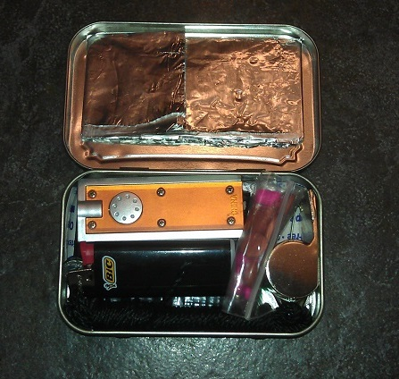
In my first year of teaching, I had an autistic student who didn’t have any problem telling me how he felt about certain things. One morning when I kneelled down beside his desk to help him in Math (2nd grade), he proceeded to let me know that my breath was bad! I responded, “Well, ____, I brush my teeth every morning. What you are smelling is my coffee breath.” I drink a lot of coffee, so I try to remember that when I have to come along side a student who is misbehaving in class to warn him/her that they need to “fix their behavior.” I also have many one on one conversations with teachers and parents and well, I don’t want them to remember the pot of coffee I drank that morning. As a result, I try to keep mints close by. One of my favorites are Altoids.
I used to throw the containers away. But now, with my preparedness mindset, I keep them and use them for all sorts of things. This Christmas, I tried my hand at building Urban Altoids Kits for my family. I put together six of them. Because these family members spend more time in the city than in the country, I decided to go with an urban purpose kit instead of a wilderness survival kit.
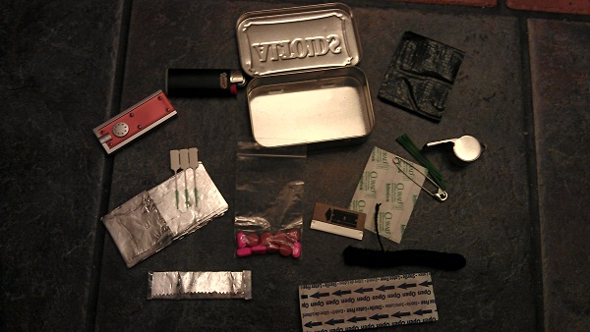
Contents:
- Flashlight
- Lighter
- 1.5 feet of Gorilla Tape
- 1 sq. foot of Heavy Duty Foil
- 3 Gum/Teeth Cleaning Sticks
- Plastic Bag of Benadryl & Ibuprofen
- Razor Blade
- Safety Pin
- Whistle
- Extra Long Twist Tie
- 2 Bandaids
- 2 Butterfly Bandages
- 1 Stick of Gun (fresh breath)
- 10 feet of Tarred or waxed Drop Line
I was very surprised that the tin stayed closed with all of that. The problem is that I wanted to place more in there. I had a button compass/thermometer that I would have liked to put in there, as well as a bigger bandage that already contained antibiotic ointment on it. I could have done the antibiotic ointment in the straw thing, but I ran out of time. I would have also liked to include a ranger band or some sort of rubber band that would have helped keep it closed, but I couldn’t get to that either. Next time, I might also include some thread and a needle for those quick sewing fix issues!
One day, I hope to make one similar to the one created by The Urban Prepper. Check out his video below.

http://www.youtube.com/watch?feature=player_embedded&v=N7YC3FjFxys

