Try Stick
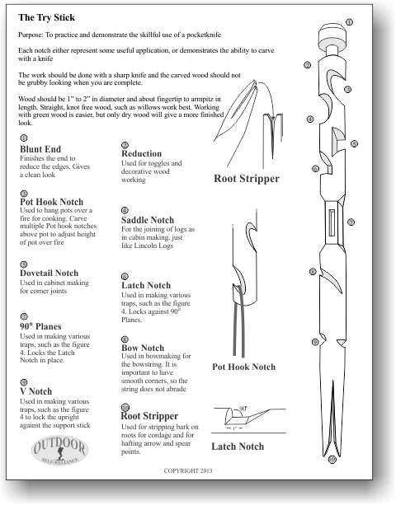
In 2006, Bushcraft Magazine ran an article for the “Try Stick”, a woodsman/bushcrafter’s training tool used to develop ones knife use skills. The article was a very beautiful reprint, with new illustrations, of Mors Kochanski’s (pronounced Koe-hanski) knife use teaching aid for his students. Sadly, because the magazine was a UK print, it did not see mass distribution this side of the planet, hence the article was missed by many here, and now hard to get your hands on.
The “Try Stick” has developed somewhat of an underground following, a must if you will, for those wanting to show their prowess with a knife, while at the same time showcasing their work for all to see.
The “Try Stick” is nothing more than a stick, approximately an inch to inch and a half in diameter, and about fingertip to armpit in length. on this stick one carves various types of carvings that would commonly be used in woodcraft/bushcraft, though some are more to showcase ones ability to wield a knife.
There are many beautiful examples of “Try Sticks” floating around the net, from woodcrafters who have demonstrated their ability and prowess with a knife. One person of note is Mark Emery of Kepis Bushcraft.
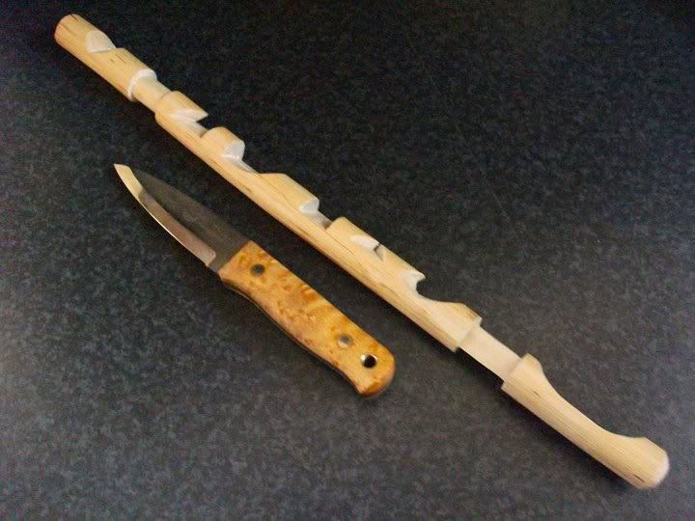
I too have adopted the “Try Stick” as an instructional aid in my immersion courses, though I’ve abbreviated the original manuscript from three pages down to one for my use, and have redrawn it to suit my needs (See lead in image to article).
The “Try Stick” can take on many forms. There is no one style, with many incarnations available around the web.
I encourage each one of you to try the “Try Stick”. It is a great way to practice your wood working ability, while show casing your skills. The beautiful designs one comes up with is only limited to the imagination, though the key is to use carvings of practical use to the Woodsman/Bushcrafter… Okay, some you make because they just look cool!
Mors Kochanski original manuscript. http://www.karamat.com/trystick.pdf
Check out all of Mark Emery’s other “Try Stick” pictures and other bush crafts at Kepis Bushcraft. http://kepisbushcraft.blogspot.com/

