- Top 15 Posts from 2013 

Sloppy Joes with Homemade Buns (Includes Basic Sandwich Bread/Bun Dough Recipe)

Home Remedies for Congestion

12 Home Remedies for Sore Muscles

Super Easy Hard Lotion Bar Recipe
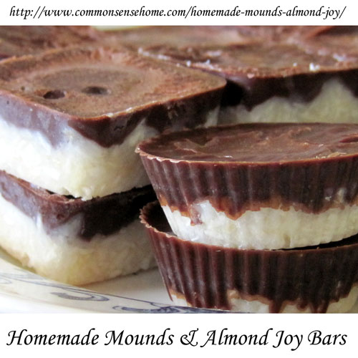
Homemade Mounds Bars and Almond Joy Bars
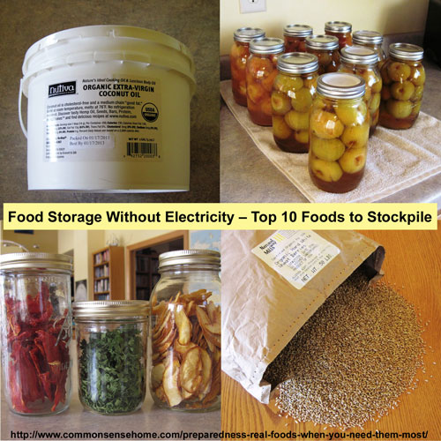
Food Storage Without Electricity – Top 10 Foods to Stockpile
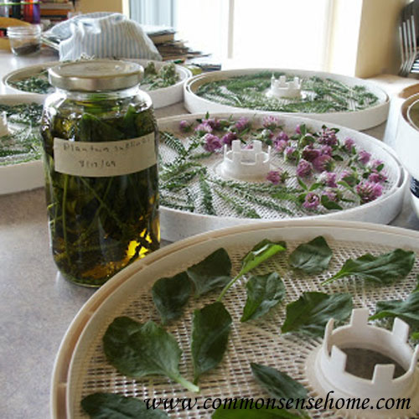
Homegrown Medicinals

Coping with Stomach Flu Symptoms (Why the BRAT diet may not be your best choice)

Herbal Antibiotics
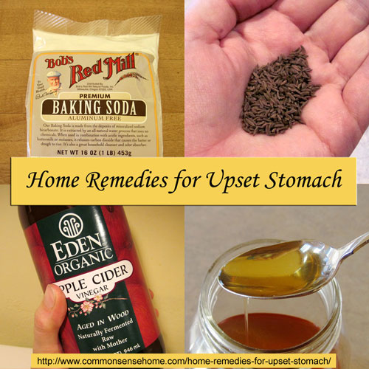
Home Remedies for Upset Stomach
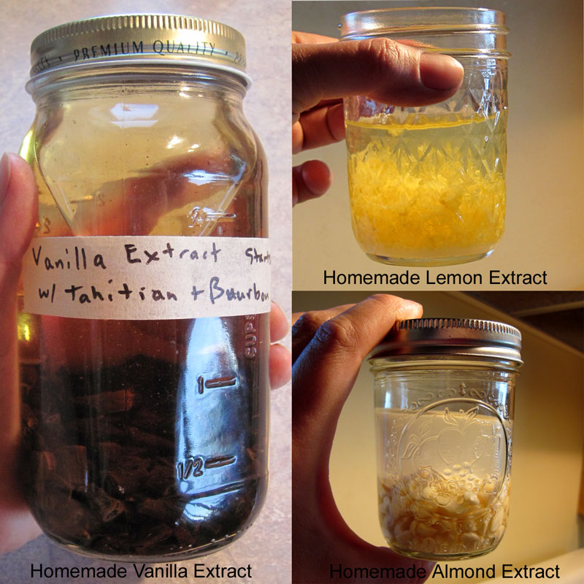
How to Make Homemade Extracts – Vanilla, Lemon and Almond
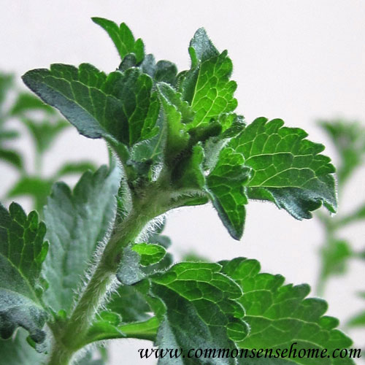
How to Grow Stevia and Make Homemade Stevia Extract

12 Home Remedies for Coughs
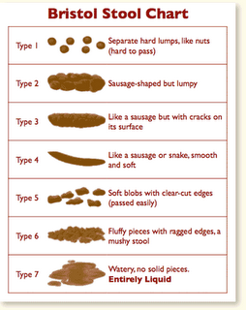
Things We’re Embarrassed to Talk About – What’s a Healthy Bowel Movement?
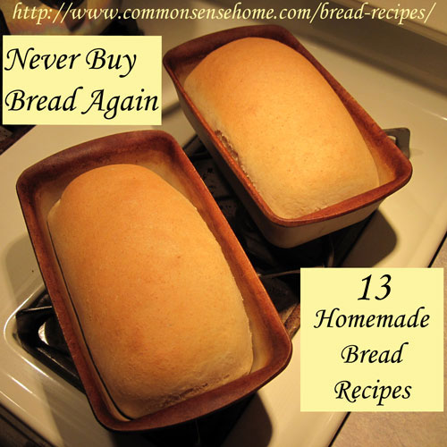
And the most popular post of the year – 13 Homemade Bread Recipes – Never Buy Bread Again

