Tool List for the Apocalypse
By Pat Henry

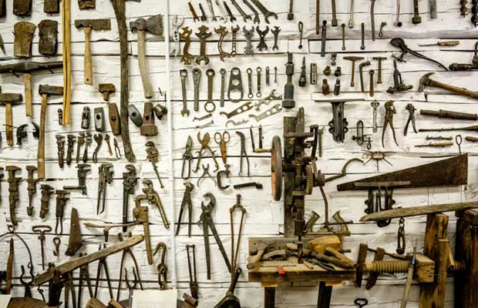

I never realized how cool my father’s workbench was when I was younger. My Dad had a corner of our basement devoted to building and fixing things for our family. His workbench wasn’t that large and he didn’t have 80 square feet of peg-board adorned with every tool imaginable. He didn’t have the sharpie silhouettes of each tool’s shape to make it easier for the messy kids to find the right spot when they rarely put the tools back but he did have shelves filled with containers of items in neat rows. He didn’t have dual rolling 6 foot high craftsmen tool lockers with a built in radio, but he did seem to have just about any tool he needed in order to work on items around the house, repair and maintain vehicles and even create things to help his children win prizes at school contests.
When I moved out on my own, I didn’t realize what I had left behind and anytime I wanted, or more accurately, needed to fix something it usually involved a trip to the store. I remember one of my early Christmas gifts after I was “on my own” was a simple tool-box with the basic tools. A hammer, various screwdrivers, set of wrenches, duct tape, pliers and a socket set. I still have the toolbox and all of the tools, but the items I have since found I needed for even basic home and vehicle maintenance have grown considerably over the years. With this new need for tools, I acquired a new found appreciation for my Dad’s workshop and even though it was small and didn’t have that pegboard, I still realized what an important investment that he put into those tools.
How many of you are just starting out and have the basic tools for your house? I am not talking about a screwdriver and a hammer; the kinds of tools you need to hang pictures or a set of blinds in an apartment. If you are like a lot of people, home maintenance and even vehicle maintenance is left to someone else. We have people that take care of our lawns. We take our vehicles in for services now. Can you imagine changing your own oil? That’s crazy! Have a flat tire? That’s what fix-a-flat is for!
Even routine jobs around the house are increasingly being done by rent-a-handyman services. I think this is a great business idea as most people in our society are too wrapped up with working or shuttling kids to a hundred activities to have the time, much less the motivation to work on their own homes or cars. When you buy a house, the whole yard is manicured for you. Got weeds? Just buy some spray and you are all done. What tools could you need other than those simple tools you have in that small box stuffed into a corner closet?
I started thinking about all the tools I have and how even that doesn’t seem to be adequate if I could never walk into a hardware store again. What if I had to rely on my own skills and the tools I possessed for a lot more? What if we had a global apocalypse or SHTF event? Would the tools I have enable me to build things I may need? Would I have tools to repair broken equipment or parts of my house? What would I as a Prepper consider as a basic tool list for someone who was going to live through a disaster or collapse and have the ability to use their own hands to build things, repair things or generally survive?
I started to put the tool list together below and I know there will be items I forgot. What did I leave out? Essentially anything that had to do with serious craftsmen activities like building a log cabin or blacksmith work. You won’t find a set of leather-working tools but that isn’t because I think there is no value. If you know how to build a log cabin, you probably already have those tools. If you don’t know how to build a log cabin, there is probably a slim chance you would be able to do it after a collapse or would need to after a disaster. There aren’t any tools specific to raising livestock or for gardening with livestock. Again, if you have any hope of doing that, you should be well on your way already. I also tried to go with tools that don’t require (for the most part) fuel or electricity.
The tool list below is for the average person to conduct routine and basic maintenance around your home and on your vehicles. If you have items to add, please let me know and I will update the list. If you want to print this list out and go on one heck of a Home Depot trip, just use the print button at the top of the page. There are a lot of links to items on this list for you to easily purchase online.
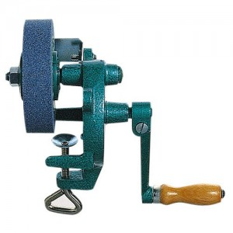
A hand powered grinder would make sharpening blades much easier.

Build Stuff
- Hammer
- Wrench’s (metric and standard)
- Socket Set
- Screwdriver Set
- Set of Pliers
- Adjustable Wrench
- Pipe Wrench
- Tape Measure
- Utility Knife – w/ spare blades
- Level
- Putty Knife
- Combination Square
- Assorted Nails
- Assorted Screws
- Spare Wood
- Hand Grinder
- Hand Drill
- Reversible Ratchet Brace
- Hand Saw
- Hacksaw
- One Man Crosscut Saw
- Clamps
- Workbench/Sawbucks
- 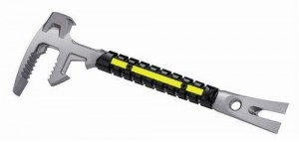
FuBar Forcible entry tool
Heavy Duty Gloves
- Chainsaw
- Axe
- Hex Wrenches
- Extension Cords
- Medium Duty Ladder
- Broom and Dust Pan
- Wire Cutters
- Electrical Tape
- More Duct Tape
- Toolbox or Bucket-Liner Tool Organizer

Grow Stuff
- Shovel X 2
- Hoe
- 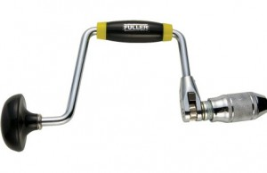
Ratchet Brace for drilling when the power is out.
Rake
- Sprayer
- Wheelbarrow or Garden Cart
- Pruning Shears
- Seed pots
- Mattock

Break Stuff
- Pry Bar
- Bolt Cutters
- Sledge Hammer
- Crowbar
- FuBar Forcible Entry Tool
- Safety Goggles

Odds and Ends Stuff
- Spare 5-gallon buckets
- Tarps and Plastic Sheeting
- Spare Gloves
- Flashlights
- Spare PVC pipe in standard sizes
- Pipe Cement
- Hose Clamps
- Silicone Sealant

