Toilet Stool
Most of us don’t spend a lot of time thinking about our bowel movements – but how you position yourself while you eliminate makes a big difference in your health. Better yet, you can regularly achieve the elusive one-wiper! Proper pooping is done in a “squat” position, which isn’t possible on an unmodified modern toilet. You will need a “poop box” or “poop stool.” The most succinct and entertaining explanation I’ve seen on this subject is the following video by Underground Wellness.
I personally (of course) use a five gallon bucket as a poop stool. Standard five gallon buckets are a little tall, so I use a shorter, wider model. (The exact unit pictured here in my bathroom is the Sterilite five gallon tote.) Not only does it help our bowel eliminations go smoother, but it stores our toilet paper and other bathroom accessories as well!
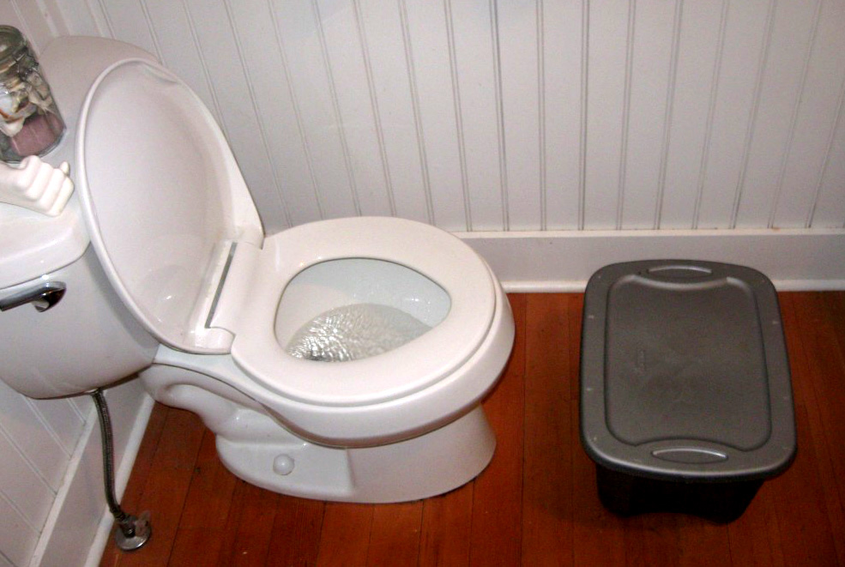
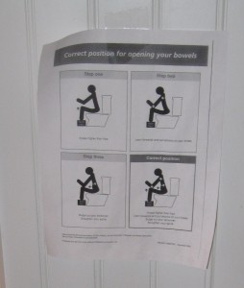As part of my proper pooping evangelism, I post this simple “correct position for opening your bowels” infographic prominently in front of the toilet. I’ve had about half a dozen people use my bathroom, see this sign, laugh out loud, try it anyway, then adopt the method in their own bathroom. Help teach others to poop properly by downloading the printable PDF and hanging it in front of your toilet!
Update: A colon-conscious entrepreneur has invented the “Squatty Potty” – a more aesthetically pleasing version of the poop stool. Their website has links to a number of testimonials and medical research on proper pooping.
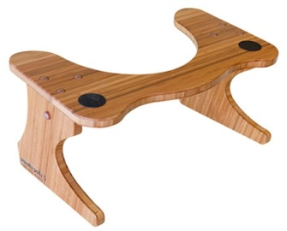
Update 2: I’ve been sent a free Squatty Potty as a gift from the company for mentioning them on this website. I’ve found that it has two main advantages over my bucket stool:
- It stows away right under the toilet, taking up less floor space.
- It’s strong enough to put your weight on, which helps you achieve a better squat.
You can read more about their stool on their website.
