For the “Refined” Prepper
By Joe
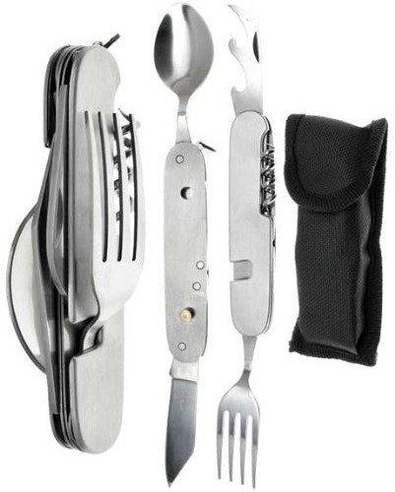
Being in the woods doesn’t mean you have to eat like a cave man.
I was rummaging through one of my go bags the other day and grabbed what I thought was my Swiss Army knife, when I went to open it I was a bit confused as to why it had a spoon on it.
My first thought was that these guys really do think of everything…
I had forgotten that I had received this little wonder a while back and apparently had put it into one of my packs for safe keeping.
I can’t remember where exactly I got it, but I think it was at a trade show.
After giving it another look I thought I should let you guys and gals know about it, and get your opinions:
The good:
Simple and convenient Swiss army style design.
Has 6 tools in one and comes with a:
- spoon
- knife
- fork
- corkscrew
- bottle opener
- and can opener
The entire tool splits in half once opened, leaving the knife and spoon on one side and a fork on the other.
This makes it much easier to use as you can use both the knife and fork at the same time instead of having to switch them out.
It comes with its own nifty black nylon storage bag.
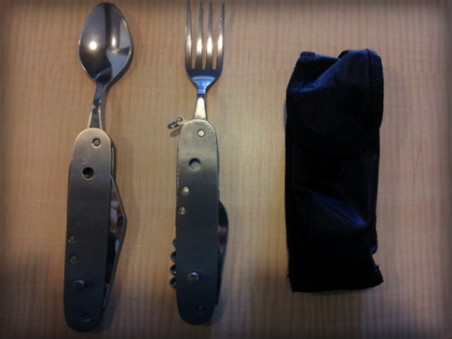

The Bad:
The knife is about as sharp as a marble right out of the package or at least mine was.
The utensils are a bit short for my liking but I suppose that is all in the effort to keep the tool compact.
The stainless steel is not the best quality, but for under $8.00 I wouldn’t really expect it to be
The fork is not as durable as I would like and the tines are a bit dull. Put too much pressure on it and it will bend and become useless.
Again I am greeted with my old nemesis the bottle opener and its halfwit brother the cork screw. I would much rather have seen an additional serrated blade for tougher cuts of meat instead of these pointless attachments.
Other notes:
The first time I opened the knife, I thought I had broken it. I did not realize that the two halves were supposed to separate. After reading some of the reviews, I found out I was not the only person that this happened to, which made me feel a little better about myself.
The short stature of the cutlery makes it easy to get food caught in the crevices left by the open tools, make sure that you inspect it after each use.
This leads to another problem, if food does get left in the tool or it is put up without completely drying, the tool will rust. For lower quality items like this I usually keep a ziplock bag of rice handy. Dunking the item overnight in the rice will help draw out any water and keep it from rusting. A bag of those silica gel packets that you find in shoe boxes would probably work just as well.
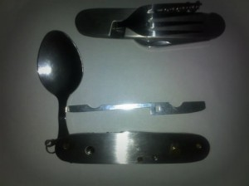

The bottom line:
Like I said earlier, I believe I got this at a trade show as a freebie a few months ago and I believe it was worth every penny.
With that being said even if it wasn’t free I think that the asking price on amazon is well within reason.
It will need to be sharpened to be of any use and if not taken care of properly it will rust. But I think this is a great tool to keep in any camping gear or bug out bag.
After all, even if you only get a few uses out of it, it sure beats having to use your hands that probably haven’t been washed in a while.

