The Portable Potty Bucket
by aptprepper
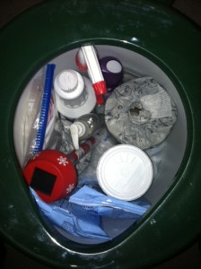
Five gallon buckets are not only great for long term food storage, they are also great for other emergency items such as personal care, and health supplies. We posted a non-threatening way to get them to prep and clever reader Ginger came up with her gift idea to give her family this year: the portable potty bucket.
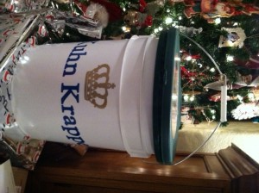
Even non-preppers couldn’t resist such a useful gift! Photo by Ginger used with permission
Ginger did some research on what to include in the buckets (here’s the You Tube video she watched http://www.youtube.com/watch?v=8qXsLohabNo) and here is a list of what she included:
- toilet paper
- Supersorb – absorbent granules that absorbs liquid for quick cleanup. Antimicrobial and odor eliminating, Ginger got hers from a janitorial supply store, you can also find them on Amazon.
- Hi-Genic – thick, non-acid cleaner disinfects and deodorizes, controls mildew and kills HIV-1 (AIDS virus). Also found at janitorial supplies or Amazon.
- rubber gloves
- personal hygiene wipes
- potty seat
- enzymes to break down waste
- plastic bags
- kitty litter
- hand sanitizer
- air freshener
- festive solar light (she included these to light the emergency toilet area)
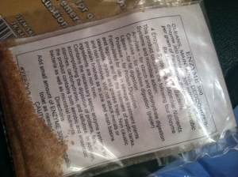
Enzyme use instructions. Photo by Ginger, used with permission.
Her gifts were a big hit and were received.

