The Bucket Budgeting System

Personal finance is one of my favorite topics so naturally I’m very interested in the crossover between budgeting and buckets – the bucket budgeting system!
It’s a simple system designed for people who are adopting a budget and savings plan for the first time. The bucket budgeting system works like this:
Several savings accounts, as few as 3 or as many as 30, are opened at your bank or credit union. Each savings account represents a single monthly, yearly, or infrequent expense that needs to be budgeted for. Each of these accounts is called a “savings bucket.” Name each account after the expense that it is meant for.
These are just a few of the savings buckets a typical American might create.
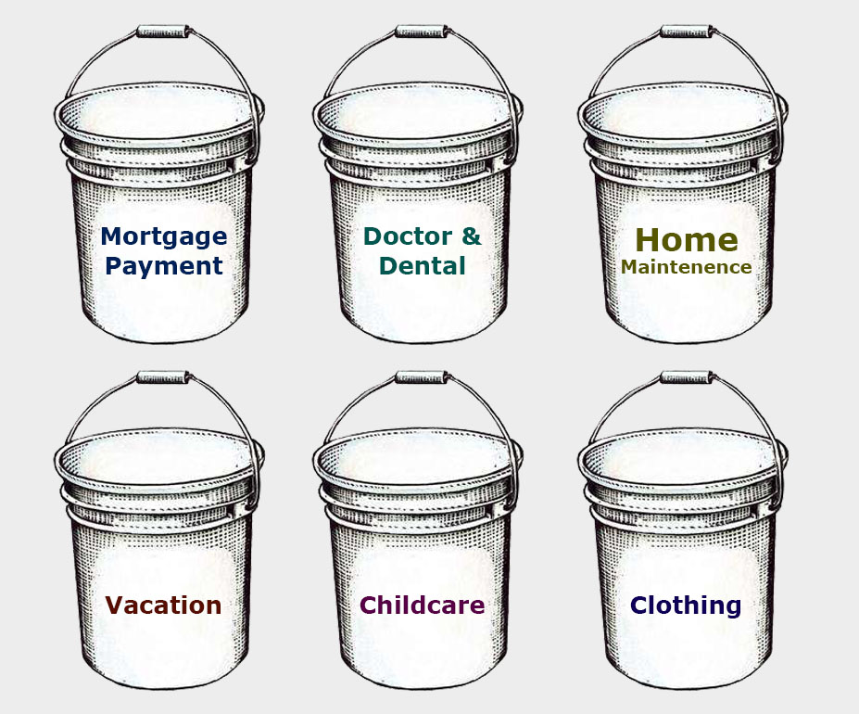
Next, the amount of money you spend per month is calculated. Say you take 1 vacation per year that runs you around $2400 for everything. Divide this annual number by the number of months in a year and you will discover that to save for this yearly trip, you will need to fill your vacation bucket with 200$ each and every month.
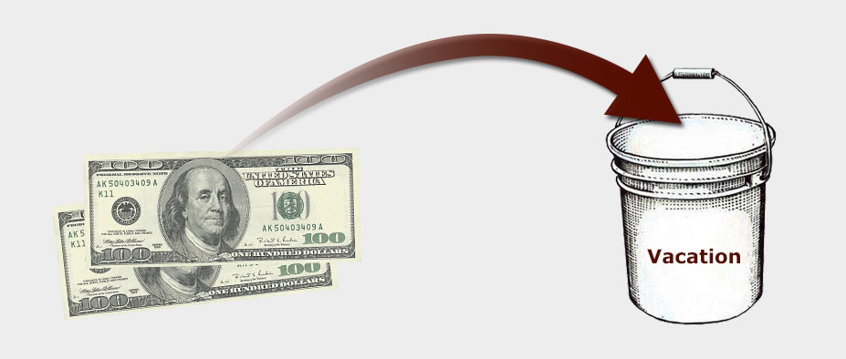
The most important part of savings buckets is for the savings to be removed from your main account automatically. I set this monthly transfer up through online banking. That money will disappear into each savings bucket at the end of every month whether you remember about it or not. This automatic savings plan was first published in the book The Automatic Millionaire by David Bach.
The bucket budgeting system helps you save for those nebulous expenses that crop up without warning – such as car maintenance, doctor’s visits, and other emergencies.The bucket budget system is simple and robust, just like buckets themselves are.
And what if you meet your savings goal in a single emergency savings bucket before that emergency happens? This is likely with the Car Maintenence bucket, for example. Then that’s great! You can stop the automatic transfer of money to that particular bucket until such time as the money is needed.
Now go forth, and start filling your savings buckets!

