The Art of ‘Smoothing It’ in Struggleville

by Todd Walker
Whether physical, mental, or spiritual, your comfort zone is an oasis of low anxiety, little risk, and predictable outcomes. It's that place which offers protection, real or perceived, from the scary unknowns of life.
You're entitled to comfort, right?
Well, yes, to some degree.
We all have comfort zones and comfort items we'd hate to do without. These places and things are needed for maintenance, rest, and recuperation.
However, they often turn into self-made snares. For some of us, stepping one toe outside our comfort zone would be like passing a kidney stone.
Here's the thing...
More comfort does not necessarily equate to survivability. We need stretching, bending, tearing, ripping to grow. It's the struggle, plain and simple, that brings new life. Babies aren't born without pain.
But, like my bug out bag or bushcraft kit, my philosophy and mindset evolve the more time I spend Doing the Stuff. The process can only happen by entering Struggleville. And yes, Struggleville is an actual "town" in GA.
Struggleville is real!
Metaphorically, Struggleville is the place you live. The place where life is forged - good or bad - peaceful or hectic. The place where kids cry, bosses fire, mistakes are made, and life lessons are caught.

Welcome to Struggleville!
It's located in the valley, not the mountain top. You'll never climb your mountain, learn that new skill, or build self-confidence living in your comfort zone.
Here's the danger of never venturing outside your warm, fuzzy boundaries...
- You stop growing
- You stop learning
- You stop doing
It's easy to talk yourself into staying put in your comfort zone. You look around at those who have reached optimal success in your field and your tempted to set your bar to their height. They make it look easy. Nothing wrong with aiming high, but your heroes didn't magically reach the top. They learned to smooth it in Struggleville.

As "Nessmuk" (aka - George Washington Sears) so eloquently wrote in Woodcraft and Camping,
We do not go to the green woods and crystal waters to rough it, we go to smooth it.
Nessmuk was referring to our ability to enjoy the great outdoors. But his statement applies to all areas of preparedness. Learning to smooth it takes practice. Skills aren't developed by just reading about how to. The smoothing it process requires "dirt time."
In a survival situation, dirt time pays off. Whether it's wilderness survival or homesteading, you must trade theory for action. The only way to get dirt time is by Doing the Stuff!
Here's my latest project.
The idea came from a video by Chris Kane on Pathfinder TV on how to build a semi-permanent trapping shelter. Cool project! I decided I needed one for base camp. It's a weekend project I work on when I get a chance.
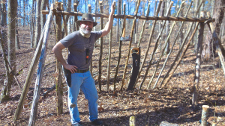

Frame almost complete. It will sleep two comfortably with room for gear.

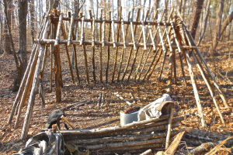
The overhang on the front was made from 32" poles lashed to the ridge beam.
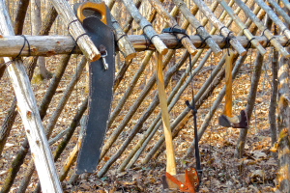
Here are the main tools used to construct the shelter: (L to R) limb saw in black sheath, almost free ax I re-helved, and a Wetterlings belt ax. Other tools used but not pictured are my Swiss Army Knife (for lashings), Bacho Laplander folding saw, and a WWII trench shovel.
Also, I used 36# tarred bank line for lashing material. I'll probably re-lash the main frame with a more robust natural fiber rope.
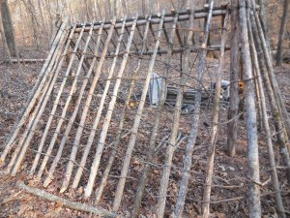
Wild grape-vine is woven between the lean-to poles for stability and to help hold debris on top. I'll use a tarp on top of a layer of pine bows for the roofing. Then I plan to cover the tarp with debris.

