THREE INEXPENSIVE BUT ESSENTIAL STORAGE TOOLS
In one of my past jobs, I worked in a warehouse that created and shipped dozens of different products. I even got the chance to help develop several of these. It was a fun job while it lasted, but there were a few very specific tools that I used on a daily basis that I could not have done my job without. These three inexpensive tools increased my efficiency and saved my hands from a lot of unneeded wear and tear. These tools can serve an even bigger purpose from anyone living a self reliant lifestyle. These are so simple and yet I never see anyone talk about them. These tools are:
Bucket Opener: So many people stock their items in 5 gallon buckets, and I know just how hard it can be to open one of them after they have sat for a while. I have cut and blistered every one of my fingers trying to pry one open with my bare hands. Now before you resort to using a screwdriver to pry the lid open, you could save yourself some time, effort, and a perfectly good bucket ( odds are you will damage the bucket or the lid when you try to open it) and use one of these simple tools that are actually made specifically for opening a pail.
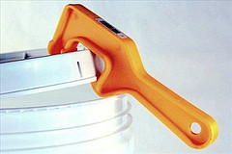
Bung Wrench: Many people store their water in 55 gallon drums, and in order to properly open or close a drum you need a bung wrench. Now I won’t lie, I have used a pair of pliers, vice grips, and even a hammer and chisel to open one of these, but its not worth it. These tools are designed to open multiple sizes and shapes of bung nuts and are a necessity to keep on hand.
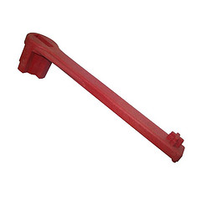
Rubber Mallet: You need to be able to open your pails to get to your item, but the most important thing is to make sure that you can properly close and seal it. If you can’t get a proper seal on your storage items you might as well just store them out in the open. having a rubber mallet on hand will allow you to hammer away at your pails to make sure that they are completely closed without causing the damage that a regular metal hammer would.
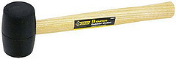
These three tools may be simple and cheap, but they are an absolute necessity for all of your food storage supplies. Save yourself the time and effort, make sure that you have them before you need them.
About Joe
A little about me (‘Above Average’ Joe): I am just an average guy with a passion for learning. .I am excited to share the things I learn with you but I am most interested in learning from you. Survival Life is more than just one man. It is a growing and living community of individuals; all with the desire to be prepared to survive and thrive no matter what this world throws at us. I want to welcome you to the Survival Life community and look forward to growing with you! Thank you, Gaye, for inviting me to share the Survival Life with your readers!
THE FINAL WORD
I use buckets with gamma seals so I do not own a bucket opener but I definitely have a bung wrench for my water barrel and a rubber mallet. Now there are times that I feel like using the rubber mallet for not-so-friendly purposes, like bopping my computer on the noggin when it is not cooperating with me, but I use restraint and all typically ends well.
Gaye

