Survival Lessons from Biosphere 2
Posted on Sunday, March 15, 2015 by Thoreau | Leave a comment
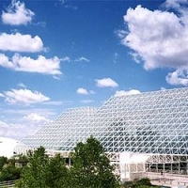
Biosphere 2 was an enclosed three-plus acre living space for 8 persons along with enough land to grow all their food. The idea was to isolate a group of researchers in their own self-contained environment. From a prepping and survival point of view, the experiment offers lessons in self-sufficiency and in planning for anyone wishing to grow all or most of their food.
“It is a 3.14-acre (1.27-hectare) structure originally built to be an artificial, materially closed ecological system in Oracle, Arizona…. Constructed between 1987 and 1991, it explored the web of interactions within life systems in a structure with five areas based on biomes, and an agricultural area and human living and working space to study the interactions between humans, farming, and technology with the rest of nature.” [Wikipedia]
So you would think that a team of scientists, with plenty of time and money, would be able to figure out how much food to grow, which crops were best, and how much land would be needed. But they seriously miscalculated. And this provides preppers with a cautionary tale on self-sufficiency and planning.
“The agricultural area of Biosphere 2 was planted a year before closure, and biospherians managed their farm, growing and processing food, so that there would be a supply of food grown inside when the full closure began.” [Wikipedia]
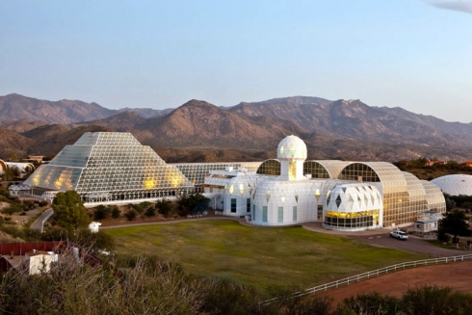
They had the idea that they would grow a low-calorie low-fat high-nutrient diet, for better health. They miscalculated. First, they were not able to grow enough food on the available land. They over-estimated the potential crop yields. Second, they underestimated the amount of fat needed in a healthy and satisfying diet. The biospherians lost an average of 16% of their initial body weight, and they reported frequent hunger during their first year of the experiment. Underestimate how much food you need to grow (and store), and you may go hungry.
Lessons for us
1. If you wish to grow all or most of your own food, hope for good crop yields, but plan for low to mediocre yields. All kinds of problems can occur in agriculture that reduce yields, especially as you first ramp up to self-sufficiency. You probably could grow a complete diet for one person on about 0.5 acres of land — with good yields and no crop problems or failures. But I estimate that 1.5 acres is needed to account for a range of possible problems that would reduce yields.
2. When growing your own food, you burn many more calories than in a typical American sedentary lifestyle. Backyard and mini-farm agriculture is labor intensive. So plan on growing and consuming more calories. I suggest planning for one million calories per person per year (2740 kcal/day).
3. A low-fat diet is not the best option for a physically active lifestyle. Fat is an essential nutrient. It also makes meals taste better and helps you avoid feeling hungry. But when growing your own food, most common crops are low in fat. For the biospherians, their crop of peanuts became very important — too important. Choose at least several high-fat crops: hulless pumpkin seeds, peanuts, soybeans, sunflower seeds, and maybe even tigernut (chufa).
If you are not planning on total self-sufficiency (which is quite difficult), you should store some vegetable oil. Otherwise, you would need to grow an oilseed crop and then press your own oil. Camelina sativa is an excellent oilseed for that purpose. It is high in omega-3 fat and keeps well (up to 2 years) without refrigeration. Safflower seeds are also a good oilseed, high in omega-6 fat.
4. Even with all their planning, the biospherians needed to supplement their closed system with outside resources. Lesson: don’t plan on a closed system. Consider that you will still need to buy some food, even if food becomes much more expensive and less available. Store some food, grow some food, buy some food. Don’t try to grow 100% of your diet.
5. The Biosphere 2 team undertook a second experiment, with 7 researchers inside the closed system. It was a disaster. There were all kinds of disputes, accusations, and controversy. And someone was sabotaging the experiment from outside. The experiment ended prematurely. The lesson for us: when the SHTF and resources are limited, there will be conflict. People will argue and contend among themselves.
And in society at large, civil unrest and an increase in violent crime is likely. So you can’t prep only for food and water. You also need some type of self-defense option. Like a gun. Or another gun.

