Simple Tarp Rigging System: Quickly Shed Pounds off your Bug Out Bag
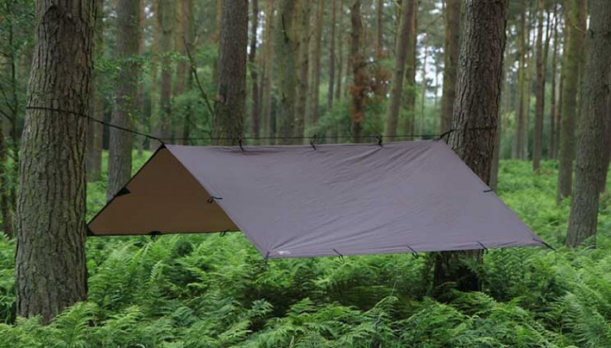

One item that can take up a lot of space and potentially the most weight in your bug out bag is a tent. That is unless of course you are spending a lot of money to get an ultra-light tent that folds up into the size of an Altoids tin and expands to sleep 20 people comfortably. Actually, when my family and I went camping in the great outdoors a while back, I had two tents in my pack because my children were too young at the time to handle the extra weight. Each tent was a two man tent and weighed 5.11 pounds. We did not spring for the more expensive tents for a couple of reasons. First, because we didn’t know how the kids would enjoy camping and didn’t want to make that investment if it wasn’t going to pan out. Second, I didn’t want to spend the money.
Now, you might be saying to yourself 11 pounds isn’t that much weight. Well, I beg to differ. It is a lot of weight and space when you consider that I could have carried a tarp system which weighs less than one pound. If I had 8 less pounds in my pack that would have made a huge difference in weight, but the sheer volume those tents occupied meant that I had to offload some of the food on my wife.
Tarps are a great idea if you are looking to shed pounds from your bug out bag and they give you most of the protection from the elements of a tent. True, they don’t enclose you completely, but they can keep the rain off just as well and the size and weight savings is nothing to sneeze at. The guys at ITS Tactical have a set of videos that show an excellent system of rigging up a tarp that will allow you to add this gear to your pack, save weight and eventually set up time. One great thing about this system is that breaking camp is a cinch.
There are a lot of varieties of camping tents out there and some are of course more expensive than others, but you will appreciate the time and weight savings.

