Sew Your Own Poo Wipes
by Prepared Housewives
Oh my, do we really have to talk about this? Can’t I just store a year’s supply of toilet paper and never think about such things?
Yes. But what happens when your one year supply only lasts six months because eating wheat and beans caused more intestinal problems than you anticipated? Every wise plan includes backups. Even if you never use them, you’ll still have the option to should the need arise and options are a very good thing. If you change your mind and decide during a disaster that flannel is better than tree leaves, you may no longer have electricity to run a sewing machine. So while we have the ability now, let’s get down to the nitty-gritty and sew some poo wipes!
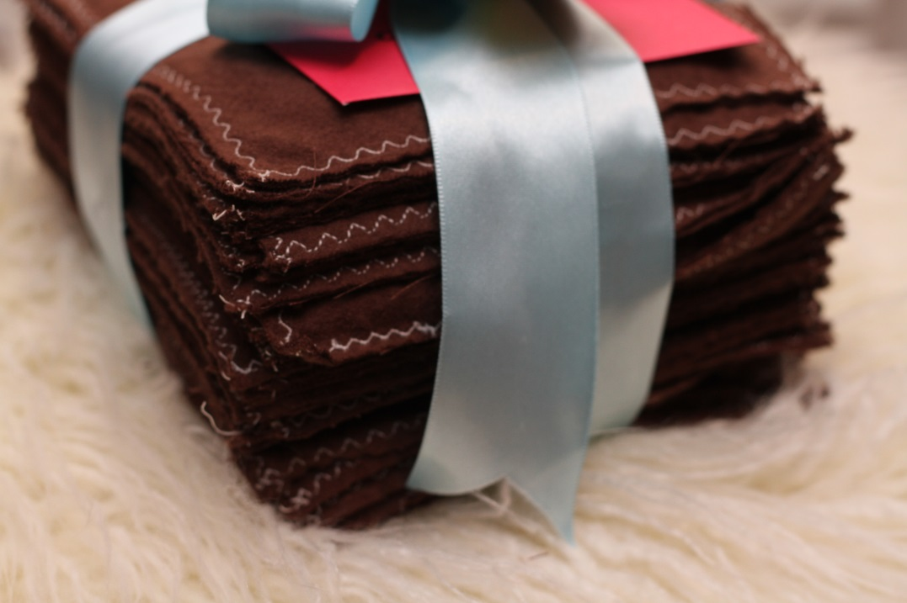
I began with 100% cotton flannel in a nice shade of brown (because let’s face it, that’s what color they will be in the end!) I cut mine into roughly 6×7 inch rectangles that were larger than my open hand. You’ll want to stitch your wipes two layers thick to protect your hands when wiping. If you’re in a situation where you’re having to use these, chances are water is pretty scarce and the last thing you need is to contaminate your hands with no way to thoroughly clean them.
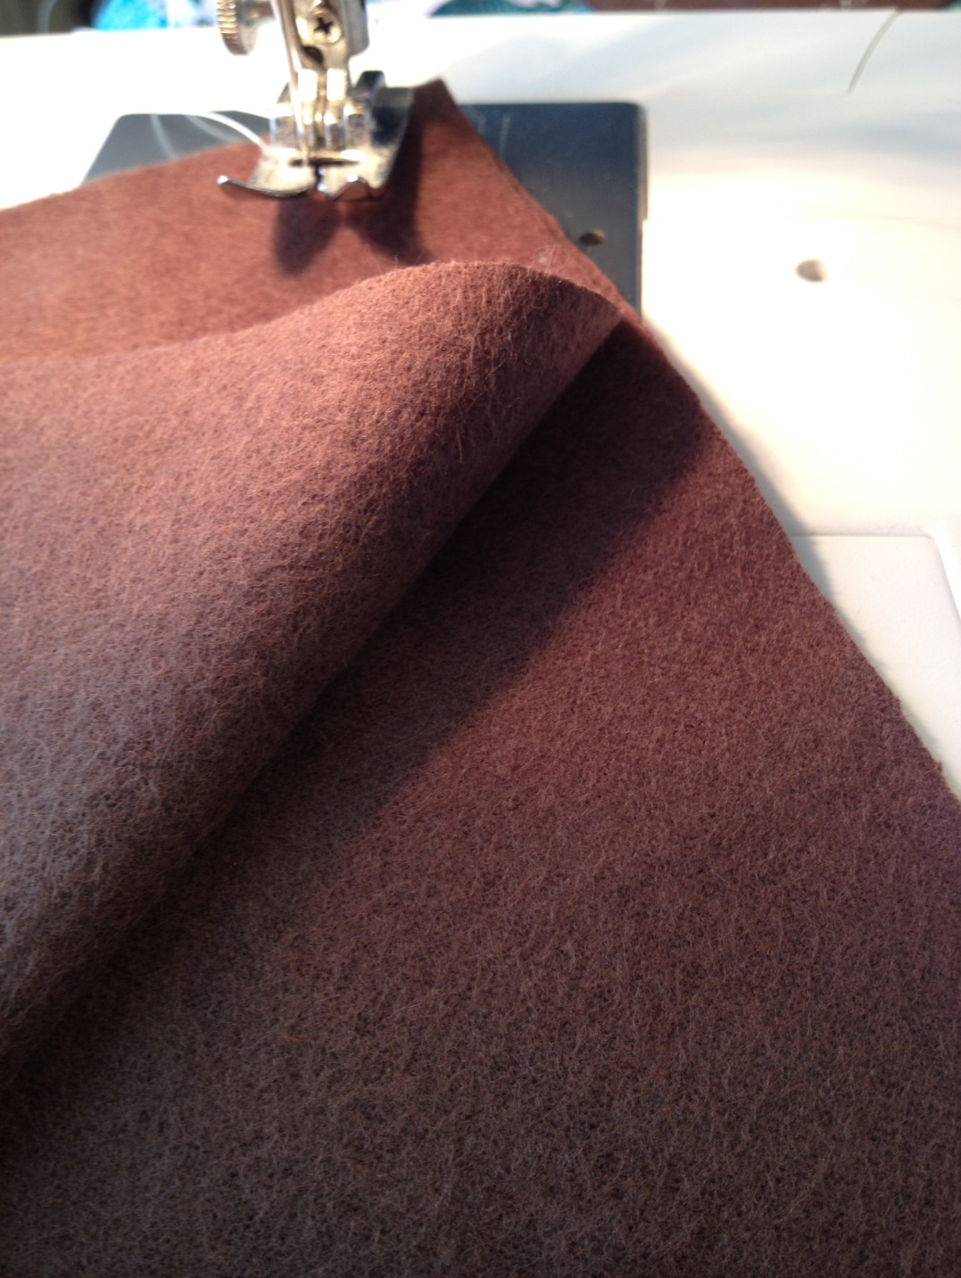
I’m using the same triple zigzag stitch and upholstery thread that I used in an earlier post to sew washable hankies. Believe me, you do NOT want these babies coming undone when you need them the most!
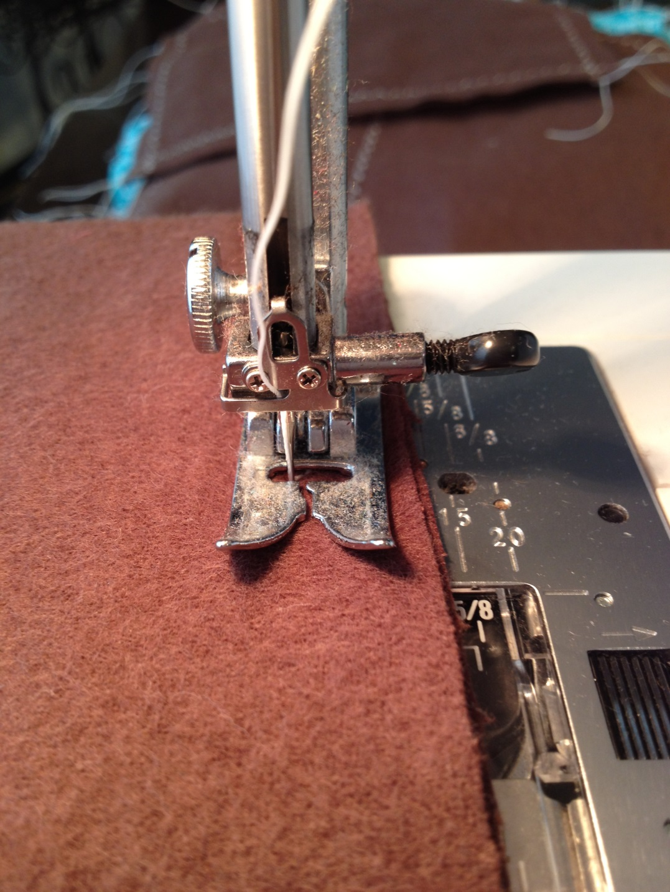
Stitch the two pieces of fabric together, sewing off each edge to create nice, secure corners.
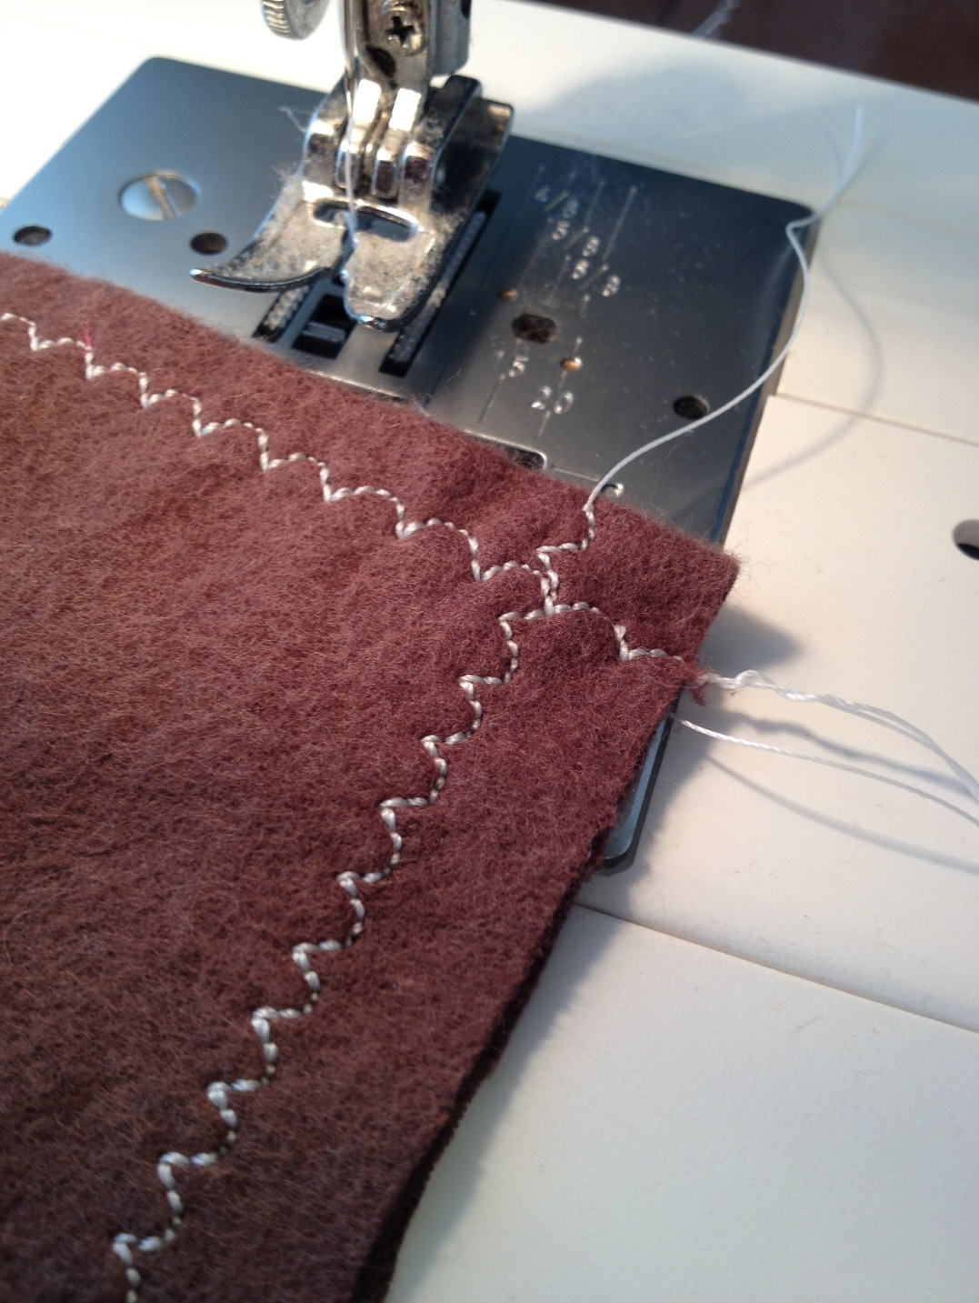
Trim away hanging threads and cut the flannel close to the stitching to lessen fraying when these are washed later. Repeat, making enough wipes for your family. (Our best estimation is 6 wipes per person per day with a minimum 2 day supply on-hand.) These are large enough that you can wipe, fold in half to reveal the clean backside and wipe again but you’ll still need at least 6 per person per day. Children in diapers will need more. Leftover scraps can be stitched into smaller squares for them and they can be single ply instead of double ply if necessary.
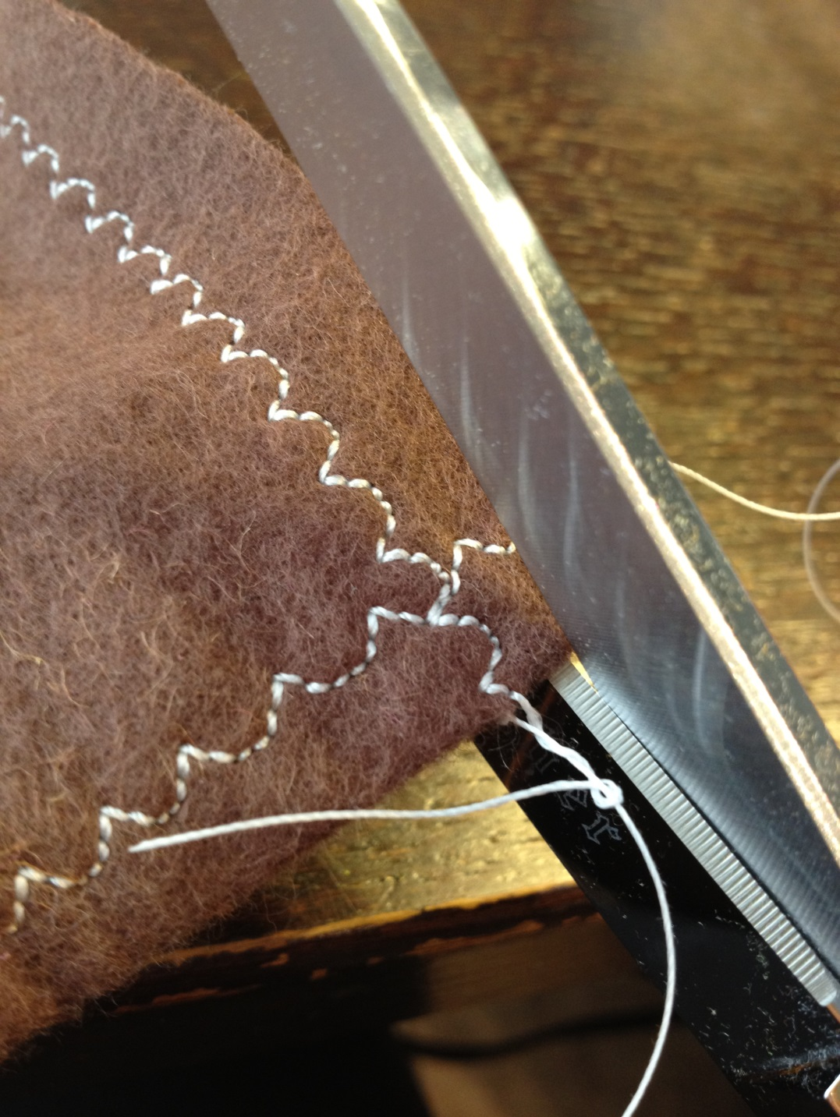
Now stack them up, tie a ribbon around them, print out the directions below, shove the wipes and the printout in a lidded plastic container and PRAY you never have to use them!
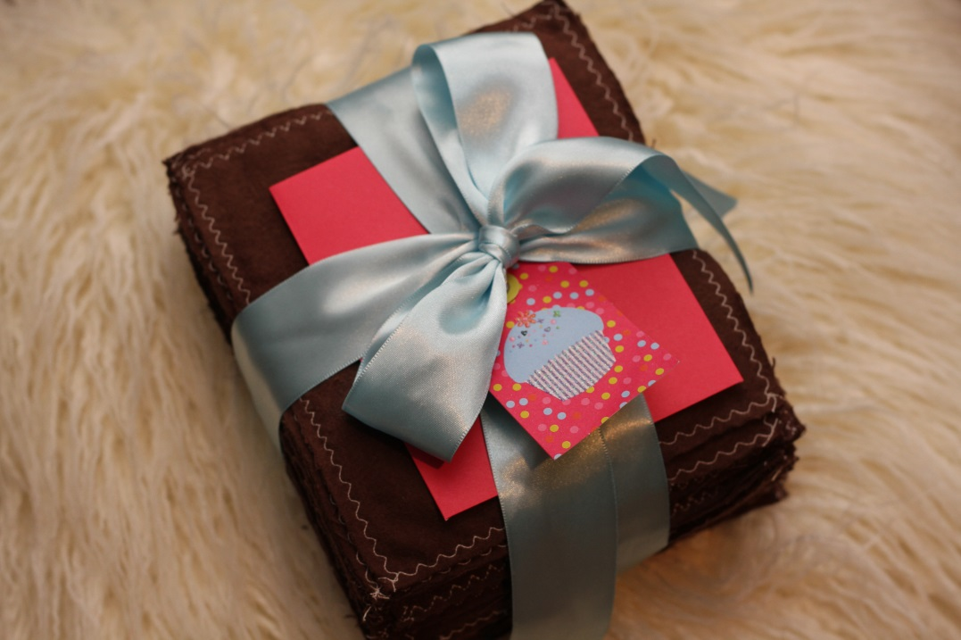

How to Use Washable Flannel Bathroom Wipes
Needless to say these wipes will be contaminated and will need special handling. To use them, first find a large plastic container with a lid that closes. Some people online have suggested things like plastic cereal containers but anything that is large enough to hold ten wipes and doesn’t tip over easily will do. The closed lid prevents odors and poo water spills.
- Fill your plastic container 1/3 to 1/2 full of water and add a few drops of laundry detergent (or 2 drops dish soap if that happens to be all you have.)
- Use the wipe as needed. When it is dirty, place it in the plastic container to soak.
- At the end of EVERY DAY, collect the container from the bathroom. The water is dangerously contaminated and if you are in a situation where it has to be dumped outside, it MUST be kept from splashing on food-growing gardens and trees. Dump the liquid in a designated spot far away from the garden and places where children play. The wipes left inside the container have been pre-soaked and are no dirtier than a pair of lightly soiled children’s underwear. You can run them through your wash as usual or they can be washed on their own in a wash bucket.
- Rinse and refill the plastic container with soapy water and immediately return it to the bathroom. You should have a two day supply of wipes so that while the previous day’s wipes are drying, you have another set already waiting to be used in the bathroom.

