SHTF Life Hacks - Secret Prepper Tip List
For the full list, check out Year Zero Survival.

Have any SHTF life hacks of your own? Share with us in the comments below!

1. Get a grip on rusted jars with some duct tape.
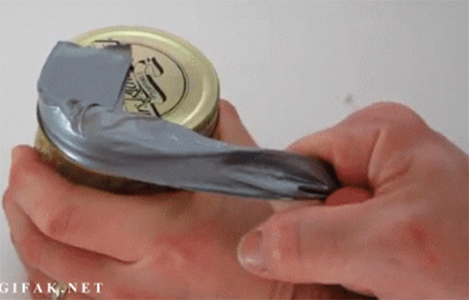
If your jars have been sitting in your preps for very long there’s a good chance that those lids might not pop off as easily as expected. Use a piece of duct tape to twist that lid right off.
Instructions here.

2. Create arrow heads out of keys.
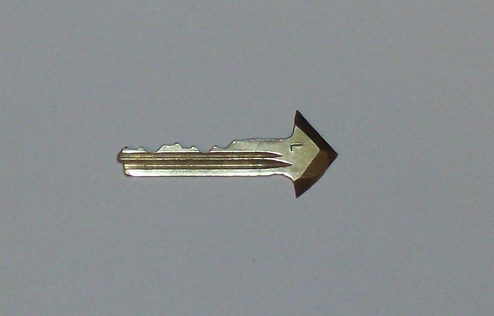
This is a great idea as a back up home defense strategy!
Instructions here.

3. Use crayons as emergency survival candles.
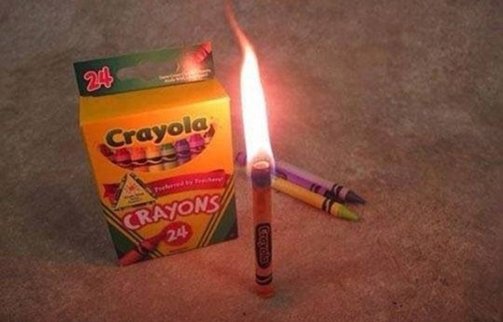
In a pinch you can light these up as an emergency light source!
Instructions here.

4. Use duct tape and toilet paper to set broken bones.
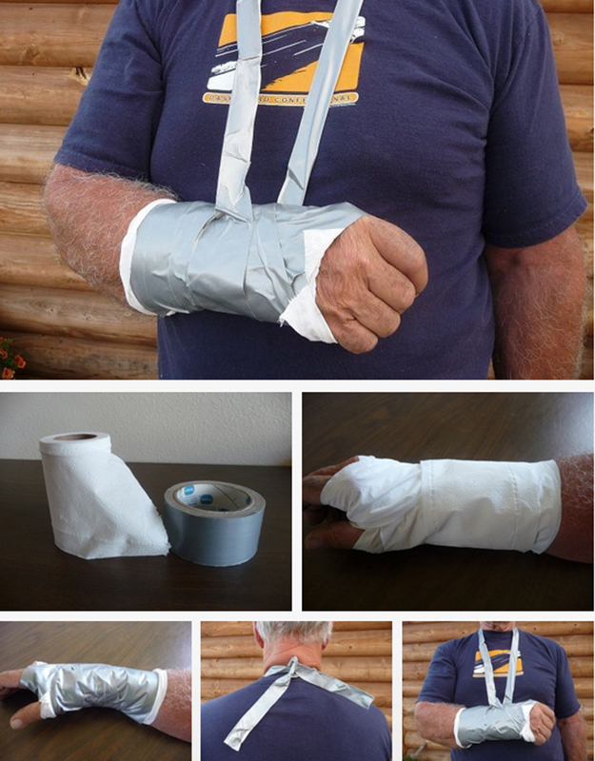
This make shift splint will help you heel up those injuries even if you can’t make it to the hospital.
Instructions here.

5. Create a toothpick cannon with keyboard cleaner.
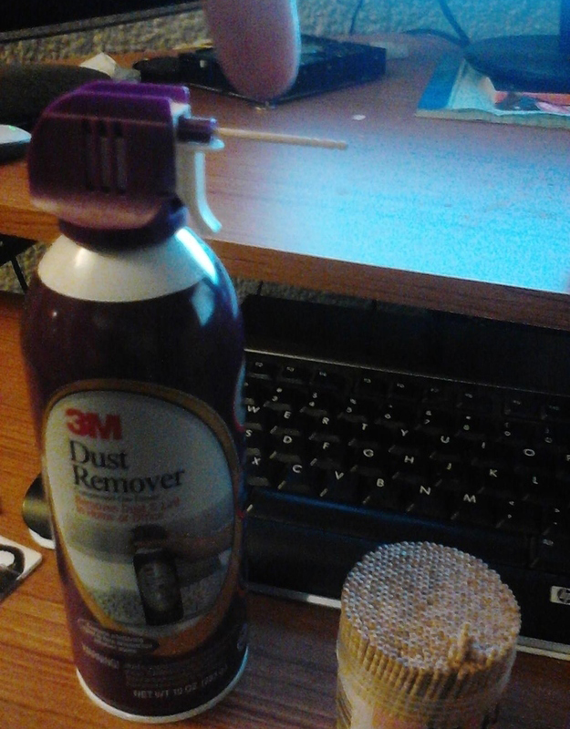
This is more for entertainment than utility. Make this mini weapon to combat boredom!
Instructions here.

6. Stash emergency cash in your phone case.
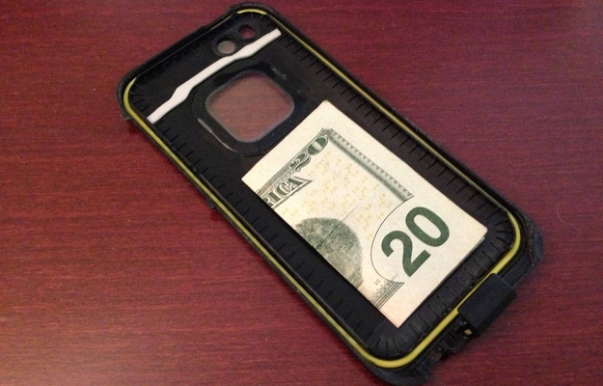
It’s somewhere that no one will ever think to look. Plus, it will stay locked up safe until you really need it!
Instructions here.

7. Stave off frost bite with baby oil.

A little baby oil can go a long way when it comes to saving your skin in extreme weather.
Instructions here.

8. Improvise a safe tick remover out of thread and a mechanical pencil.
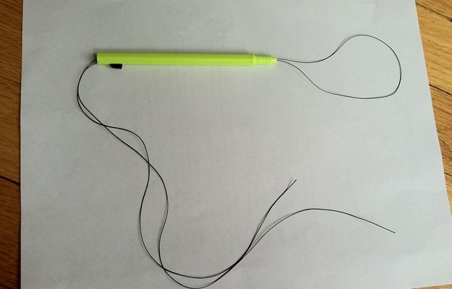
In case you encounter ticks, here’s a method for safely and effectively removing them from your skin!
Instructions here.

9. Carry all your water in one trip with a stick.
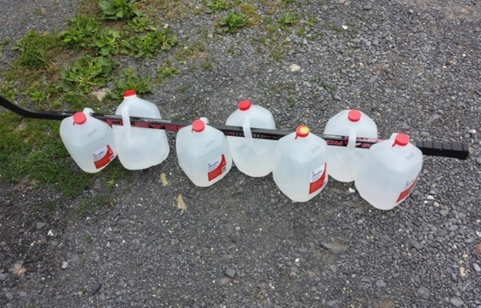
Whether you have a hockey stick around or just a branch off of a tree, you can haul all your water jugs at once with this practical tip.
Instructions here.

10. Turn an old bike into a crossbow.
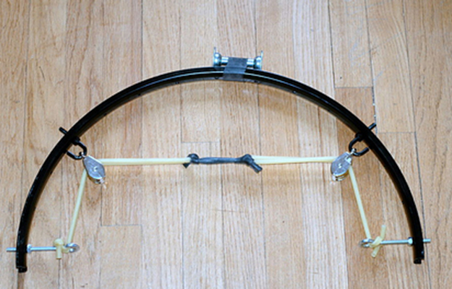
A bike, some tubing, a little duct tape, and you have an improvised crossbow!
Instructions here.

11. Turn lemons into power with a couple of pennies.
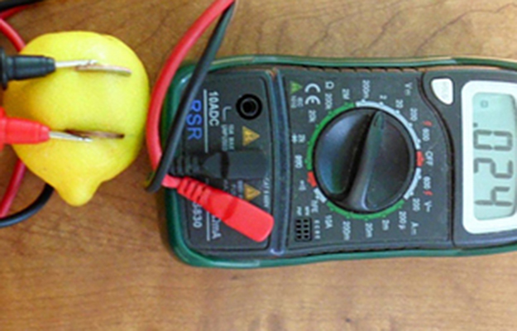
Some pennies and some know how are all you need to turn this citrus into some electrical current.
Instructions here.

Want more hacks and tips? Check out these posts:

Best AR15 Hacks and Tips

Camp Like A Genius | 25 Additions For Your Camping Gear

Fish Like A Redneck | 14 Unique Fishing Tips

Badass Improvised Survival Gear | 7 Easy Prepper Projects

