Rope Making 101
Knowing how to make rope is a great skill to have in an emergency. You might be able to find weaker materials like twine, string, yarn, plant fibers or even plastic bags but they won’t be able to hold anything strong until they are bound together as rope.
Making rope is a great skill to know and very easy to do. Below, we’ve listed some instructions on how you can make a simple rope design. Keep in mind that there are multiple ways to make a rope and many materials you can use.
For this design, you’ll need:
• Twine or string
• Two sticks
First Spin
1. Attach the twine to one stick using a bowline knot. Make the loop large enough to slip off of the stick, if you don’t, it will get too tight and you’ll have to cut the line instead.
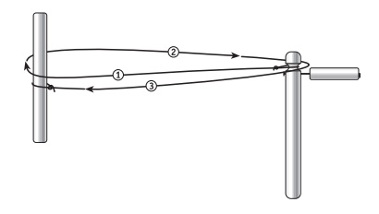
2. Stretch the twine to ensure all the yarns are of equal tension and begin spinning clockwise. As it becomes more difficult to spin while the strand is under moderate tension, you’re probably finished. (For very long strands, use a spinner at each end to speed up the process.)
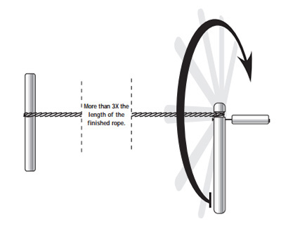
3. Once the strand is tightly spun, it must be folded to make rope. This is the tricky part for first-timers, since the individual segments must be kept tight at all times to prevent kinks. With two additional helpers placed at “thirds” on opposite sides of the strand, have each back up while holding his or her segment.
These bends are then looped over the spinner and the anchor stick, respectively, making the rope one-third its original length. (This can be done with only two people by looping the strand over something like a trailer hitch ball or a sturdy fence post.)
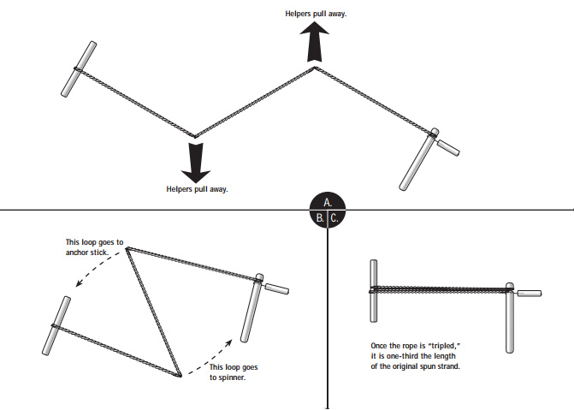
Second Spin
1. Once the line has been folded into thirds, stretch the three strands until they are even lengths. Continue to spin the rope but this time, do it in the opposite direction (counterclockwise) until the rope is tight.
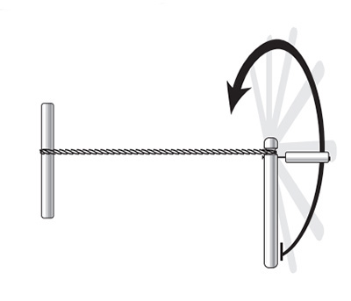
2. Over-tighten the rope and quickly tug on the rope to set it in place.
3. Slide the rope off the sticks and let it relax a bit. Splice the ends to make sure the rope doesn’t come undone.

