Retool or Be a Tool
Retool is defined by the Merriam-Webster dictionary as:
1. to make changes to (something) in order to improve it
2. to reequip with tools
As #1 states, you have to make changes to something to see improvement. That "something" is you. There's no better way to improve you than to learn new skills and enhance existing ones. New skills require new tools.
Sherpa Tip: Strive for progress, not perfection in your retooling. Buy/acquire the best tools you can afford. Cheap shiny objects from China are tempting but you'll end up replacing them several times costing you more in the long run. Cheap tools aren't good and good tools aren't cheap. You can find quality, inexpensive tools at yard/estate sales and used online sites.
Get 'em, you'll need them someday when the power fails to help rebuild. Until then, make smart use of modern power tools while building your non-powered toolbox. Like any new undertaking, there's always a learning curve, especially with forgotten pioneer tools.
Here's my top 23+ human-powered tools that your grandparents or great grandparents used to forge a self-reliant lifestyle. Don't be shy about jumping in and adding to the list in the comments.

Tools for Self-Reliance
- Scythe - This tool was used to cut grass at a camp I ran in Siberia in 1993. An American friend with good intentions wanted to help speed up the landscaping chores and bought a combustion engine lawn mower. It through a rod in 15 minutes. The scythe never lost power.
- Hoe and shovel- There will be long rows to hoe and holes to dig.
- Posthole diggers - Job specific tool that is indispensable for setting fence posts and digging round, vertical holes.
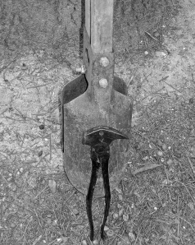Scary looking fencing pliers
- Fencing pliers - A nasty looking tool no homestead should be without.
- Come-Along and block and tackle - Use mechanical advantage to lift carcasses for cleaning or persuade leaning trees to fall away from your cabin. 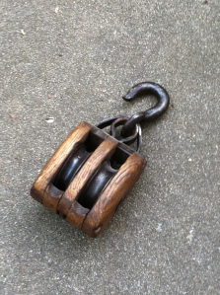
- Wheeled carts - Based on a simple machine: lever. Give me a long enough lever and I can move the world.
- 4 pronged garden fork - Turns compost and sod.
- Containers - The most overlooked of all tools is the humble container. Collect metal, cast iron, plastic, glass, large barrels, stainless steel (milk pails), rubber, and clay containers. Animals have to be fed, water hauled, crops canned, food cooked, water stored, etc., etc.
- Carpentry - Hand saws (rip and cross cut), screw drivers, chisels, draw knives, shaving horse, brace and bits, spoke shave, froe, mallet, miter box, framing square, levels (4', 2', torpedo), hammer, pencils, and plenty of hardware.
- Handyman tools - Channel Lock pliers, socket set, adjustable wrenches, hand saws (cross and rip), hacks saw and blades, clamps, claw hammers (sledge, ball peen, claw), pry bars, pipe wrenches, measuring devices, heavy-duty vise, and files (all shapes and sizes).
- Cutting tools - Knives (fixed blade, folding, and everything in between paring to butcher), axes, hatchets, bush hook,two man saw,adz, broad ax, sharpening stones, and a butcher's steel. I prefer high carbon steel over stainless steel for achieving razor-sharp edges. Plus, high carbon steel knives all you to create sparks with flint, chert, or other hard rock. Redundancy!
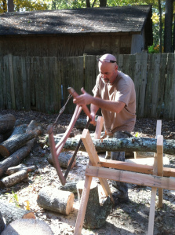
Buck sawing on the Sawbuck
- Blacksmithing - Forge, billow, anvil, hammers, tongs, post vice, files, and quench bucket. After acquiring these, you can make your own tools and needed items. Stock up on salvaged steel.
- Cordage - Natural and synthetic rope, twine, tarred bank line, and paracord of all sizes. Making your own takes time, resources, and skill. Stock up now. Don't forget sewing thread as cordage.
- Food prep - Wood cook stove, cast iron cookware, utensils, pressure canner (relatively new tool), crocks, and churn.
- Personal care - Straight razor, strop, and sharpening stones.
- Weaponry - Modern to primitive. Modern: At a minimum, a common caliber (for your area) shotgun (12 or 20 gauge), side arm (.45, .357, .38, 9mm, .22), high-powered center fire (30-06, .308, 30-30, .223) and rim fire (.22 cal) rifle. When you run out of cartridges... Traditional muzzleloaders: Black powder rifle, shotgun, and pistols. Primitive: bow and arrows, atlatl, slings.
- Music - Forgotten but important culturally and entertainment wise.
- Education - Books - lots of hard bound books from all genres. Writing utensils and reams of paper. Reading glasses.
- Trapping - Foothold, bodygrip (Conibear), snares, and live traps. Check local laws and regulations.
- Beekeeping - Because we all love honey, right!? Bee hives, hive tool, smoker, hat and veil, gloves, and protective clothing.
- Leather work - Down and Dirty Basics: Cutting tool, punch, awl (ice pick works), needle, glue and clamps.
- Medical - Surgical kit that covers minor and major needs. Of course, if you don't have the skill to use these tools, someone in your tribe may. Collect 'em!
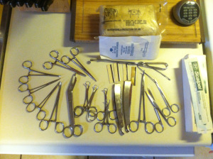
Surgical tools a good friend gave us but I have no experience using - yet
- Animal husbandry - This list of tools can get long really quickly. Take care of your animals and your animals will take care of you. So here goes... Species specific halters, leads, and restraints; wound care, hoof care, syringes, oral dose syringe, etc., etc.
Some of these tools and the skills to use them were common in earlier generations. After a reset, you'll be proud you retooled with a collection of human-powered pioneer tools. Think muscle over motor to rebuild a strong, self-reliant future for your family.
Even if you never learn how to use all these tools, they'd make great barter items for stuff you do need at your local SHTF swap meet.

