Topographic Map Contour
Submitted by: Ken (MSB)
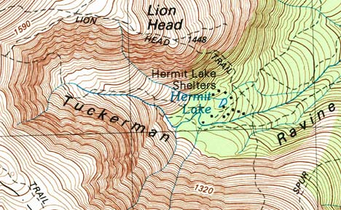
A topographic map is a two-dimensional representation of the three-dimensional surface of the land. A topographic map enables you to visualize the hills and valleys of the land itself, and provides specific details as to the elevation of the surface. Topography is the shape of the land surface, and topographic maps represent the land surface.
Lines snake their way around a topographic map and are called contour lines. All points along the same contour line are at the same elevation above sea level. Think of a contour line as a closed loop. By following a contour line, you would travel flat, not uphill or downhill, and would eventually end up back around at your starting point if you went all the way around it. Contour lines are used to determine elevations (referred to in feet, or meters, above sea level).
Contour lines allow you to figure out general terrain characteristics from their patterns. For example, contour lines that are crowded close together mean steep sections. Contour lines spaced widely apart indicate more gentle slopes. Contour lines trend up valleys and form a “V” or a “U” where they cross a stream.
You’ll notice both thin and thick contour lines on a topo map. The thick lines are known as “index lines” and are typically labeled with a number indicating the elevation. The thinner, unmarked contour lines between the index lines are called “interval lines.” The distance represented between each of the interval lines is known as the contour interval. The contour interval is stated on every topographic map and is usually located near the scale.
For example, if a topographic map scale indicates a contour interval of 6 meters (nearly 20 feet), and a particular thick ‘index’ contour line on the map is labeled ’1040′, this means that everything along that contour line is at 1040 meters elevation above sea level (the newer USGS topo maps are in meters), and each thin line above or below that index line is a difference of 6 meters.
The beauty of a topographic map is its ability to infer a picture in your mind of the lay of the land. Once you allow your eyes to observe the overall pattern of the thick and thin contour lines, it becomes fairly easy to imagine the hills and valleys.
The topo map becomes one very important tool in locating where you are. For example, if you know that you are within the confines of a given map, you could potentially look around and identify several (3 is good) points such as hilltops, valleys, etc. and then look at your map with that frame of reference in your mind while searching for the same identifiers on the contour of the map itself. By using triangulation you could discover your current position on the map.
The unique “V” or “U” shapes along lines of contour will indicate where rivers and streams will likely be (which themselves are typically drawn on the map in blue).
There are countless uses for topographic maps. It may be a good idea to have several which cover the geography of the land near where you live, or other areas of interest where you may travel. I have found a source of free downloads of USGS topographic maps where you can select or enter an address or location (select the TOPO option). The resulting surrounding available topo map grids for that area will be displayed. Clicking the map at any location will place a red pin. Then click on the pin to retrieve the choices underneath the download button and column.

