Project - Country Retreat
I have a dream of having a place in the country – a retreat. Maybe not an entire side of mountain and not a massive underground complex with blast -proof doors and an underground stream running through it. I am talking a few acres down a country road with living quarters not visible when driving by. I have a limited budget and my timeframe is 3-4 years away before funding would be possible. This is an additional residence to my house I have now.
I am at the beginning of this project so what follows are just a few thoughts.
- I am reading the book Dirt-Cheap Survival Retreat: One Man’s Solution again.
- Minimum of 5 acres – more preferable. If the lot was perfect 3 acres might be acceptable.
- Would like a lot with plenty of trees/vegetation/wooded however some space that is already cleared.
- Need to be able to place a camper or large shed on it as the living quarters (more on this later).
- Being able to drill a well at some point is important.
- Owner financing the land is fine.
- This land and the land around it would be considered out in the middle of “no where”.
The purpose of this retreat is two-fold:
#1 – Weekend Getaway: A place where the family can escape to and enjoy the quiet solitude of nature. My wife enjoys the country atmosphere and landscaping the area would provide her and I a lot of fun.
# – Retreat in Case of “?”: If something were to happen that made staying in my home located on the outskirts of a small city unsafe – we could go to the retreat.
I would not rule out that a home could be built at some point and our residence located at the retreat permanently. However at this point this is not really a consideration. A retreat and weekend getaway is the primary focus.

A few examples of possible living quarters on the property:
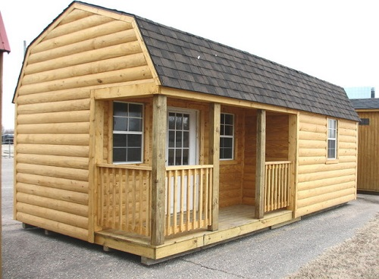
A medium sized single-story shed could be made into the living quarters. The one pictured above is a bit on the small side for what I imagine.
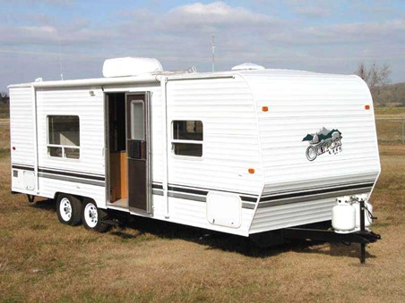
A camper may provide the most feature-friendly living quarters for the money.
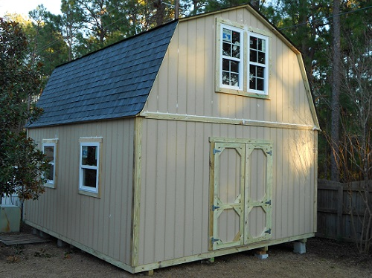
The two-story shed is my preferred living quarters. Lots of space and flexibility in design and set up.
If this works out it will be a long journey however one which in my heart I feel I must partake. Having this remote piece of land set up with shelter, power, communication equipment, etc. would be awesome.

