Procrastination – the death of a Prepper

It’s 5am. I sit here, having woken out of a deep sleep with such a start that it launched me out of bed and into the general blurry direction of my laptop. My article! It’s due today! The screen blinds me as I try to make my sleepy fingers type. My brain strains to string coherent thoughts together. What was my article supposed to be on again? Oh right…getting prepared when it is quiet.

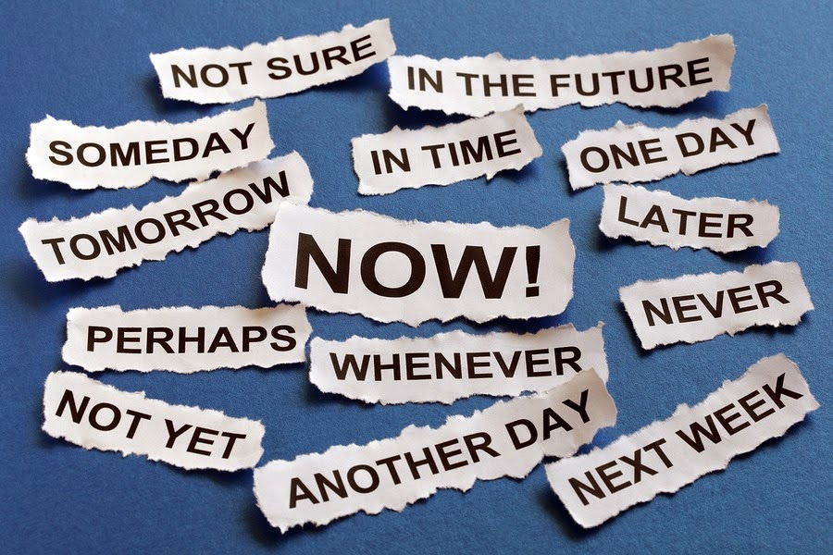

I had a whole month of quiet. Well, as quiet as a busy family with three active teenagers and two working parents can be. I thought of my article many times. “Lots of time!” I told myself. 5am, on my day off no less, laughs at me.

Then it hits me – this is only a small taste of what it feels like to be thrown into an unexpected situation, even though you know the unexpected “could” happen someday. What if this had been an earthquake? THE earthquake. The Big One that haunts us here on the West Coast of Canada? Would I be thinking the same thing? I had a quiet month. Why didn’t I prepare?

Over Christmas we had a number of rumbles in our area that sent a flurry of motivated people to our store to finally get that earthquake kit they’ve been meaning to get for the past 10 years. We rejoiced with every call. Yay! Another family set with the necessities to survive! Our existence as a company was affirmed - this is why we love what we do.

Now that the rumbles have ceased, so too has died down the customers who responded from the gentle kick in the derriere from Mother Nature. The same phenomenon happened when those two cases of Ebola hit Texas last fall. Two cases! That’s all it took to wipe out our manufacturer’s supply of emergency freeze dried food and in turn, our supply of food. We were out within the month. That was our wake up call. As an emergency preparedness company, we too, need to be prepared!

It’s quiet. NOW is the time to get prepared. Don’t flirt with the clock assuming that you can put off to tomorrow, again, whatever you have left to prepare. Stop for a moment and think through the scenario of having life disrupted for a day, a week, a month. If this were to happen to you at 5am tomorrow morning, would you too be stumbling around blindly, trying to gather your thoughts let alone your family and then all your supplies scattered around the house? Don’t let procrastination be the death of you. Finish getting ready, strike a huge check mark through that item on your list, and reward yourself with the peace of mind that comes from being prepared.

