Processing Flax

by Katherine Grossman
Yesterday I began to process some of the flax straw for my bread cloth/dish towel project.
The flax is not as soft nor as super fine as I had hoped for.
That’s because I probably should have harvested the flax a week sooner than I did. Nevertheless, the flax straw will make up into a very nice stricks.
Stricks are small bundles or bunches of processed and combed flax that is ready for spinning into thread or yarn.
At some point in the future I’d like to write a more inclusive and involved post or do a short video when I have more time. For now I thought you might like to see some of the tools that I use for processing flax straw and learn the purpose behind each tool if you don’t already know.
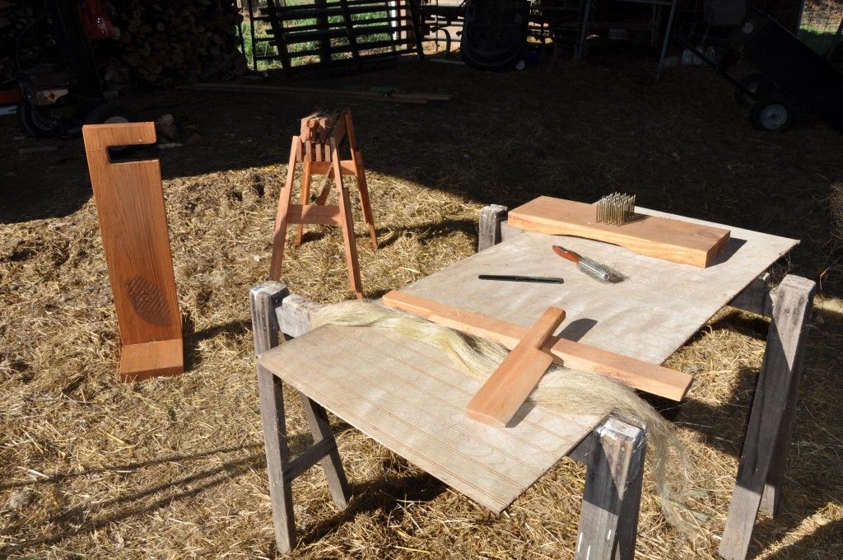
Flax Processing Equipement
All my equipment is homemade except for the round brush and black plastic comb in the above photo.
Once flax has been properly retted is must dry out. I left the flax straw undisturbed for about 6 weeks in the barn after it was retted to allow it to dry completely. It was placed across a feed bunk and well out-of-the-way of rain or snow.
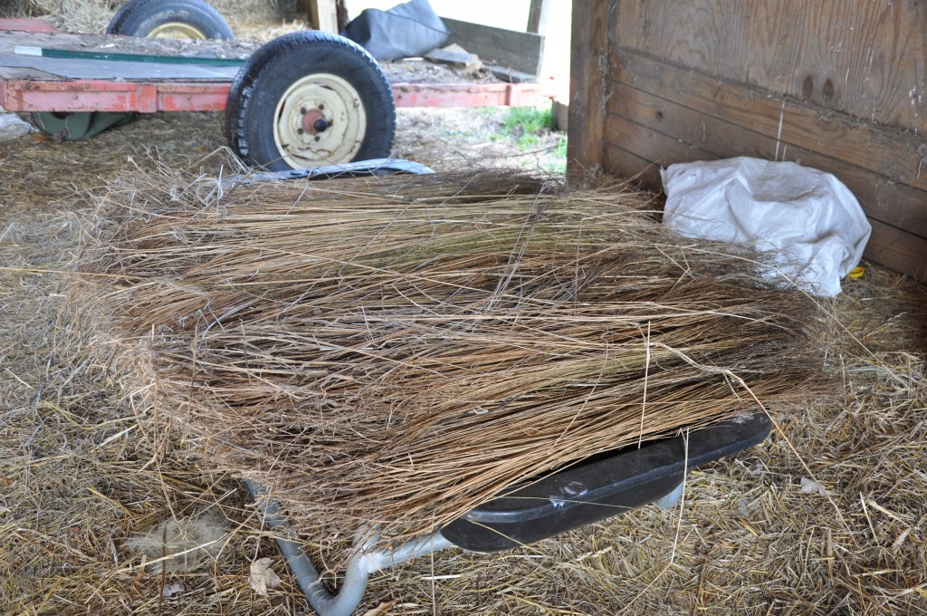
Flax Straw
Flax thread is spun from the bast fibers that are located inside the stem of the flax plant. In order to get to the soft bast fibers, the hard stem or woody part of the plant must be removed. The stems must be crushed or “broken”. The tool that I use to “break” flax straw is known as a “flax brake”. The words are different and are used as a noun and as a verb.
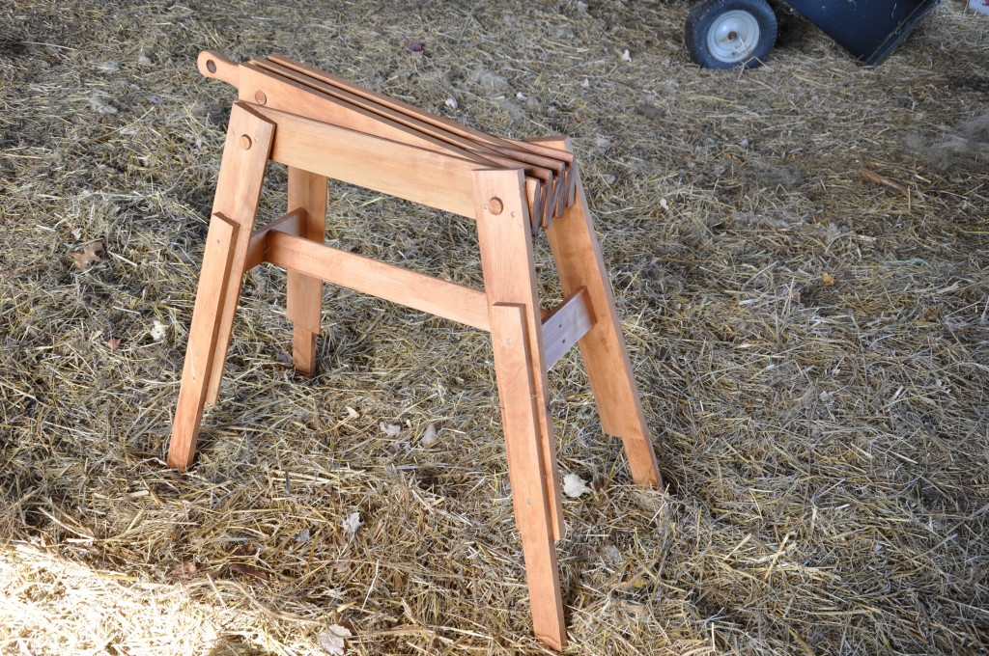
Flax Brake
There are many different types of flax brakes but they all do the same thing. Flax brakes crush the outer stems of flax straw. With the flax brake that I employ, the flax straw is drawn through the brake and the upper part of the brake comes down on the straw in a quick chopping motion. The chopping crushes the stems and exposes the interior fibers. As the flax straw is drawn through the flax brake, the bundle is shaken and whipped so that the hard outer straw bits fall or blow away and leave the soft interior bast fibers exposed. The process goes very quickly.
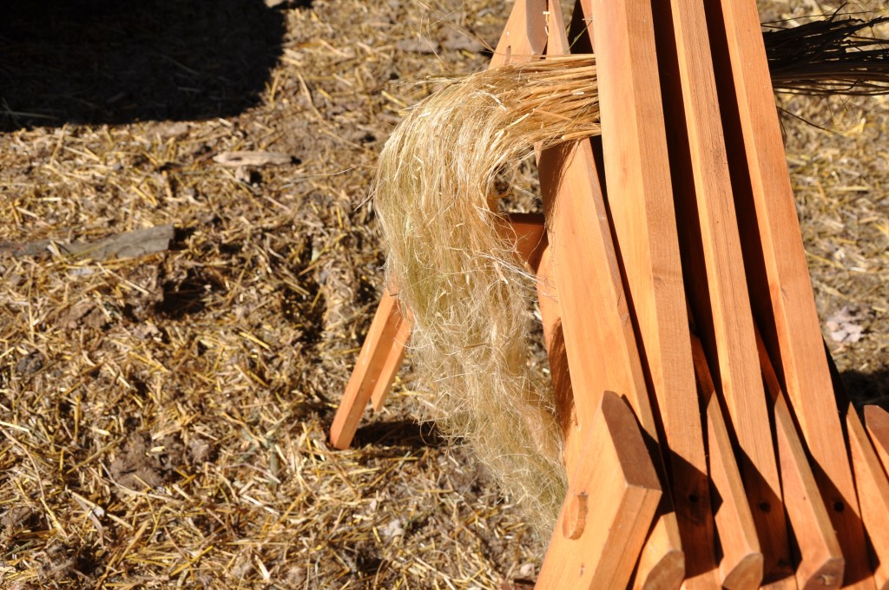
Broken Flax
Once the fibers are exposed there are usually pieces of chaff and boon left in and on the fibers that have to be removed. The tools that are used to remove the chaff from the linen fibers is called a scutching board and scutching knife.
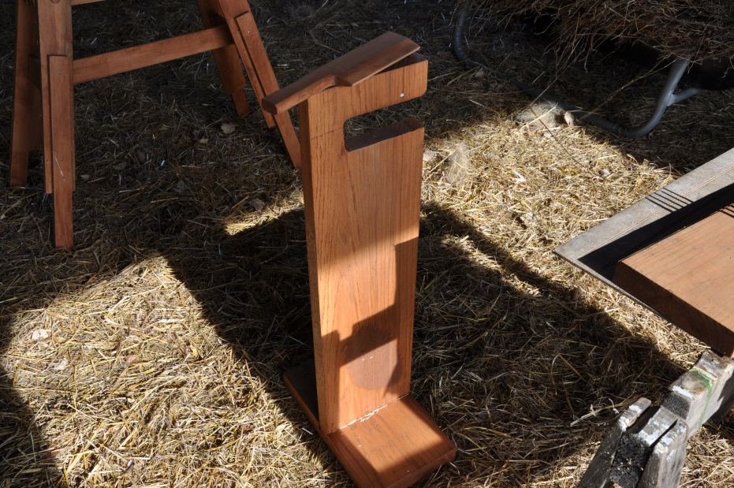
Scutching Board & Scutching Knife
The way that it works is that the fibers are held to the front of the board, and then scraped or smacked with a wooden knife. This helps to further loosen any pieces of chaff that may be stuck on the fiber. It also helps to break the fibers down and make them smoother.
Once the linen fibers are fairly clean and free from chaff they must be combed. Combing the fibers aligns them in a parallel fashion so that they may be spun into thread or yarn. It also separates the short fibers from the long fibers. Usually two or sometimes three different combs are used to smooth and straighten the linen fibers.
The fibers are run through a coarse comb called a “hackle” or “hatchel” for the first combing and then through a finer comb for the subsequent combing(s).
In the past, in my corner of the world, hackles or hatchels were made from hand forged square spikes. Hackles usually had a top or a lid made for them to keep them safe in storage and to help prevent accidents.
You can find them for sale on eBay but they are very expensive.
My homemade hackle is simply a board with spikes. I use a round hair brush for the finer combing.
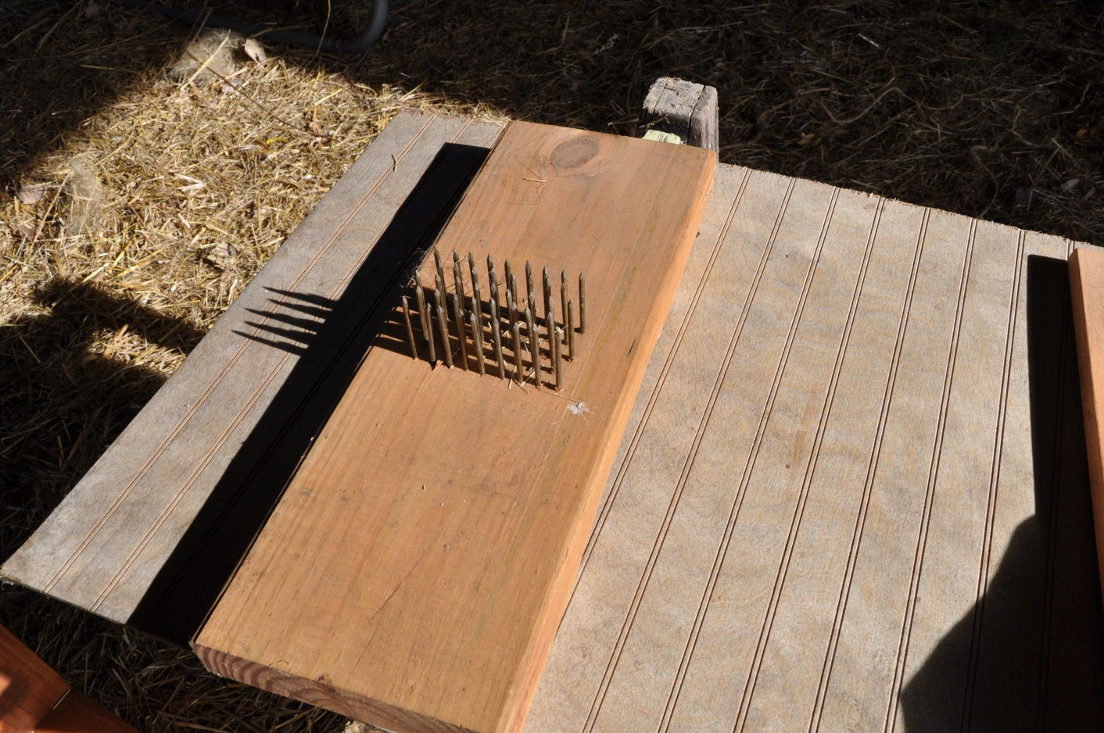
Homemade Flax Hackle
With each combing the flax fibers begin to smooth and straighten. The short, course or tangled fibers are left behind in the flax comb and these fibers are known as “tow”. Tow linen is coarse and has many different uses. The best known is probably tow rope. Tow linen is a favorite for cleaning black powder guns and at one time was used to stuff mattresses and start fires.
Tow linen can be hand spun and makes a very sturdy thread or yarn, which in turn makes a very sturdy but coarse cloth. When spun is correlates to woolen yarn.
Fine linen is spun using “line” flax. Line flax fibers are very long and smooth. Line flax correlates to spinning a worsted yarn.
With every subsequent combing the amount of usable fiber decreases. Only about 10% to 15% of the flax plant is actually used for spinning fine linen – the rest is tow and waste.
In Colonial America, the traditional allotment was 1/4 acre of flax per person per year for clothing, bed linens and toweling. One quarter acre of flax can make depending upon how it is spun and woven, about 20 – 22 yards of cloth.
When flax straw is properly prepared for spinning it has the appearance of over bleached blond hair.
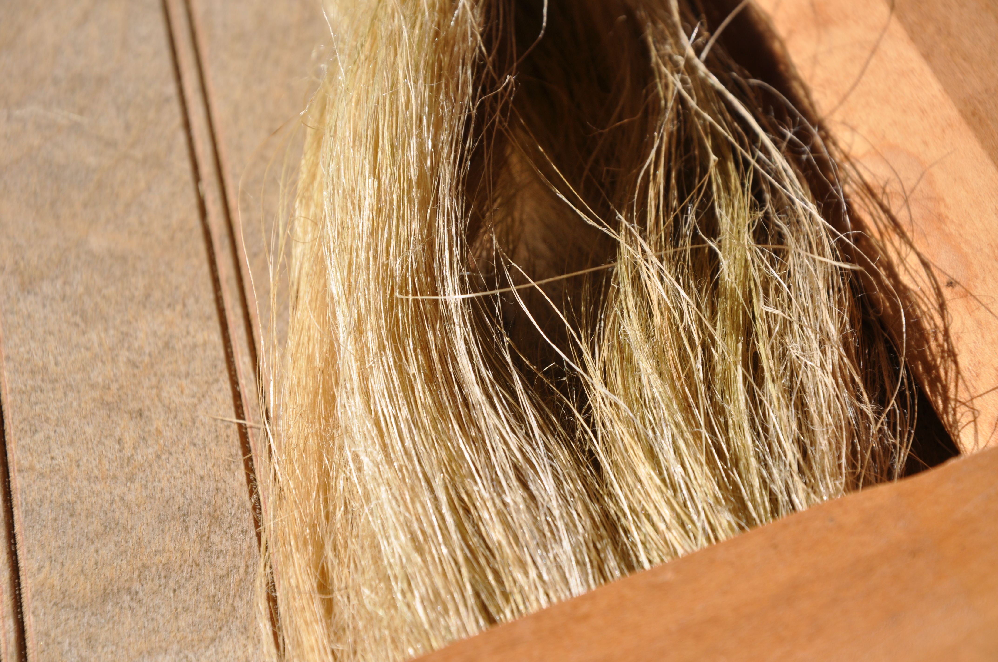
Processed Flax Ready To Be Spun Into Linen Thread or Yarn
It should take me about a week or so working a couple of hours every day to prepare the flax I grew this past summer for spinning.

