Prepping Tips For Ladies
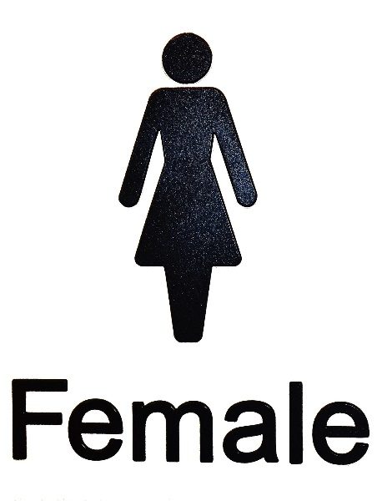
Alright…I’m going to talk about something today that doesn’t get addressed too often by the prepping community…and that’s prepping tips for ladies.
We don’t talk about this that often – but the fact is, once SHTF, about half of the population that gets affected is going to be women.
And women have certain specific needs that need to be addressed once the crisis occurs.
This may be uncomfortable to talk about, but I think it’s important that the ladies get the specific survival tips they may need to survive.
If you are a woman, I thank you for reading this and hope you find the information helpful.
If you aren’t, and you are married to a woman, or you have a sister, or if you have a daughter, or if you even know someone that is a woman, they will be better prepared by being aware of these…
First things first – it’s important to remember that this is by no means a comprehensive list of things ladies need to know in order to survive. However, this will hopefully get the ball rolling and get your ideas flowing of what else the female gender will specifically need to stay alive and healthy in a crisis.

1 – What To Do For Periods
Ladies that are still having periods will need to know how to deal with them once SHTF. Luckily, there are a variety of options they can use to help them out.
- Stockpiling Disposable Feminine Products: At first glance, this can be a well-thought out, logical course of action. However, if you recognize that the average woman uses about 4 tampons per day, for 5 days of an average period, that’s 20 tampons/month. Multiply that by 12 months and you’ve got 240 tampons you need to store in your bug out bag (not to mention that many women’s cycles can last up to 7 or 8 days). Plus, there’s the disposal issue to think about.
- Moon Cups (aka Diva Cups): These are silicone cups that are able to be inserted beneath a a woman’s cervix to collect blood flow. These are reusable, so once it’s full, the woman can take it out, dump it out, and then wash it with soap and water. The key here is to wash it with CLEAN water, so you’ll want to boil the water you clean it with in order to prevent infection. These can be used indefinitely (when cared for properly), and take up a lot less space in your pack.
Note: Did you know that tampons have a surprising amount of uses in a survival situation? After reading about them here, you may just decide to stock them after all!
- Reusable Cotton Pads: These pads are made out of 100% cotton, and can be purchased or handmade. They often are thin, so that you can add multiple layers as needed. Plus, all you need to do is wash them in the washing machine (or with soap and boiled water in an off-grid scenario) and you’ll be able to use these again and again.
- Birth Control: Women can also help to control their menstrual periods with the use of certain types of birth control. Under most circumstances, it is recommended (and healthy) to allow yourself to have a period. However, this will help women both suppress it and control it.

2 – Surviving While Pregnant
The fact is that a crisis can happen at any moment – and, if you’re pregnant, this could make things a whole lot more complicated. If you have the baby in a survival situation, you will need the absolute basics to get you through, such as lots of purified water, clean sheets, pads, and bacteria-killing creams, such as Betadine.
However, it’s a much bigger issue than just having these common items – in a grid-down scenario you won’t have access to the technology, and modern sterilized conveniences that hospitals can provide.
Therefore, it’s much easier for women to get infections and even die in childbirth without the proper precautions.
Below is a video from PatriotNurse – she talks about the top 3 things that can be fatal for a child-bearing mom, and what to do so it doesn’t happen to you. Check it out:
https://youtu.be/-Ql-Jr4JeJk
Hopefully that didn’t scare you too much…the most important thing to consider is PREVENTION in this scenario. Here’s PatriotNurse again to show you, this time, which products you’ll need to stock in your bug out bag in order to prepare for child birth: https://youtu.be/Vy5TZlxt3do

3 – How To Avoid Getting Pregnant
If you haven’t yet started a family, an SHTF situation may not be the best time to start. That’s why you’ll need to carefully consider your options.
- Condoms: Condoms seem to be one of the best methods for this, as they’re about 98% effective when used correctly. Plus, when taken out of the box, they’re pretty compact and easy to store.
- Birth Control Pills: This is a good short-term solution; however, in a long-term survival scenario, it’s likely you’ll run out of these (especially since they’re so expensive). Plus, in a disaster scenario, you’ll have the hassle of taking them every day (often at the same time per day), which can be extremely inconvenient when SHTF. If you’ve got the money, stock up on these, but have a backup method in case you forget to take your pill.
- Diaphragm: Diaphragms are reusable, and are about 85-95% effective when coupled with spermicide. Although less effective than condoms, this method will still help prevent pregnancy.
- Implant: Implants (such as Nexplanon) are inserted into the underside of your upper arm. These release hormones into your body to help prevent pregnancy. These are often extremely effective (some as much as 99%) and are incredibly convenient, so you don’t have to remember to take a pill or use a condom. These are also effective for as much as 3-4 years (depending on the type). The downside is getting the implant inserted, which can be painful. Obviously, you would need to schedule this procedure ASAP so that you can avoid getting pregnant once SHTF.
There are, of course, plenty of factors to consider when it comes to women’s health and birth control once SHTF. Here’s a video with some more details on how to prepare: https://youtu.be/xJogm47aW2w

4 – Eliminate Trading Sex For Survival
Although this idea will repulse most of us, the fact is that when SHTF most people will find themselves worrying about, doing, and saying things they never dreamed they would worry about/do/say. So, for these instances, it’s far better to come prepared.
One way to do this is to mentally prepare yourself. Understand that when men are in a desperate situation, they will act in ways that may not happen in everyday society. As such, it’s important to come up with a plan of how to react when things get really bad, and to continue thinking about/revising that plan as time goes on.
Whether you choose to run and hide, stay and fight, offer something else to barter, or do something completely different, you’ll need to be ready when the time comes.
Like I said, one way to avoid this situation is to, instead, offer another item up for bartering in place of sex. Valuable items, especially those that you know the other person needs, can help sway them into taking the idea of you off the table.
Finally, another option is to have a weapon on-hand when the time comes so that you can defend yourself. Using compact items that fit in your pocket are usually best, as they’re easy to conceal and can often take your attacker by surprise. Pepper spray can also be a great survival tool in situations like this.
Now when it comes to prepping gear, we understand that both genders can and should be able to utilize their preps equally efficiently. That’s why we don’t have many gender-specific products in our online store – we see men and women as being equal, and want to prepare them equally for disaster.
However, the fact is that women have some very specific needs that men just don’t have. And this is where they need to be treated a little differently.
For example, our 22-piece Female Hygiene Kit contains all the basic hygiene products you’ll need and love in a survival situation, such as shampoo, body lotion, deodorant, toothbrush, toothpaste, antibacterial soap, tissue pack, and a comb.
However, this female-specific hygiene kit also includes tampons, sanitary napkins, sanitary cleansing towelettes, and a clean washcloth, giving you the protection and cleansing products you need to stay healthy and dry in a survival situation.
Not only that, but we also recognize that things can get messy in a survival situation, especially when you’re dealing with things hygiene-related.
We think that you should be able to maintain your privacy as much as possible – even after SHTF. That’s why we also carry our Deluxe Privacy Shelter.
This shelter makes bathroom and emergency changing experiences much more manageable, as it offers four walls and a large, zippered door for easy access.
Not only that, this privacy shelter is also made of durable 190 D nylon, ensuring that nobody can see in (or out) when you’re using it. Plus, its screened windows provide plenty of ventilation so you don’t get claustrophobic.
The fact is that once SHTF, most of our modern sanitary conveniences will go down the drain (if you pardon the pun). However, you still have time to hold onto these advantages for yourself, and to prepare yourself so that you stay healthy in a crisis.
Grab our Female Hygiene Kit and Privacy Shelter today to help you get the sanitation and privacy you need for a survival situation.
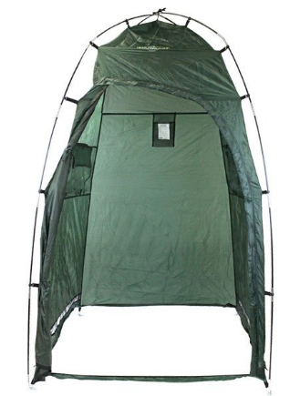 | 