Ready for Anything
- 02 Jun 2009
- phil801
- 2 Comments and 1 Reaction

“Ready for Anything”
That’s our Motto, this series will focus on how to live it.
Or at least, it will focus on some ideas on how to live ‘Ready for Anything’. Specifically we’ll be looking at Evacuation Kits – commonly known as 72 Hour Kits, BOBs (Bug Out Bags), G.O.O.D. (Get Out Of Dodge) Bags among other names, all of which are similar but have distinctive differences. This series will explore all over the Preparedness Rabbit Hole as we discuss multiple methods for Evacuation Preparedness and/or Shelter In Preparedness – which are similar yet critically different.
If we knew what was coming, it would be a lot easier to be prepared. Unfortunately there are endless possibilities ranging from job loss to nuclear war for which we can prepare. Through all of them there is one binary option – Sheltering In (staying in and surviving in your home) or Bugging Out / Evacuating. Another huge effect on Preparedness Plans is whether it’s just you and maybe a small part of your community that’s effected or if it’s the whole state/country/world. The definition of TEOTWAWKI (The End Of The World As We Know It) can just as easily be Global Nuclear War or a sudden layoff when the country is in a recession.
As Preppers, we tend to categorize Preps into survival time frames – Instant Chaos Survival (car crash in the middle of no-where), 3 Day Survival (extended power outage, serious earthquake), 14 Day Survival (Nuclear Fallout), 3 Month Survival (Decent food and supplies to get through a crisis), 1 year (long term food and supply storage to get through an extended crisis) and Ultimate TEOTWAWKI – Catastrophic collapse of civilization with very long term effect. This series will focus on the 3 Day Survival objective and will combine several types of preparations we should/can be making for this. 3 Day Survival is usually looked at as a transitory survival phase – being able to live long enough to get to the next stage – whether the next stage be returning home and getting back to normal or settling into a longer term survival, adjustment and re-establishment phase. Either way, you’ve got to be able to ride out the initial 3 days.
If we’re Sheltering In, our 3 Day Kits will likely be retrieved and kept on hand, likely in bedrooms or in a family room – but out of storage. If we’re Bugging Out, our 3 Day Kits will be retrieved and brought with us, serving as a supply system while we re-situate. By retrieving them for Sheltering In we can be sure that certain necessities are readily accessible such as medical, light or cooking/eating equipment and supplies. If we’re Bugging Out, we are ensuring we have food, water and clothing supplies with us as we rush to get away from the house. But how do we know what to put in there? How do we know what will be needed for 3 days? How do we know what we’ll need after 3 days and how can we be assured we’ll be able to get it? How are we transporting our 3 day kits? How much time will we have to grab and load? And on and on!

Living Prepared
The first thing to clear up is the misconception of “All I need to do is throw a bunch of junk in a bag and I’m prepared”. If you’ve been reading this site for a while then you know that none of the authors here are casual Preppers. We all live a Prepared Lifestyle. Our 3 Day Kit is not just ‘a bunch of junk in a bag’, it is actually a multi-pronged plan with multiple redundancies, extensions, and so on. Those who live a preparedness lifestyle have and maintain mulitple ‘kits’ that are specialized preparedness items in addition to a Bug Out Bag. Some of these include:
- Every Day Carry (items that are with you everywhere you go, typically in pockets or a bag)
  - Jayce’s Every Day Carry
  - ekim’s Every Day Carry
  - Phil801′s Every Day Carry
- Vehicle Emergency Kits
  - Jayce’s Get Home Bag
  - Phil’s Car Kit List
  - Angela’s Car Kit
- Office Preparedness Kits (we need to write a post or two about this!)
- Pandemic Preparedness Kits
  - A full Pandemic/Quarantine Kit
  - A Pandemic Kit to supplement your EDC and Car Kit
These kits are generally considered extensions of one another.

Every Day Carry
The concept behind Every Day Carry is to keep on you at all times the bare minimum you would need to survive and are often things that are part of your daily routine. This generally means tools or items that would allow you to: Defend yourself, build a shelter, start a fire, get somewhere else. For many of us, this means carrying a concealed firearm, a knife or leatherman, a lighter of some sort, a flashlight and a myriad of other things (see the above links for detailed posts). EDC is generally kept in your pockets but can also be kept in a bag or backpack that you always have with you. It serves as your basic survival system that you are never without. This is actually core to living a preparedness lifestyle and serves as the initial building block of your Evacuation Kit.

Car Kits
We spend a huge amount of our time in our cars. If we’re not in our cars, they are usually not far from us. It makes good sense then, to keep an extended survival kit in your car. A Car Kit is also a general survival kit for your car itself. It should contain plenty of tools to allow you to repair your vehicle if it breaks down or has problems. This usually includes: Jumper cables, a tow strap, duct tape, hand tools, a flashlight and so on. It should also contain a good First Aid Kit and items and tools to allow you to survive beyond your EDC if you break down and are stranded. Your Car Kit becomes the second building block in your Evacuation Kit in that it will not only keep your evacuation vehicle running, it can help keep you alive. One thing to always keep in mind with your Car Kit is that the items in it will be subject to extreme heat in the summer and freezing in the winter. This can cause food to spoil and water bottles to crack (from freezing).

Office Preparedness Kits
Many of us spend a large chunk of our day sitting at the office. There is a huge possibility for all kinds of things to happen either at/to the office or that we’ll have to start our evacuation from the office. A good Office Preparedness Kit will contain lots of different OTC medications and a good First Aid Kit that will serve you well for regular day to day occurrences. It should also contain basic survival items for scenarios (such as an earthquake) where you have to survive before you get to your Car Kit. This includes water, water purification, simple foods, a whistle (to alert rescuers), a flashlight, etc. Your Office Preparedness Kit should be able to stand on its own (combined with your EDC) and in an evacuation scenario you should be able to grab it and go. In certain scenarios, the Office Preparedness Kit will supplement your Car Kit if you begin an evacuation from there.

Bug Out Bags or 72 Hour Kits
Your BOB is basically a 3 day survival backpack. It should be designed to allow you to seek shelter on foot and should contain everything you need to defend yourself, keep you fed, hydrated and sheltered and somewhat comfortable. The items that go into it will be a very personal decision based on your skills, inclinations and personal experience. A BOB may be something you have to grab on the run while you’re getting out of the house as fast as possible, it also serves as an item of your Evac Kit.

Evacuation Kits
An Evacuation Kit goes beyond a BOB, actually a BOB is one of the things on the Evac Kit’s checklist. An Evacuation Kit consists of the things you need to take with you to head into the unknown in any kind of an emergency. It assumes you are heading out in a vehicle, that you have at least a little bit of time to grab things and throw them in a trailer or trunk. How much and what your Evacuation Kit contains will depend heavily on your ability to transport it. Preferably you’ll have a trailer that can be pre-loaded and just waiting to go in case of an emergency. Where a BOB list looks like you’re going on a long hike, an Evac Kit list looks like you’re going on an extended family camping trip. You may have several pre-packed bags or containers for your Evac Kit or you may have bags or containers waiting to be packed with lists of what go into them. The key is to consider everything ahead of time and make preparations to be able to load your Evacuation Kit in less than a half hour.

Ready for Anything
This post has covered the basics so we can all be on the same page going into this series (sorry if it bored some of the old pros :) ). From here we’ll start going through how to determine the contents of your Evacuation Kit, consider multiple things you may need and start figuring out how to be prepared for a possible evacuation.
I have spent many hours over the last month or so reviewing over 100 72 Hour Kit, Bug Out Bag, and Get Out Of Dodge bag lists. As I’ve gone through all these lists I’ve made a master list that we’ll start using in the next post. It is, by far, the most complete evacuation list I’ve seen but I’m also sure it is still missing some things. As we go through it, hopefully we’ll get some good feedback on what might be missing. To allow easy updating and re-distribution, I’ve made the list into a Google Spreadsheet

The Master Evacuation Kit List
- 03 Jun 2009
- phil801
- 8 Comments and 0 Reactions
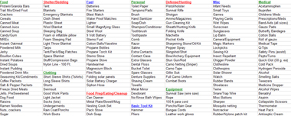This is the second post in a series, the first post covers Evacuation Preparedness basics and can be read here.
Previously, I briefly introduced the Mother of all Evacuation Lists. This list is the result of reviewing well over 100 Bug Out Bag, 72 Hour Kit and G.O.O.D. bag lists and building a master list from them. The new master list can be found here. The link will take you to a Google Spreadsheet which is what we’ll be using for now. I’m hoping to get feedback from readers on other items that should be included which I’ll add to the list. By the end of the series I’ll post an excel file that you can download and store or share. In the meantime, feel free to share the link to the spreadsheet. In this post we’ll start going over the list and get familiar with it.

Categories
Everything on the list is broken down into categories. We have Food, Shelter/Bedding, Fuel, Personal, Defense/Hunting, Misc, Medical, Documents/Money, Address/Phone Lists, Communication, Navigation, Info Carsds, Nuclear/Bio/Chem, Don’t Forget List, Fishing Equipment, Light, Books, Winter Clothes, Automotive, Water, Food Prep/Eating/Cleanup, Tool Kit, Equipment and Clothing. Over the next few posts we’ll break each of these categories down and discuss the types of items that you might include in your Evac Kits from these categories.

Organization
When I put this list together the goal was to provide an all-inclusive list that each person could pare down to what made sense for themselves. There will likely be many things on this list that you don’t feel a need for. You shouldn’t feel like you have to go buy everything on the list or anything like that. The idea is that you can reliably make a personalized list for yourself from this one and know that most everything has been considered – by over 100 people who felt that their list was good enough! Due to this goal, this list is organized a bit differently than others that you’ll find.
One of the first things you might notice is that there are no quantities given. The reason for this is that the quantity needed/desired can be very different from person to person and you should consider the item and multiple scenarios and determine how much you need.
The next thing you might notice is that many lists have a prioritization system – this one does not. You will need to decide for yourself how much of a priority each item should have. There is also no indication as to which container things should go in. We’ll talk about containerizing in a later post, but some of the items on the list should go into your BOB, others should be stored in a category container such as Fishing Equipment, others might be in a rifle case containing a rifle and cleaning equipment. This is also something you’ll need to decide for yourself.
There are also a few categories that may not make much sense – Address/Phone Lists is a list that you keep in your BOB that contains the phone and address of several important contacts you may need while you’re evacuated. We’ll be providing a list you can fill out and print in a later post. There is also a ‘Don’t Forget List’, this is a list of things that you aren’t going to keep pre-staged but that you must not forget when you are rushing around trying to evacuate. It’s a customized check list for before you leave the house – we’ll be providing a downloadable worksheet later in the series. Finally, the Info Card contains vital information for a family member. Each family member should have one in their BOB with the parents/guardians having a copy of all them in their BOB or Document Case. We’ll also be providing a downloadable worksheet for this. Several of these lists are such that you’ll need to update them on a regular basis, like every 6 months.
Over the next few posts we’ll be going through the items in the categories and discussing their use and why they’re included. Once we’ve done that, we’ll discuss Kit Inventories – reviewing our kits on a regular basis to make sure they’re ready to go.

Evacuation Preparedness List Review part 1
- 04 Jun 2009
- phil801
- 5 Comments and 0 Reactions
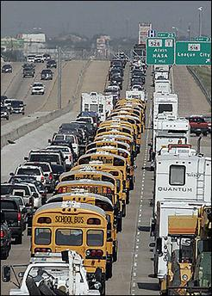This is the third installment of the Evacuation Preparedness Kit Series. The first post, on Evac Prep Basics is here, and the second post, which introduces the Evac Prep Master List is here.
In this post we’ll be discussing the items in the different categories on the Master List. If you haven’t seen the list yet, you can access it here.
As we go through these categories, keep in mind that your 72 hour kit will be more like packing for an extended hiking trip whereas your Evacuation Kit will be more like packing for an extended camping trip. Also keep in mind that redundancy and the ability to shed your larger kits and still be able to survive with your smaller kits is critically important. You may find yourself in a scenario where you have bugged out with your Evacuation Kit, but for whatever reason you have to ditch most of it and go on foot. Your G.O.O.D bag had better be able to support you while your on foot. Potentially, you could have to drop supplies all the way down to your EDC and be able to survive off the items in your pockets. Redundancy across your kits is paramount.

Pre-Planning
This is a topic we’ll cover in more detail in a later post, but it’s important to start off your evacuation planning by considering several scenarios – what you take with you is only one of the considerations!

Bug Out Vehicles
The first thing to know is, what vehicle(s) will you be evacuating in? Your Bug Out Vehicle (BOV) is going to be a critical part of your successful evacuation since it’s what will get you there! We’ll have an in depth post on this later in the series but you need to consider comfort for all those riding, gear storage, fuel capacity, reliability and so on. If you are able, it’s a great idea to have a vehicle that you can hitch a trailer (camping or regular) to (or an RV). This way you can pre-pack your gear into the trailer so everything is ready to go at a moments notice. If you don’t currently have an adequate BOV, you may consider starting to save up for one and looking for good deals.

Timing
Getting out ahead of the crowds is an important part of evacuating. You do NOT want to be in the situation pictured at the top of this post! By planning ahead, pre-packing, pre-staging your gear in your trailer, etc. you can get a huge jump on the un-prepared masses and Get Out of Dodge before the traffic jams start. Meet with your family, plan rally points, make sure everyone knows what will happen in an evacuation.

Bug Out Location (BOL)
Where are you going to go? You might head to a friends place out of town or state. You may head for the mountains. Where you go is going to depend on lots of factors including what the emergency is that made you bug out. Plan ahead and know where you can go. Many preppers buy small (or large) parcels of land away from civilization and turn it into a retreat. This may or may not mean building a cabin, building a storage facility, etc. But having a retreat provides you with a location to get to and a place where you can pre-position some of your supplies.
You may end up going to a town just outside the danger zone and stay in a hotel or campsite there. If you’re doing this, plan on having ways to look up phone numbers etc. so you can call ahead and find vacancies to reserve. Of course, right outside the danger zone will probably be cramped and crazy. You may want to head another 30 miles or so out. With this plan, many preppers will pre-stage supplies in small storage units or at friends houses along the way.

Route Planning
Once you know where you’re going to go and you know your family rally points, plan out how to get there. Consider typical traffic, where traffic jams may occur in an evacuation, types of roads, etc. The best plan will avoid the masses as much as possible. Try to figure out a route using uncommon roads to get out of town and hit the highway quickly. If you can’t avoid high traffic areas, plan multiple optional routes to work around traffic so you can pick an alternate based on the situation.

Comfort
We’ll talk about entertainment later, but consider the comfort of the passengers in your BOV. You don’t want kids packed unsafely in between storage crates in the back seat. You’ll want to have games and books for the kids, some snacks, water, etc. Consider how long a drive it is to your BOL and plan a trip kit accordingly. Then be prepared for the 2,806 “Are we there yet?”. You’ll want to keep them from getting bored but also from getting scared. Also consider weather – if it’s hot you’ll want extra water, if it’s cold you’ll want extra blankets. You’ll want to avoid wasting gas idling in a traffic jam just to run the heater/AC.

The List
Keep in mind (or re-read the second post in this series) that the purpose of this list is to make sure you’ve considered everything. You should be paring down the list to what you personally feel you need to have. And so, on to the Category review.

Food
The majority of the food types listed are dry, high in energy types of food. Most of them are lightweight and will keep for extended periods of time. Note that many of them require water to be added to them – you should keep this in mind when you are deciding your water requirements. There is a variety of foods listed, these are suggested possibilities. You should build a list of the foods you want to take with you and stock on those (don’t feel like you need to get each item on the list).

Your Evacuation Food Crate
The Canned foods on the list, which include the liquid foods like honey, should be stored in a box or crate (labeled ‘Food’) and made ready to go. These are the heavier foods and you won’t want to carry them around in a BOB. The fragile foods like crackers should also be stored in your food crate along with whatever amounts and types of other foods you feel you need to evacuate with. Keep in mind that your Evac Kit is your top comfort level, you’re keeping stuff to make several meals on the road – you don’t have to be over-limiting in what you’re willing to pack.

Bug Out Bag Food Packet
The food you store in your BOB should be the highest in energy/protien that you can get. You’ll want enough to have a few meals with and also several snacks. Gum and Hard Tack candies are great for you BOB. I personally keep several packets of Ramen Noodles and oatmeal in my BOB for meals along with a few MREs. While your BOB will sustain you for a couple days, you’re likely going to need to supplement your food supply with hunting and foraging. Make sure you have the skills and tools to do so.

EDC Food
In your EDC Kit, you should have high energy foods that you can eat on the run. I recommend bouillon cubes for their high protein value along with some jerky and a protein bar or two. A pack of gum and a few pieces of hard tack candy are nice as well. If you are required to live off of your EDC Kit, you should have or develop foraging and hunting skills as well – you won’t be able to keep enough food to last you long. Your EDC Kit should include any tools or items you will need for foraging and hunting.
If you’re planning to take a pet with you if you have to evacuate, don’t forget to store some food for several days for them as well!

Water
You won’t last long at all if you haven’t planned for water. Water preparation is one of the most important things in your Evacuation plans! If you’re going to overkill anywhere, this is the category to do it in!
We’ve covered water preparedness at home, but for Evacuation it’s a bit of a different thing. Depending on how many people you’re going to be supporting, I personally would start off with a couple 5-7 gallon jugs full of water that can be thrown in a trailer or truck during your evacuation loading. You can store these full or empty – if you store them full be sure to rotate the water every 6 months (follow other guidelines for safe water storage as well). The key here is to have something prepared so that in an evacuation you can grab your water and go.
You’ll also need to make sure you have ways of carrying water as you work down through the BOB and EDC Levels. Water bottles, canteens and hydration bladders work well in your BOB. It is also a good idea to keep several store bought bottled water bottles in your Vehicle Kit, Office Kit and Bug Out Bag. An empty hydration bladder is very compact, I suggest keeping one rolled up in your EDC Kit as well.

Water Filters
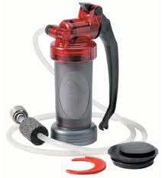There are lots of different water filters available and I would strongly recommend you have several of them in your preps. I suggest keeping a really good and decent sized one in your Evacuation Food Kit so that when you’re throwing everything in the trailer you’ll know you have it. With this filter, keep in mind that the purpose of it is to refill those 5 gallon jugs – so make sure it’s easy and fast to use!
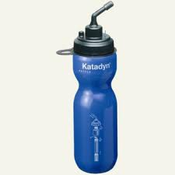You also need to make sure you have a separate water filter in your Bug Out Bag. The purpose of this water filter is to allow you to fill a container and take the container with you. There are some great bottle filtration systems that allow you to fill your water bottle and it is filtered as you drink it. I carry two of these in my personal BOB.
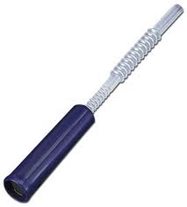You’ll also want to keep a Straw Filter in your EDC gear. These filters are ultra compact and let you drink from almost any water source. The one pictured can also adapt to a hydration bladder. If you’re on the move with only your EDC you’ve got to be able to consume water safely!
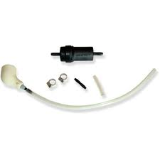If you’re using a hydration bladder, there are inline filtration systems you can get that allow you to fill them from almost any source and filter them at consumption time. (If you’re doing this, make sure you know which bladders have had unfiltered water in them and don’t use them for clean water!)
Hydration bladders can be stored/used independently or incorporated into day packs or backpacks where the drinking tube allows you to use them without removing them. This makes them ideal for almost any of your Kits.

Fuel (Automotive)
If there is cause for evacuation, history has shown us repeatedly that fuel almost instantly become a rare commodity. If you’re not already, become accustomed to keeping your vehicle, especially your Bug Out Vehicle (BOV), full of gas as frequently as possible. Consider your half tank marker to be your empty marker and fill it back up!
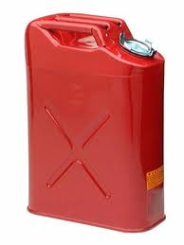If you have a 20 gallon tank on your car, store six 5 gallon cans full of gas at home. This gives you 10 gallons to top off your tank with when you bug out (preferably you’ll be ahead of the game and be able to do this at the gas station and take that 10 gallons with you) and allows you to take a full tank of gas with you. 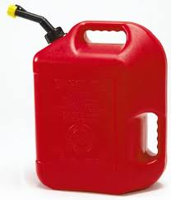If you’re able to, consider storing even more cans of gas at home. A good way to store this away from your house is to dig a trench at the back of your property, put the cans in it and cover the trench with plywood (to hide it, throw a little dirt over the plywood and incorporate a flower garden around it). Be sure to use Sta-Bil to keep your gas from going bad. We’ll have a post going into this in depth shortly.
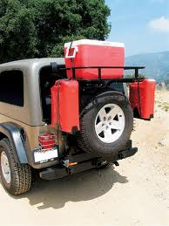Be sure you have a plan for carrying your gas with you in your BOV so that when you evacuate you’re able to grab the gas cans and go. There are external carrying systems you can get for your vehicle, or you can just stow them in a trailer or the back of a truck. Planning to store gas inside the vehicle you’re driving is a bad idea as there is a good chance that fumes can accumulate in the car making everyone sick.
It’s also a good idea to keep a siphon system or just a length of hose in your evacuation kit (and your Vehicle Kit). In a pinch you may need to get fuel out of a different vehicle and into your BOV.

Shelter/Bedding
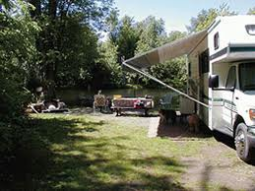Your Bug Out Vehicle (BOV) might be an RV, Camp or other Trailer that you can sleep in – or it may be a little car that the last thing you’d never want to sleep in (a later post in this series will discuss BOVs).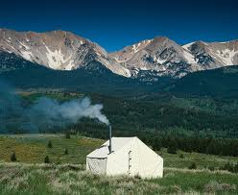 Either way, it is a very good idea to have a large tent that will comfortably house your family and much of your gear for several days in your Evacuation Kit. You’ll also want to have a box or crate pre-packed with bedding (blankets, sleeping bags, pillows, etc) so you can just grab it and go. Be sure to include tarps, ropes, tent stakes, etc in your Evac Kit. Your shelter is a critical part of successful evacuation, spend a bit of time and effort making sure it is all there and packed properly.

Bug Out Bag Shelters
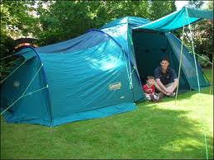Assuming you don’t have your Evac Kit shelter with you, your BOB should contain a backpacking tent and sleeping bag or, if you plan to rough it a bit, a tarp can serve just fine as a shelter. If you’re using a tarp for a shelter, make sure you practice building different types of shelters with it – bugged out is not the time to learn!
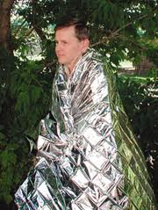For EDC, it’s a good idea to carry an Emergency (or Space) Blanket with you. They are extremely compact and will give you something to wrap up in during the night. It is a good idea to also learn survival skills that will allow you to create a shelter while on the run, and then carry the tools with you to do so.
In our next segment, we continue working through the categories in our master list. If you have anything to add about these categories, please do so in the comments!

Evacuation Preparedness List Review part 2
- 05 Jun 2009
- phil801
- 1 Comment and 0 Reactions
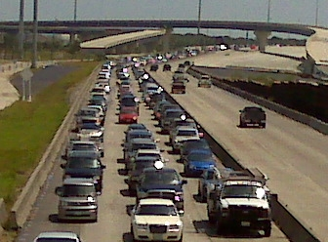This is the fourth installment of the Evacuation Preparedness Kit Series. The first post, on Evac Prep Basics is here, and the second post, which introduces the Evac Prep Master List is here. The third post, and the first post on the list review is here. This post will pick up where we previously left off in reviewing the categories on the Master List.

Clothing
This is another highly personal selection category. The main thing to consider is that you have NO idea what type of situation you’re preparing for. I suggest packing two separate crates for clothing. The first should be regular/warm weather clothes with the second containing winter clothes. This way you won’t have to carry or dig through all the winter clothes unnecessarily.
Consider that during an evacuation you will likely be outside a lot, be doing much manual labor, could be schlepping through the woods, and may be doing industrial type cleanup. You will want to have good sturdy clothes with you! Also consider and prepare for different inclement weather. It could be rainy, windy, sweltering hot, or freezing cold.
Also take your footwear into serious consideration. You’ll need sturdy boots for clean-up and hiking and tennis shoes for around camp to give your feet a break from the boots. You’ll also want to make sure you can keep your feet dry as much as possible. I never met a camper who thought they had too many socks!

Cleaning Clothes
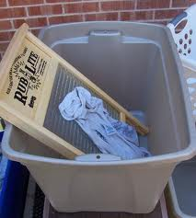You’ll also want to make sure you have a method for washing out your clothes – especially if you end up outside a lot or doing disaster clean-up. This is another area that you’ll want to pay careful attention to and make sure you Know Before You Go how to wash your clothes! There are several techniques for doing this including using a scrub/washboard for cleaning hard dirt/stains, a plunger washer (plunger, 5 gallon bucket, water, laundry soap) for cleaning/rinsing and a clothes line and clothes pins for drying.

Bug Out and EDC Clothes
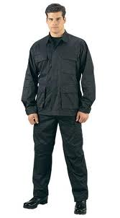In a bug out situation, you can’t assume that you will have suitable clothes on when you bug out. You should have at least 2, preferably more, changes of clothes in your BOB. You’ll want to add and remove winter clothing considerations as the seasons change. Gloves are always a critical component of a good BOB.
For EDC consideration, many serious preppers wouldn’t be caught wearing clothes that weren’t suitable for survival. I personally only wear cargo or BDU style pants (in nice business dress colors), shirts which can conceal a firearm, sturdy boots and carry gloves and a beanie in my EDC bag. Serious preppers are Ready for Anything Day in and Day out. If this isn’t describing you, you may want to consider whether your accustomed daily attire is very fitting for an emergency situation and assess whether you want/need to make any changes.

Fuel
There are many, many techniques and tools for starting and maintaining fire – and to survive you MUST have this ability for heating yourself, cooking food and generating light. I have been working on a post that covers many areas of fire starting, look for it soon. Here, we will just briefly touch on several ways to start fire (create a flame) that you may include in your evacuation kit – remember, redundancy is your friend:
- BlastMatch
or similar magnesium/flint combination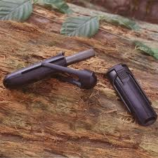
- Matches (waterproof)
- Lighter
- Magnifying Glass
- Steel Wool/9 volt battery
The type of fuel you pack in your Evacuation Kit will depend on what type of stove you have. Make sure that you pack enough fuel to cook and heat for several days. You may also be using battery powered light sources – if so you may consider stocking rechargeable batteries, a solar battery charger and solar panels. We’ll have a post soon on this particular topic as well.

Fuel and EDC/BOB
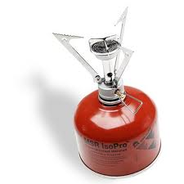Whereas in your Evacuation Kit you can pack a lot of fuel, your BOB and EDC kits will have much less to none. For your Bug Out Bag, I suggest getting a compact backpacking stove and keeping the stove and one can of fuel in your BOB. I also keep a Blast Match (pictured above), 2 lighters, matches and a flint/steel set in my BOB.
For EDC, I keep a BlastMatch and a lighter in my EDC Bag. If you’re on the run with only your EDC and you need to cook or need heat, a fire is probably your best bet. It would be wise to obtain the training and experience needed to be able to survive with just a fire.

Food Prep/Eating/Cleanup
I strongly recommend that you buy or build a good Chuck Box to keep all of your camping kitchen supplies in. I will be following this series up with a full pictorial post and plans on how to build your own Chuck Box. Not only does it serve to hold all your kitchen gear for your Evac Kit, but it helps keep it clean, organized and accessible. Camping kitchen gear is famous for being lost, filthy or broken.
From experience, I suggest you pack more silverware and dishes than you think you need (not just one per person). Make sure that you have a wash and a rinse basin along with sponges, a scouring pad and dish soap. For you Evac Kit I would pack everything on our Master List for the kitchen.

BOB/EDC Food Preps

In your BOB you’ll want to pack a compact cooking set – the most important things are a pan to boil water in and a frying type pan. With those two pans you can cook almost anything over a fire. A wide metal plate, deep metal bowl, a metal mug and a spork type utensil are, in my experience, the best personal outdoor eating gear. Mostly because they don’t take up much room, you can pack stuff inside them easily and when using them, you can put them over the fire to heat or boil their contents. I keep a scouring pad with them as well for quick and easy cleaning.
For EDC, a spork and the previously mentioned Hydration Bladder and Straw Filter along with the assumed Pocket Knife will allow you to eat (it may not be the most convienent way to eat, but it’s convienent to carry). Survival and Foraging skills will help you learn good methods for eathing without containers.

Books
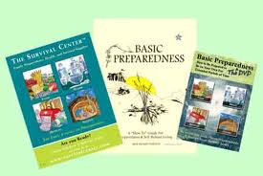The list has only a few books listed. A proper emergency and survival book list would have to be it’s own never-ending list. I’ve attempted to put some examples of categories of books that you might find useful in your Evacuation Kit, you’ll need to choose your favorites that you’ll want as both a reference and as reading material to pass potentially boring time.
I will say however that, if you’re religious, having your scriptures with you can help calm things and provide you with fine reading while you wait out the emergency. I personally carry a very small set of scriptures in my EDC bag.

Personal Items
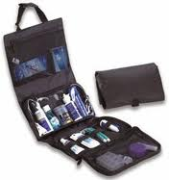Some quick comments about this category:
- Toilet paper is something you really don’t want to be without. Pack what you think you’re going to need, then add a roll or two. Keep a roll in your BOB and at least some in your EDC.
- Tampons have their obvious uses, but they also make a great blood absorber. If you’re in a situation where there’s a heavily bleeding wound, you can stuff a tampon in there to clot it off.
- Extra Glasses – if you missed it, here’s our post about getting quality, inexpensive glasses online.
- Contacts – if you wear contacts and if you don’t have a spare pair in your kit, make sure you put a spare contact case and some saline in there. Chances are you’ll be wearing them when you bug out and will need to take them out.
- Hand Sanitizer – here’s our post on how to make your own hand sanitizer
Most of these items I keep in both my Evacuation Kit and my BOB, but other than TP, contact supplies, hand sanitizer and glasses, I don’t keep any of them in my EDC.

Basic Tool Kit
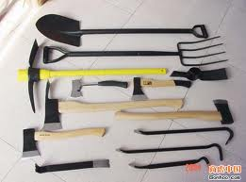The tools listed will allow you to accomplish most of the common types of jobs you might run into in an evacuation. I suggest putting together a toolbox that is specifically for your Evac Kit and loading it with tools NOT from your workbench, hopefully they’ll still be in there when it’s time to go. Anything on the tool list that you feel you should take but don’t have doubles of, add to your “Don’t Forget List” and grab them on your way out. If you have a BOV, you can pre-load it with the hand tools like shovel and pick.
There are a few things on this list that make sense in a BOB and possibly in your EDC kit – duct tape, Multitool, Hatchet, crow bar, wire cutters and a saw. There may be others that make sense to you. I keep duct tape in my EDC kit as well as a small crow bar. I also have several of these tools in my Vehicle Kit.

Defense/Hunting
You may want some/none/all of the items in this category depending on your comfort levels and personal beliefs. In an extended evacuation scenario, it may become necessary for you to provide food for you family by hunting. It may also become necessary (witness New Orleans) to defend yourself from those who mean you harm.

Firearms
You’ll notice that the list includes all types of firearms: Rifles, shotguns and pistols. If you don’t know much about guns but would like an introduction to what types of firearms you might need for different scenarios, you can read this Introduction to Firearms that I wrote a while ago. Although you probably know what you’ll want to take (if you’re a gun owner), you may consider putting together a “Don’t Forget List” for firearms. Be sure to grab as many magazines and ammunition as you feel you need and don’t forget your gun cleaning kit.
If you are inclined to prepare for a possible defensive situation, the other defensive items on this list will be useful for you. I personally include my Battle Vest as part of my 72 Hour Kit and have it pre-packed so I can grab it on the run.

Evacuation Preparedness List Review part 3
- 08 Jun 2009
- phil801
- 4 Comments and 0 Reactions
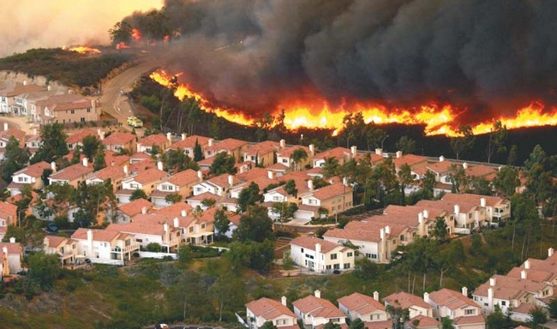This is the fifth installment of the Evacuation Preparedness Kit Series. The first post, on Evac Prep Basics is here, and the second post, which introduces the Evac Prep Master List is here. The third post, and the first post on the list review is here. This post will pick up where we previously left off in reviewing the categories on the Master List.

Equipment
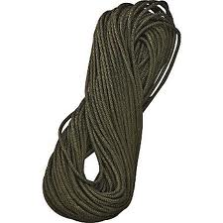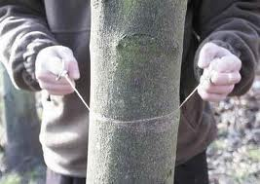The saw, rope, paracord, raingear and work gloves are typical survival/hiking equipment. You should keep all of them in both your BOB and your Evac Kit, I recommend you also keep a length of para cord and a pair of gloves in your EDC Kit.
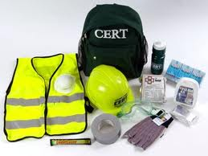If you are CERT trained, you purchased a hardhat, goggles, ear plugs and vest when you bought your CERT kit. Your CERT supplies should be on your Evac list to grab but should also be in its own container so they are available to you if you are needed in a CERT role. If you’re not CERT trained, you should be, we’ll post bout that later.
The Plastic Sheeting on the list is useful for many things but most notably for the ability to seal the airways in your house to inhibit air circulation. This is useful and could be necessary for survival in a Bio/Chemical/Nuclear situation.
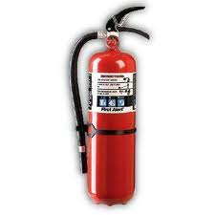A fire extinguisher should be in your Car Kit already and definitely there should be a couple around your house – if you can, stick another one in your Evac Kit or add it to you’re Don’t Forget List.
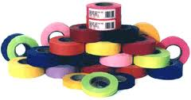Surveyor Flagging can be used to mark a trail, would be useful in your Evac Kit as well as your BOB. A spare set of keys to pretty much everything – vehicles, house, ATVs, Gun Lockers, etc should definitely be in your Evac Kit, probably in your BOB and absolutely in your EDC. Additionally, it’s a good idea to have a spare full set of keys just in a bedroom drawer or somewhere out of site but convenient. I can’t count how many times I’ve needed that spare set!

Light
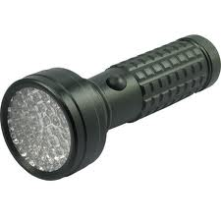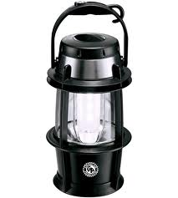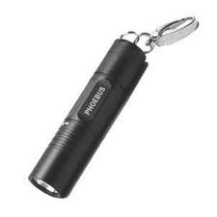
Light is another area where redundancy is your friend! The best way to ensure that you always have a light is to carry more than one light source in your Evac Kit, BOB, EDC, Car Kit, Office Kit, and wherever else makes sense. The main difference is the size of the light that you carry in each of your kits. Fortunately, technology has given us extremely small flashlights that are still extremely bright. LED flashlights are fantastic for their ability to last for a very long time without running down their batteries.
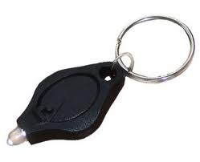
In your Evac Kit, I suggest keeping a couple strong flashlights, at least one lantern and several spare fuel/batteries for them. In your BOB a couple smallish flashlights will work great. I also keep an LED pack lantern (battery powered) in my BOB. For EDC, keychain style flashlights work great and a couple lightsticks will serve for a lantern.

Misc
Many of the items in this category are very useful but not necessary for your survival – with the exception of infant needs if you’re planning on having an infant with you. Wet Wipes are fantastic for keeping hands and faces clean. I suggest having at least a box of them in your Evac Kit and a travel pack of them in your BOB.
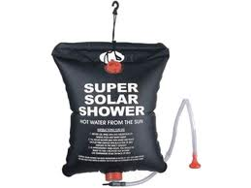A camera can be fairly important to document an evacuation/crisis. However, many of us have decent ones on our phones and can use those. If you want to take a camera with you, it’s probably best to add it to your Don’t Forget List. A solar shower could make a huge difference in your evacuation experience, we keep 3 in our Evac Kit.

Fishing Equipment
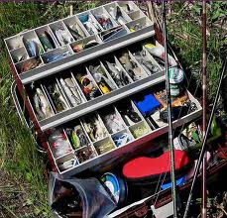Having a complete set of fishing equipment with you will allow you to catch your own food during an evacuation to supplement your stored food.
I suggest keeping it all in its own container and tackle box, usable day to day but ready to go. It’s a good idea to keep some line, sinkers, hooks and bobbers in your BOB for the same reason. You should probably add it to your Don’t Forget List as well since it’s possible it won’t be sitting with everything else.

Medical
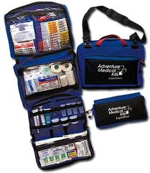The amount and type of medical gear you carry is a personal decision. Because I have a daughter with Leukemia, I have a very extensive one. My opinion is that you should have a medical supply kit in your Evac Kit, an extensive First Aid Kit in your BOB and a light First Aid Kit in your EDC. The Master List has a pretty comprehensive list of items to keep in a Medical Kit and this post outlines the details of my Medical Kits.

Documents/Money
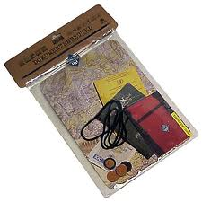The Master List has a laundry list of documents that you may or may not have and which may or may not be important to you. The important thing is to consider each document and decide if it would be important for you to have – especially if you were unable to return home for an extended period of time. Any documents you feel you need, make copies or request original copies and put them all in a water proof container in which they can lay flat. Give careful consideration to Wills – if someone in your family dies during an evacuation things could potentially be very messy to get straightened up. Designation of Power of Attorney to your spouse, parents, or whoever can also be very important. Consider documents you might need if you end up staying in a shelter, etc.
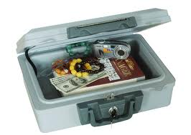If you don’t have one, I strongly suggest getting a fireproof/waterproof portable safe. You can get them at Wal-Mart for around $60.00. Store your document bag in it along with the money we’re about to talk about. Make sure you put the safe on your Don’t Forget List.

Money
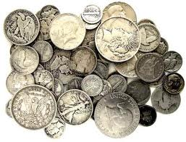There are several forms of money suggested on the Master List, I suggest you set aside as many of the types as you can – store them in your portable safe. Once an evacuation starts crazy things can happen – ATMs run out of cash, power is out and credit cards don’t work, things that are cheap become in high demand and prices skyrocket. If the worse happens and there is an economic collapse, your paper money will be worthless. Precious metals like gold and silver however will still have intrinsic trade value – as will food, fuel, and other necessities. Having a cache of these with you will help ensure you can acquire the things you and your family need. I explain in detail about purchasing silver for this reason in this post.

Electronic Files
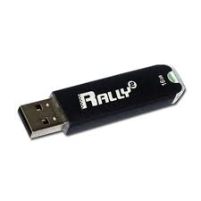Unless you have a laptop with all your files on it, you can’t really take your computer with you and depending on the scenario, it might not be there when/if you get back. I very strongly recommend you get a 16 GB or larger USB Flash Drive that you can put all your digital pictures, documents, videos, etc. on. These are wonderful devices that can take a beating and will store all your files on them. Here’s one of our posts discussing this.

Info Cards
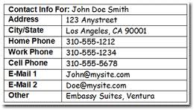I’ve seen several Info Cards over the years. I’ve taken several of those and several other suggestions and created a new one that matches the Master List. Some of the information you may not be comfortable with including or feel that it’s too personal, that’s fine, fill in whatever you feel is necessary.
You can download the Utah Preppers Info Card here.
There are a couple strategies with the Info Cards. First, each person in the family should have one in their BOB. For younger children this helps them have information on themselves that they probably won’t know. If they become separated from you or your spouse for some reason, it will help them get taken care of. If their is some kind of medical emergency with any of your kids, it will ensure that they have their information with them to help them get treatment.
Second, both parents should have copies of Info Cards for everyone in their family. If one of your children or your spouse goes missing during an evacuation, the card has everything on it you will need to post a missing persons report. Also, if you have to take anyone for medical treatment you will have all the information you need for them.

Don’t Forget List
The Don’t Forget List is a checkoff list that will help you be extremely efficient if you have to evacuate. I recommend you print it out and keep it on a clipboard with a pen attached to the clipboard with a string. Store the clipboard on one of your storage shelves where you KNOW where it is. If you have properly maintained your Don’t Forget List, when you are evacuating you can grab it and start checking things off as you load them. You can also put where they are stored on the list (i.e. outside shed, garage, store room, buried in the backyard, etc), this will help if you’re are panicked and scatterbrained during the evacuation. If you’ve properly prepared and pre-staged, you should be able to load up in under half an hour.
You can download the Utah Preppers Don’t Forget List here and add to it all you like.

Address/Phone Lists
A Phone and Address List will make sure you have critical information on how to reach those you need to. It may be that phone/cellular service is down and you have to drive somewhere, you’ll have addresses with you. Or, if you are somehow separated from your Mobile Phone (oh the horror!) and have to act like it’s the 80′s again, it will provide you with a hard copy of all your important numbers.
You can download and edit the Utah Preppers Address List here.

Communication
Being able to communicate is vitally important. For most of us, that starts with our Mobile Phone, but those may not always function properly for us. There are several other ways to send and receive communications.

Receiving Updates
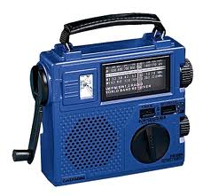With a hand crank radio you can get weather updates and local news information. Sometimes this is the best way to get this information even if your Mobile Phone is working. With the hand crank system you NEVER have to worry about powering it and it takes very little cranking to run the radio for several minutes.
I keep one of these in my Evac Kit and in my BOB.

Sending a Signal
A whistle, smoke, strobe light, flare and several other things all send a message of “I’m here, Please come!”. You should have tools to send these types of messages in your Evac Kit, your BOB and your EDC. For our post reviewing whistles, click here.

Sending and Receiving
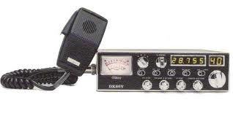There are several Radio Systems that you can learn and invest in. HAM radio is the most reliable system out there. You have to be certified to use them though, it’s very very easy to get licensed for Ham Radio, is very cheap and fast as well. If you haven’t gotten licensed yet, search for classes in your area and spend an afternoon getting your HAM Technician license. This will give you a call sign and authorize you for basic HAM use. There are several types of HAM radios you can get from a large base station to a hand-held portable. The one pictured installs in your vehicle.
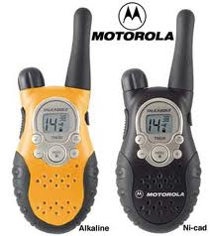FRS (Family Radio Service) Radios are the cheapest and easiest radios to use. They only have a limited distance though and are totally unsecured. Anyone can use them. I suggest designating with your family ahead of time certain channels that your family will communicate on. For added security, you can create a rolling system. For instance, start on channel twelve at midnite and every hour roll one channel or subchannel forward. For simple family communication, just pick a channel, preset it, and leave it there. Consider providing every member of your family with one of these. Definitely put one in each vehicle, keep one in your BOB and in your EDC. If you’re looking for help, you can scan through the channels to find someone talking – if you can hear them, you know they are close. Butt in and ask for help.
Keeping writing materials in your Evacuation Kit is also a good idea for several reasons. In an actual evacuation, it would be wise to regularly journal what is going on. It also gives you a way to send a message to someone. Having pre-stamped postcards allows you to address them to loved ones, like your extended family, and drop them a note that you’re ok.

Navigation
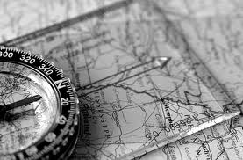Even if you know where you’re going, you still have to know how to get there. When evacuating, you may NOT know where you’re going to go. Keeping tools and resources that will help you find somewhere to go and how to get there is very wise. Storing maps and compasses will help you both on the road and on foot. Having a GPS will be extremely helpful, but be cautious relying on it. Make sure you have spare batteries for it or a way to charge it. If you plan to bug out to the mountains or woods, make sure you have good topographical maps of your region and that you know how to use them.

Nuclear/Bio/Chem

We have several posts on the site that deal with Nuclear Preparedness, with more coming soon to complete the series. We also have several posts dealing with Pandemic Preparedness including how to put together a full Pandemic Kit. For a myriad of scenarios, you really should at least have an N95 Mask and Nitrile gloves in your Every Day Carry, Bug Out Bag and Evacuation Kits. These tools help keep you safe in scenarios beyond those mentioned such as a massive dust storm, wildfire, volcano, etc. Breathing is important!

Pandemic Quarantine Preparedness
- 04 May 2009
- phil801
- 6 Comments and 0 Reactions
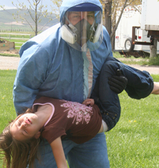Swine Flu is gonna kill us all! Swine flu is going away! Swine Flu is man-made! Swine Flu is a natural mutation! Oh, we offended the pigs. It’s H1N1! Does anyone know what’s actually going on??? Does it matter? Whatever the truth is about this H1N1 (formerly known as Swine Flu) virus there is ONE THING we can each know for sure. Has the last week caused you to think very seriously about your Pandemic Preparedness? Have you reviewed and identified holes in your preps? Have you done something about it? Are you Ready for Anything?
Hopefully everyone has taken this opportunity to do just that – consider the possible worst situation, review your preps and fill holes. Whatever the truth of the situation is, we can all know for ourselves if we were ready and, if you weren’t, if you are ready now! Have you taken the time in the last week to consider just what Pandemic Preparedness means for you? We’ve presented a couple scenarios here on the site and offered some ideas for Pandemic Preps. Hopefully they’ve been helpful. Now I would like to explore deeper down the Preparedness Rabbit Hole with you – and wander the quarantine branches of Pandemic Preparedness.
What EXACTLY is the point of Pandemic Preparedness? What are we trying to protect ourselves from? The simplest answer I can come up with is: We’re trying to NOT get ourselves or our family sick. For each one of us this will mean something very different. Our family make-up, our home, the location of our home, our work, kids in school, church responsibilities, etc. I want to explain a bit about my status of all these things to put my prep ideas/plans in context.
Many of you know I have a 3 year old with Leukemia. This means her immune system is compromised. In her life we are actually already into a semi-quarantine; we practice social distancing, we are sensitive to germs, cleanliness, and sanitation. She is comfortable and used to wearing an N95 mask, we are always wary when someone around us is sick, we rarely take her in very public places, we wipe down (sanitize) shopping carts before we put her in them. Because of her situation, I have two primary goals in my Pandemic Preps. 1) Keep her from getting infected and 2)Keep any family members from infecting her. Here is the rest of my personal environment. I live in a 2 story house, the basement is designed as a separate apartment; there is a kitchen, laundry room and 3 bedrooms down there, with a separate outside entrance. I live in the country on 50 acres and there are very few people around us. I have 8 children, 7 of whom live at home.
So, your plan will need to be tailored to your situation, but now you can understand mine and hopefully this post will give you some ideas for your quarantine plans. The scenario I’m working with here is one of my kids (not Serenity, my Cancer Chic) getting sick or showing symptoms of being sick. Isolation of the sick person from Serenity (and the rest of the kids so it doesn’t spread) is the objective here.

Quarantine Plan
The entire basement will immediately become the sick ward. The air vents, doorways and the upstairs entrance to the basement will be sealed off with 6 mil plastic to deter air flow. The window to the sick room will be open to allow fresh air circulation. I plan to get a UV Air filtration system to use in the basement as well. The sick person will be confined to a bedroom while in the house and will be allowed to play outside in a designated area that the other children will not be allowed to go to. The bathroom will become a decon room to dress and undress for entry into the sick rooms. The basement laundry room will be the only place the sick person and caretakers laundry will be done. All dishes used by the sick person will be washed in the sink downstairs. The sick person will be required to wear an N95 mask anytime someone is in the room with them, anyone going into the room will need full protective gear on (more on that in a minute). The sick rooms will be sanitized twice a day including changing and washing all linens on the bed. All paper trash (kleenexes, etc) that is able will be burned in our fire pit daily. All other trash will be collected into a garbage bags and disposed of twice daily. To make this quarantine plan work requires several specific preps.

Sanitation Preparedness
In another post I discussed a couple methods of making your own sanitizer. I also have a lot of cleaning supplies stored up as part of my regular preps. You can see many of them in this picture.
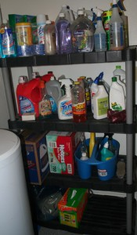
When thinking about cleaning preps, be sure to consider that you’ll likely be cleaning several areas at least a couple times a day. You should have enough cleaner stored to handle doing this for at least a couple weeks to a couple months. Think about needing to sanitize all of the following more than once a day: floors, walls, linens, dishes, clothes, toys, toothbrushes, bodies, etc.

Pandemic Preparedness Gear
I previously posted about my personal and vehicle Pandemic Go-Kits and discussed the preps I’ve taken there. This next kit is another Go-Kit but is meant for being able to take care of someone sick whether you’re at home or bugged out somewhere else. Here is my Pandemic 72 hour kit:
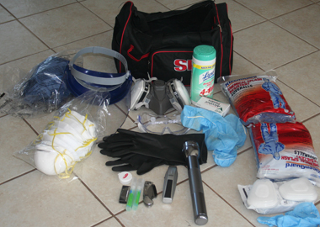
From left to right, front to back, here are the contents:
- Front Row
  - Replacement razor blades
  - Sanitizer spray
  - Razor blade knife
  - Battery powered shaver
  - Flashlight
  - P95 replacement cartridges
- 2nd Row
  - Pack of 10 N95 masks with exhale valves
  - Industrial gloves
  - Shoe covers
  - Tyvex chemical suit with hood (2)
- Back Row
  - 3rd Tyvex Suit
  - Face Shield
  - P95 Respirator
  - Goggles
  - Lysol Disinfectant Wipes
  - Alcohol Wipes
The knife and flashlight are tools that can be left in the contaminated area and used easily with bulky gear on. The shaver is to remove facial hair if needed so that masks can achieve a good face seal, it is specifically battery powered instead of electric/rechargeable in case power is not readily available. N95 masks are for the patient disinfectant wipes and spray are for the reusable mask and other gear and for wiping up in the sick room.
Here’s what this very unflattering gear looks like on:
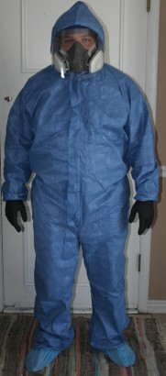
This gear setup isn’t perfect – or final for that matter – and much of it was bought this last week. Yes, I was surprised to find that I was not properly prepared for a Pandemic but have made sure this week that I have the minimum of what I needed.
I plan to find and purchase several washable bio suits – I’m looking for ones with booties and a hood built into them. This is very close to what I’m looking for. Currently, the filters I have for my respirator are 95% (like N95) filters – meaning they miss 5%. I’m planning on getting N100 filters to replace them. I’ll be doing that in the next week or two. The critical part for me is that I have the minimum preps required to implement my plan.

More Mask Information
I also want to pass on some further information I found this week. By now we’ve all heard of N95 masks, what you may not have heard of yet are P95 and R95 masks. With mask supplies acting like ammunition lately N95 masks have become rather scarce. However, most hardware stores still have decent supplies in their painting and tool safety sections. What you’ll find there though are N95, P95 and R95 masks. When I first saw this I wasn’t sure what the other two were or if they would work for me. What I found out about NIOSH ratings is this: N = Not resistant to oil, R = Resistant to oil, P = oil Proof. The 95, 99 and 100 rating are the filtration levels. The prefixed letter is the oil filtration rating. What this means is that any Nx, Px, Rx rated mask will work for you as a pandemic filtration mask. 95% filters are good enough to get you home, but for in home care I want a 100% filter. Here’s a pdf that explains all this.
Hopefully this post will give you some good ideas for considering your own pandemic quarantine preps. Remember, the main thing to gain from the swine flu outbreak to this point is a good understanding of how well prepped you are for a Pandemic! Don’t miss Angela’s excellent post on avoiding Cabin Fever during quarantine!
Have you gained a new perspective on pandemic preps from the current outbreak? Have you considered quarantine preparedness?

On Quarantine and Cabin Fever
- 01 May 2009
- angela
- 0 Comments and 0 Reactions

image from survivetheflu.com
With the Swine Flu news is coming talk of possible quarantines.
When I was a kid my family was quarantined by the county health department because my baby sister contracted whooping cough at less than a month old and more than one of the rest of us were carriers. We were pulled out of school in the middle of the day and escorted home.We were not supposed to leave or have anyone over. Homework got deposited in our milk box where we would retrieve it when the deliverer had gone. Thankfully there were medications we could take and the quarantine period was under a week—just until we weren’t contagious anymore. But what about a disease there is not medication for? How would that be dealt with? How long would a quarantine need to be in place to be effective? And what would you do with all that time isolated from society?
The Federal Government and most state and local governments have the authority to quarantine someone who they believe has a disease that could cause a public health hazard. These government-ordered quarantines can last hours or weeks until the quarantined individual is no longer believed to be a threat to the health of others. This doesn’t happen too often on the Federal level, the most recent case being Andrew Speaker who was quarantined in a hospital in Denver in 2007, thought to have a drug resistant strain of Tuberculosis.
In the case of a true pandemic, there will be too many affected individuals to quarantine them all in hospitals. Individuals will likely be requested to self-quarantine if someone in the household is sick. This means the whole household should stay home to make sure nobody else is infected and to keep the disease from spreading. The length of time you would need to be isolated depends on the incubation period and contagious stage length of the disease, and of course what is recommended by health care providers. A recent computer model for studying pandemic flu outbreaks in Georgia found that an 8 week quarantine period would be most effective in stopping the spread of the disease. A 4 week quarantine was as effective as closing schools for 6 weeks. So we’re probably looking at period of weeks rather than days.
You could also choose to “reverse quarantine” by isolating your healthy family before any of you are exposed to whatever disease is going around. How long you stay in your quarantine is up to you, but if an infected person is quarantined 8 weeks, you could easily need to stay isolated 3 months or more for the risk of infection to subside.
Obviously you will need to be able to meet your family’s food and basic sanitation needs during this extended period. Besides health and food supplies in your pandemic preparations, you might also think of “preparing” things you can do at home with your family if you all are stuck there with each other and nobody else for the duration of the quarantine. You might as well enjoy your time together (which to me means NOT sitting around watching the news). It will be especially important for children to have a sense of normalcy or even that it is a special time rather than the stressful time a pandemic or other extended disaster could be. So here’s a few suggestions for beating “cabin fever” during a quarantine.
Of course if the power’s on you can resort to video games, computer, TV, etc., but I’d use these sparingly—especially if news reports are disturbing. You’ll want to keep a positive atmosphere in your home.

Play board games or card games. There are even “junior” versions of classic games like Clue, Pictionary, and Scrabble for the younger ones. Here’s a huge resource for card game rules. Just make sure you have a couple of decks on hand.
Play charades, make music, draw, paint, or write something. Build a puzzle or two or ten. Read books or download audio books to listen to. Build a city out of legos. Sew, crochet, knit. Set up your tent and “camp” in your living room. Build a model. Work on books of crossword puzzles, word searches, etc. You get the idea. If noise increases your stress level, take that into consideration before planning to build paper plate and dry bean tambourines. ;)
Those of you in the country or more rural areas may be able to get out in the yard, so take advantage of outdoor games if you can.
If you’re in for an extended stay, maybe it’s time to take up that hobby you’ve always wanted to learn but never had time to—just make sure you have supplies on hand so you don’t have to go out in public. (Here’s me buying knitting needles and yarn and a book on how to knit.)
Educational supplies would be good to have on hand also so the kids’ brains don’t turn to mush
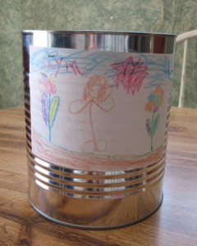
Daughter's emergency fun can
Have a few things tucked away that will be “new” when you need something new. A new coloring book, non hardening clay, colored pencils, a game, watercolor paints—think of things that could store for long periods before they get used. We’ve “canned” some fun items for each of our kids in an emergency can. We did this at a preparedness fair, but it could also be done by renting the canner from your local dry pack cannery or just using Ziploc bags or a box would also work. Stuff the can with fun non-perishable games or activities and seal it up. I honestly can’t remember what all is in them—I know I put crochet stuff in my girls’ cans and I think a puzzle, but I know that’s not all because the cans were full before they were sealed, so it will be new to all of us when they need to be opened.
You know who you’ll be quarantined with–brainstorm some age appropriate activities, make yourself a list, and make sure you’ve got the supplies on hand ahead of time for a variety of activities.
Most of these ideas can be used for any extended emergency situation, whether you’re quarantined or not. And if you don’t end up needing them for an emergency, you’ll have them for some lazy Saturday instead.

- Resources
- Glossary
- Authors
- Contact
Top of Form
Bottom of Form

Creating your own Bug Out Location
- 24 Apr 2012
- ekim
- 1 Comment and 0 Reactions
You have a perfectly set up 72 hour kit/bug out bag for each member of your family. They are located in vehicles or in a grab and dash spot so you can be on the road and on your way within seconds. Now what? Where are you going? Generally speaking, an evacuation plan should include a few set locations that you and those you are bugging out with are familiar with. One common solution is to head to a family member’s house some distance away. This solution might work in some scenarios, but in many circumstances you might find that you’ve placed a burden on your family by bringing more mouths to feed in an extended crisis. In other situations you might find it difficult to get to your family member’s home due to distance, lack of fuel or inaccessible roads depending on the nature of the disaster that has caused you to leave your home.
When starting your journey down the rabbit hole of preparedness you’ll often see terms referenced such as GOOD (Get out of Dodge), BOL, BOB (Bug out Location, Bug out Bag) and other acronyms that hint at evacuating an area should there be a disaster, civil unrest or many of the other events that we prepare for. One question that can’t be answered by a simple acronym however is WHERE?
My nearest family is about 10 hours away and in either highly populated areas or in areas with limited access in a disaster, so my family needs to consider something more local for our evacuation plan. We decided that as part of our general preparedness efforts we would like to work towards obtaining a property to eventually build a bug out location as well as provide a place for our family to camp and enjoy nature on a frequent basis. I’d like to share some of the things I learned in this process on creating your own bug out location.
You hear it all the time when anyone talks about real estate. Location, Location, Location. But what does this really mean? While everyone would love the ideal 5 acres with a wood lot, a small year round stream, a nice house site and a pasture that is a dream out of reach for most people. In reality, particularly for my area in Northern Utah, a bug out location will probably be located in the local mountains and be well under 5 acres. And when was the last time you saw a stream and wood lot on affordable land here in Utah? Here are some other location considerations to take stock of.

Cabin on a lake by Pathfinder Photo, on Flickr

Distance
One of the primary considerations I had in finding some property was that it should be located no more than 1 to 3 hours away by car. Since this property is meant to serve both a recreational purpose as well as host a bug out location, I also didn’t want it too close to any large populated areas. A property within this range can also be easily visited during Summer on a Friday after work with some daylight left to set up camp. Any farther than this and getting to the property particularly if there are fuel shortages could be a challenge.

Accessibility
Another consideration when you are reviewing potential locations is how accessible the property is in different seasons. Can you get to it should you need to bug out in Winter? What about the “mud season”? Many rural lots are only accessible via dirt roads. In the Spring and Fall, these can become impassable to most vehicles. Some locations have well maintained roads, others may not have been serviced in a decade. Will you be able to safely get you, your family and your supplies to your property without destroying your vehicles and equipment?
The populated areas of Utah are typically in the desert where we get our water from the snow fall in the mountains. This means that there are likely a number of streams and rivers up in the mountains near our bug out areas. While this is great from a water access stand point, it can complicate how accessible a property might be. Ideally you will have multiple ways in and out of the area where your property is located. Should there be a flood that knocks out bridges along the way you should still have at least one more route to get to your property by vehicle. Keep your eyes open when you are on your way to look at property in your chosen area. Take note of any bridges, dams, likely landslide areas, and other hazards that could impede you getting to the area.
One final thought on accessibility is Operational Security or OpSec. Many hard core preppers go to great lengths to ensure that their bug out location is difficult to find and easily defendable. Choosing a piece of property based on this principle is a very personal decision and can greatly limit the areas where you’ll be looking for acceptable land. Keep in mind though that even barring post apocalyptic fantasies, your bug out location will be vacant for stretches of time so vandalism can become an issue. There are pros and cons to either argument. Google Earth, Google Maps and topographical maps can provide you with valuable information without leaving your home. However, nothing beats actually standing on a piece of property and surveying it with your own eyes to determine if it will meet your needs.

County Specific Rules and Building Codes
Laws on land use vary by county so you’ll need to check with your specific county first to know what the rules are. Here are some things to think about and plan ahead for when you are starting to narrow in on a location for your future property.

Water
Some counties in Utah have requirements that a structure cannot be built unless the property has a functional well. This can greatly increase the cost of your bug out location as water rights and well drilling are expensive propositions. Without a well in these locations, you are limited to “recreational” property which can severally limit the improvements you can legally make to your land. There are few subdivisions that may be classified as “Dry” subdivisions where you may be able to build without a well or public water.

Square footage/footprint requirements
I know of one county that requires a permit for any building larger than 200 square feet. 200 square feet and under is considered a shed and cannot be inhabited. The minimum size for a habitable structure is 20 by 20 feet. At this size the property can’t be a year round residence. At 24 by 24 feet, a structure is legal to be inhabited year round.

Septic/sewer considerations
For inhabited structures you’ll generally also be required to hook up to a city sewer system or install a septic system. Either of these can drive up the price of building your retreat. Some areas don’t allow composting toilets either.

Building Process
Your county will have specific rules for what permits are needed for the area your property is located in. If your property is within an HOA you’ll need to follow their rules as well. Depending on where your property is located you may also need to get special permits from the fire department and the health department in order to build and occupy a structure. You should be aware that generally the use of an outhouse seems to be illegal, but I have seen a number of them in different areas, so this could be a sanitation option. Be sure to understand and comply with local laws so you stay out of trouble.

Producing or storing food
Some of your bug out locations may not be in the mountains, but rather in the desert or in an isolated agricultural valley. How well you can produce food on your land will therefore vary widely depending on climate, soil conditions and access to water. If you are planning on growing your own food in the event of an emergency you’ll need to seriously look at these factors. If you are planning on caching a supply of food on your property you should still be aware of how well your land can produce food and the effort involved in doing so. In addition to supplementing your food stores, gardening can be a fun activity.
Finally, take into account the animals that frequent your bug out location. Deer can jump over surprisingly tall fences and love to destroy entire gardens. Find out what pests might exist in your area and take steps to reduce their impact on your food plans.

Finding available land
You’ve decided you are ready to purchase some land to begin prepping for your bug out location, you have a list of everything you want in a property and have narrowed down a specific area. How do you go about finding your own piece of prepper Valhalla?

Know somebody
One of the best ways to find some land that meets your needs is to know someone familiar with the area. They can provide invaluable first hand experience, places to avoid and common pit falls. They may even be able to help you find land for sale that is not available on the open market.

MLS and a good local realtor
Assuming you have a specific area where you are focusing your search, Real Estate sites (select your county, nearby city and choose the property type) can provide you with an idea of properties available for sale in an area as well as an idea of the going price for properties in the area. MLS listings also generally have information about what services are available on each parcel such as power, water, sewer, telephone, etc.
A local realtor can often provide many of the same benefits as knowing a local. Finding the perfect realtor can be challenging. Be sure to ask lots of questions. They should have some familiarity with the local building codes, water issues as well as other local issues that you should be aware of. A realtor is there to advocate for you, the purchaser so be sure to take advantage of their local knowledge. Also, don’t feel obligated to continue using a particular realtor even if you’ve spent a lot of time with them. If they aren’t doing their best as an advocate for you, find someone who will.

KSL
The KSL Classifieds is another potential source for finding property. As always with classified ads, caveat emptor. Be sure to take precautions to protect yourself. If a deal seems too good to be true it probably is.

Seasonality
Once you’ve found your dream property, be sure to look before you leap. I highly advise that you take your time in the process. If you feel pressured to quickly close on a deal that is probably a warning sign. I recommend visiting the area during different times of the year to see how the seasons change the landscape. A forested lot in mid-summer may be a shadeless nightmare from Fall through most of Spring.
After you’ve purchased your land and before you make any concrete plans you’ll want to watch the land over the period of a year. Determine where any run off might go and adapt your plans accordingly.

Deeds
I am not a lawyer, nor do I play one on TV so take this amateur advice for what it is worth and consult a professional should you have any questions. In order to obtain ownership of your property, you’ll need to have a deed filed with the county recorder’s office. There are two different types of deeds that I am aware of.

Quitclaim
Sellers typically prefer to transfer title this way. They essentially Quit or give up their interest in the property, whether they actually own the property or not.

Warranty
Buyers generally prefer to have the title transferred in their name this way. A warranty deed provides the buyer with an extra level of protection should the ownership of the property by previous title holders come into question. Along with title insurance this seems like a bullet proof method of ensuring legal ownership.

Surveying
Depending on where you property is, you may need to have it surveyed in order to determine exactly where the boundaries of your property might be. This can have a huge affect on how you make your plans as there are generally rules regarding building setbacks from property lines. It should also help you identify where any easements (if any) lie on your property. It is better to plan ahead than to be forced to move or tear down a structure later.

Conclusions
I’ve attempted to provide information that I have gleaned by going through this process myself. I plan on doing more posts throughout the year as my family and I begin to improve our property. We are also hoping to get a guest post from Chris Jaussi of Zip Kit Homes to talk about bug out location building alternatives.

A new preppers thoughts on prepping, preparedness and survival
by M.D. Creekmore on April 6, 2012
This is a guest post and entry in our non-fiction writing contest by Deb H
I am new to prepping. Brand new, “just started” new. I’ve put a lot of time and energy into planning and researching, but renting a condo has not allowed me to really begin lying in supplies on a large-scale.
We just bought a house in central Ohio, in a town of about 18,000 people. We haven’t even moved in yet – can’t do that until mid-April. But I’m making plans, lots and lots of plans. I think any number of disasters can and will happen, but Pandemic is where my money is.
Let me say here It will be me, my husband and his adult son living in the house, with room for about 5-6 more people when necessary, and even more if we don’t mind being crowded. I’m the prepper; my husband and stepson humor me and help when I need it, but I’m the catalyst and the only one who will see that it gets done.
First thing will be having a well dug in the back yard & put up privacy fencing. I’ve started my heirloom vegetables from seeds, and will transplant to raised beds in my new yard; hope to have all of that done by May 1st. Then it’s build a solar water heater and install rain barrels. I’ll install a one way valve in the central sewer line, so stuff can only travel away from the house, not back into the house – pretty important since we plan on sheltering in place.
You see, we were living on Lido Key in Florida about 6-7 years ago, and we had to evacuate for a hurricane. We were kept off the island for 4 days, but no shelter would take us because we had dogs and a parrot. We lived in our car in the shelter parking lot, and only went in the shelter to use the bathrooms. It sucked BIG TIME. After that ordeal I decided I would never leave my home again – I will prepare the best I can and weather it out at home. What happens, happens. I’ve earned the right to stay in my home if that’s what I choose to do.
OK. Next, install an incinerating toilet in the basement, with a bicycle-driven generator to burn the waste. If you have to use the toilet, hop on the bike when you’re done. I think that’s fair, don’t you? We have a full basement (about 1000 sq ft), so there is room for the toilet. The root cellar will go in the windowless northeast corner of the basement. Shelf stable foods will go in the laundry area and in the huge pantry off the 1st floor kitchen. Installation of a wood burning stove in the living room fire-place will be done by the end of summer, and possibly another installed in the kitchen too – I need to do further research on that one.
Solar panels will be installed on the roof of the house, but I probably won’t be able to go completely off grid for another year or so due to the total cost. Need to lay in more lamp oil, matches and candles; I keep an oil lamp in every room in the house just in case. My stepson is going to build a solar food dehydrator so I’m not dependent on electricity to dry foods. I do have an electric dehydrator but would prefer to use solar whenever possible.
I’ve made my own bread for sometime now, and I finally bought a Country Living brand grain mill (http://countrylivinggrainmills.com/). I LOVE it! Sometimes they have models with cosmetic issues (such as paint finish) that still work fine and are covered by the warranty. I bought one of these and saved $70.00, so it was well worth the email I sent asking about 2nds. If you’ve considered buying one, DO IT. You won’t regret it.
My husband and I really enjoy reading for both knowledge and pleasure, and I’ve been working on increasing our library by hitting library sales, estate sales, etc. When we lose cable TV and the internet (I don’t doubt for a heartbeat we will lose these services) we will be able to read by lamplight in the evenings.
We also have a good supply of playing cards, poker chips and board games for entertainment. I sew and spend the winter months making quilts. They will never win a prize at the County Fair, but they will keep us warm! I use a treadle sewing machine whenever possible. I’ve accumulated more cast iron cookware, as it can be used over an open fire and holds heat for a long period. Don’t get me wrong – I love my copper pots and pans, but ANY food turns into comfort food when cooked in cast iron.
We will need to replace the back door to the house for security reasons; it’s a nice old wooden door with a great big window you could easily crawl thru after you break it. We have a double door front entry, so if you make it thru one door you still have to make it thru another, so no problem then. Maybe a razor wire bale to put between the doors when the SHTF? I want to install a security door at the top of the basement stairs, and window protection on the first floor.
I need to research beefing up the basement ceiling so if a tornado hits, the basement will still be livable. We also have a gas stove and sink in the basement which I will use as my “summer kitchen” for canning this year. I want to be able to live in the basement if we have to. Ideally I would like to be able to stay home continuously for at least 6 months, and hope to expand that to 12 months in the near future.
I haven’t mentioned weapons or defensive tools yet. We will arm up this summer (guns, knives, crossbows and body armor ) and do whatever is necessary to develop adequate skills. My husband & stepson are behind me 100% on this issue, which is fortunate – it can be a deal breaker otherwise.
I will discreetly put out feelers for like-minded neighbors after we move in; I do believe there is strength and safety in numbers. However, I am normally a somewhat guarded person and imagine that will only get worse under duress. We have extended family members who live between 600-1400 miles from us.

Zip Kit Homes
- Home
- Plans & Pricing
- Business Opportunities
- About The Homes
- FAQ
- Contact
- About Us

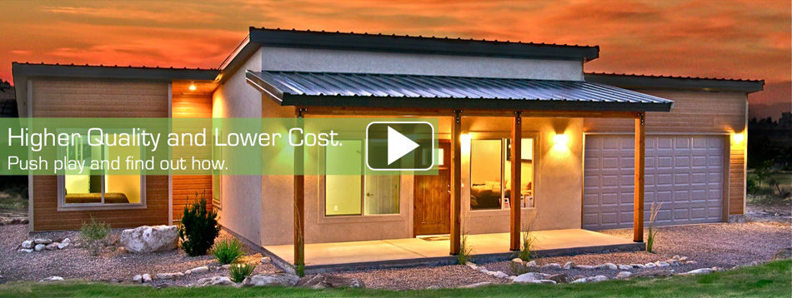

High Quality, Energy Efficient Homes – Faster, Better and Less Expensive.

We build high quality, energy efficient homes using the same building codes and standards as custom homes. However, our construction method is very different. We build panels and components in a controlled environment with high-tech, automated equipment. We then ship the components to your building lot where the home is assembled. More…
Partner with us! If you are a land owner, builder, realtor, or want to sell our homes in your area click here. Check out our floor plans & pricing by clicking here. Have one of our certified builders build your home or save money by building it yourself. Get updated plans, specials, opportunities and news with our monthly newsletter.

Top of Form

Bottom of Form

Videos
Frontier Virtual Tour Mobile Zip Kit Homes Frontier Virtual Tour. Affordable, panelized prefab kit homes and cabins at an affordable price. 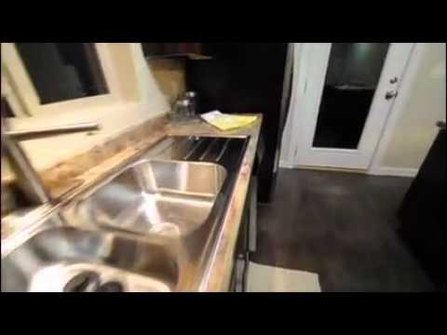Zip Kit Homes Sedona Video Tour This is a video tour of our largest kit home, the Sedona. It is 1050 sf.

