Preparedness Quick Tip #20: Take Those Photos
by momwithaprep
Imagine that you were separated from little Susie after a large transportation accident. You were hurt, she was incapable of speaking due to shock. How would the emergency responders get her to you?
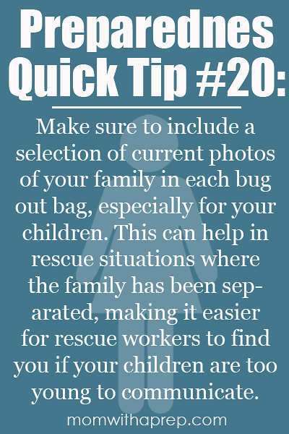
If your child normally carries a bug out bag, or has an emergency kit at school, make sure to keep a photo of your whole family in it. Tuck it into their pants pocket when you're traveling so that you don't have to worry about it being separated from them.
In a time of crisis when you need all the help you can get to get your children back to safety, this is a really simple one - especially in the days of digital cameras and home printing.

