Preparedness Fail
There are things I do that don't always turn out right. I kind of expect this to be a recurring topic as I continue to try new things. Even if it's not a total fail, I may talk about it and what I can do to make it better. For those of you who don't follow my every move, we launched a Facebook page: https://www.facebook.com/ForTomorrowWe - which makes it easier for you to...follow my every move. So like and share the page.
One of the most important things we can do for preparedness is to try it out. You don't have to turn off your electricity for three days. ... ...but no one is stopping you. We seem to think we have an idea of how things would go in an emergency or disaster. Whether you don't prepare much and think you'll be alright or you are pretty prepared and you've filled a bug-out bag with every possible item you could think of, including silver, and it weighs about 100lbs(good story-you know who you are). If you get a new gadget or make a plan, you need to make sure it works, or you're basically hoping it will. When you realize your pack is as heavy as a person, you make some changes. If you feel pretty confident that what you have will work, then you may be alright. If you buy a pair of pliers, they'll probably be alright(given you know how to use them). If you buy some food, you can be pretty sure that it's going to be good(we hope). However, if you plan on using, doing, or eating something that you don't normally use, then you should learn how or try it. Take an MRE for example; are they as bad as people say? Are they as good as other people say? What will they do to my bowels? Well, give it a try.
Unfortunately, not everything goes as well as we plan, even in a non-emergency, so we learn from them. In fact, the best time to learn how poorly something works is when you don't need it to work well, so don't wait until an emergency. The first thing I will show you is something that you may have seen; a paracord bracelet.
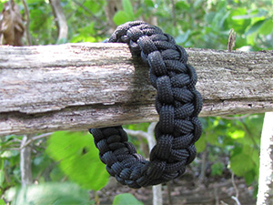
Photo: The Ready Store
Pretty awesome, huh? I mean, how rugged and tough can you possibly be without one of these? Believe it or not, there are practical reasons for wearing one of these, all of which have something to do with the 10 feet of rope that are so intricately disguised as a bracelet. Tricky, I know. It's not too difficult to put together, you have to do a little loop-do-loo knot tying like this:
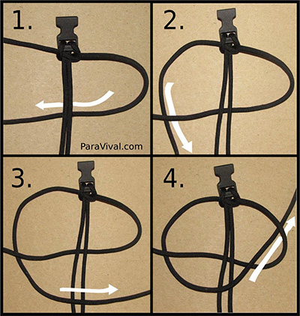
Not too bad, right? The problem is that in order to use the cord, you have to do that in reverse. It's not a quick-release sort of thing. It makes me feel like the manliness factor of wearing this bracelet has been reduced to the fact that it's made of paracord and no other reason. It's not really good for anything, so it's just a pretty design. I kind of expected this, so I gave it a try the other day. I pulled it out, cut the cord, and slowly began unwinding it into a nice tangle like this:
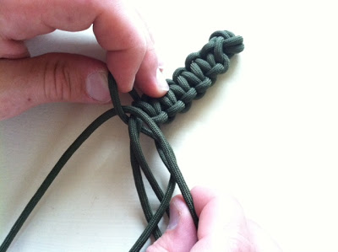
After a minute I had enough to tie off what I needed, but still had most of the bracelet intact. Another problem with these is that you start with two ends so you will always have the rest of the bracelet in the middle. I decided to try things a bit differently. By doing a two strand core and weaving one cord back and forth around them, I can just cut the end and pull it right off. It seems to have turned out just fine.
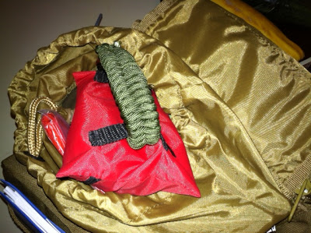
Just cut the end and it practically unravels itself. A paracord bracelet you can actually use.
Here's a little something I tried that I showcased right here on the blog. It's my Altoids Tin Kit. You'll find these all over the internet, but to tell you the truth, it didn't really work for me. I used it quite a bit, maybe a bit too much, because this is how it ended up.
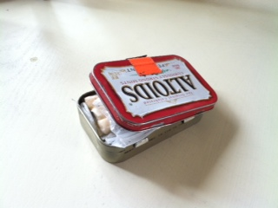
...all busted up with stuff falling out. I tried not to be rough on it. Maybe I overstuffed it. Anyway, if you decide to make one of these, don't keep it in your pocket. This would still work fine if you are putting it in a backpack or purse or something, since it won't get as abused there. If you make one of these, maybe you shouldn't plan on using it unless you really need to, or maybe you could just get a better container. Whatever you decide to do, learn from my mistakes.
One last thing: just because you can do something by yourself doesn't mean you should. What I mean is that you don't need to make everything yourself for it to be more preparedness-ish. There are some really creative ideas out there, like your own wax dipped matches. I think they would probably make a bit of a mess if they melt, like an emergency candle did once in my car(another fail). Also, there are wonderful alternatives, like lighters. It's fun to play with new things and try them out, even if you know it won't work, but when it comes to really being prepared, don't leave it to chance. Sometimes you can do it better than what you can buy, like many kits you find out there, so try it and find out.

