

Amazon.com has new recommendations for you based on items you purchased or told us you own.

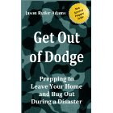 | Get Out of Dodge! Prepping to Leave Your Home and...  by by Jason Ryder Adams  $0.99  When most people think of and picture a "survivalist", they think of a big, hairy man living alone in a cabin in the woods, wearing a camouflage jacket and pants. With missing teeth and ... Read More

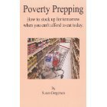 | Poverty Prepping: How to Stock up For Tomorrow When...  by by Susan Gregersen  $2.99  A lot of people think they don't have enough money to store extra food for emergencies. It's a struggle just to make ends meet and afford what they need right now. I think anyone can start to ... Read More

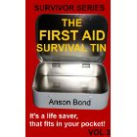 | The First Aid Survival Tin (Survivor Series)  by by Anson Bond  $0.99  This book will explain what items to carry in your First Aid Survival Tin. It is so small and light weight, you should always have it on you! Read More

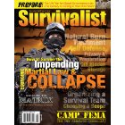 | Survivalist Magazine Issue #8 - Survive Martial Law  by by Nurse Amy" Alton  $3.95  This Kindle edition is a direct reproduction of articles from the highly sought after print magazine. Only design graphics and ads have been removed for compatibility for all Kindle devices.Table of ... Read More

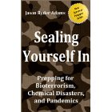 | Sealing Yourself In: Prepping for Bioterrorism...  by by Jason Ryder Adams  $0.99  "Survival preppers" want to be prepared for any emergency.Whether it's a natural disaster like a hurricane or tornado, or a man-made disaster such as civil unrest or government collapse, we ... Read More

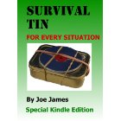 | Survival Tin for Every Situation  by by Joe James  $0.99  The survival tin is by no means a new concept, they have been used mainly by military personnel for many years. This book - Survival Tin for Every Situation - gives you a set of contents for your ... Read More

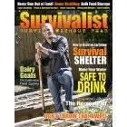 | Survivalist Magazine Issue #3 - Self-Reliance  by by Lisa Bedford  $3.95  Survivalist Magazine is the premiere resource for the preparedness community. Indepth articles, resource lists, product reviews, how to's and more. All professionally written, edited and chock full of ... Read More

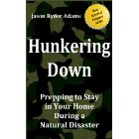 | Hunkering Down: Prepping to Survive in Your Home...  by by Jason Ryder Adams  $2.99  No one knows WHAT it will be. It could be a natural disaster or a medical pandemic. Financial system collapse or bioterrorism. Governmental shutdowns or societal breakdowns. The media is full of ... Read More

Thanks,
Matt Wright

