Plyban Cheesecloth
by KMG
I make a lot of homemade Greek yogurt.
And I don’t know if you know it or not but Greek yogurt is simply regular yogurt which has been drained with cheese cloth to make it thicker. In fact if you drain yogurt overnight you’ll end up with yogurt cheese – but that’s a whole other post.
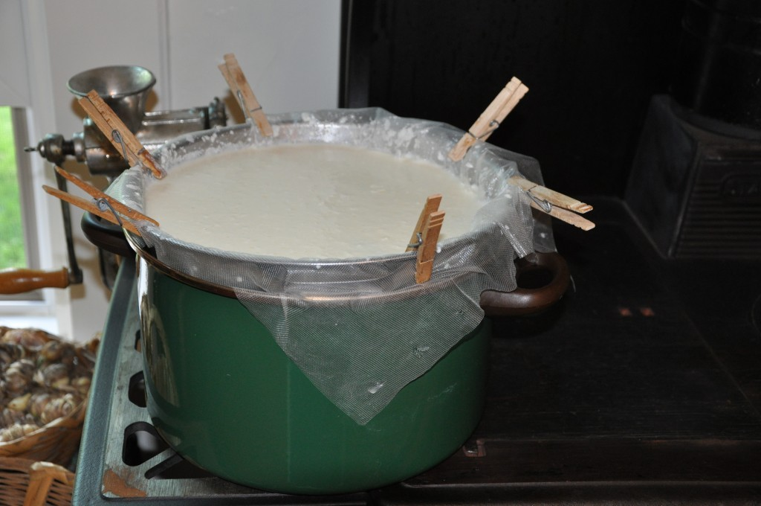
Plyban Cheesecloth Lining A Colandar
The actual point of this post and what I wanted to share with you, is the special type of cheesecloth that I use in my kitchen and recommend.
For Greek yogurt and cheese making I use a synthetic plastic cheesecloth called “Plyban”.
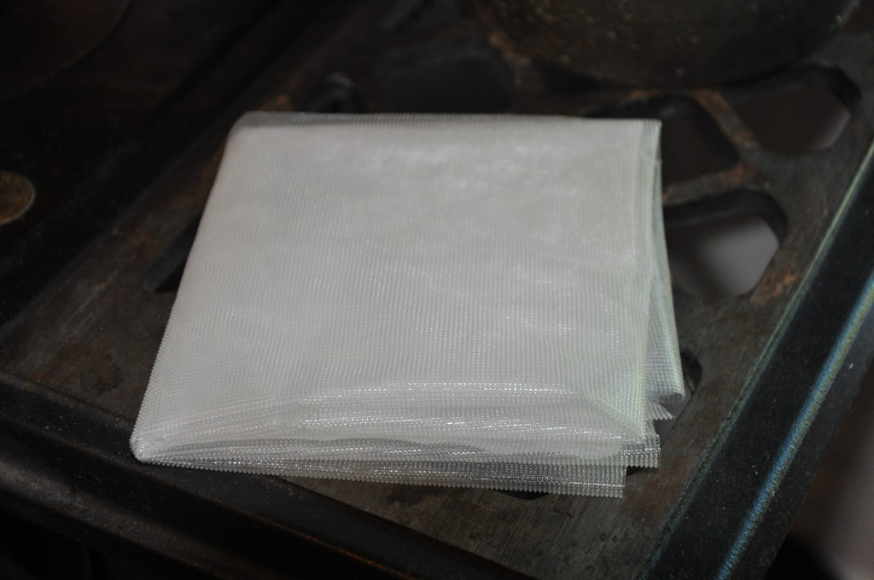
Plyban Folded After Washing
I prefer Plyband because the weave is tighter than regular cheesecloth and one piece will last me a really long time. Curds don’t tend to stick to the surface of Plyban the way that they will with regular cotton cheesecloth, nor will Plyban stain or discolor from repeated usage like cotton cheesecloth.
Plyban is completely washable and will hold its shape after repeated washings.
I clean Plyban by gently scraping any excess yogurt or cheese from the surface with a butter knife prior to hand washing it in hot soapy water. I rinse it well and hang it out to dry. Once it's dry I fold it up and place it neatly in the cupboard to wait for another cheese or batch of yogurt.
Plyban can be found online at different cheese making suppliers.
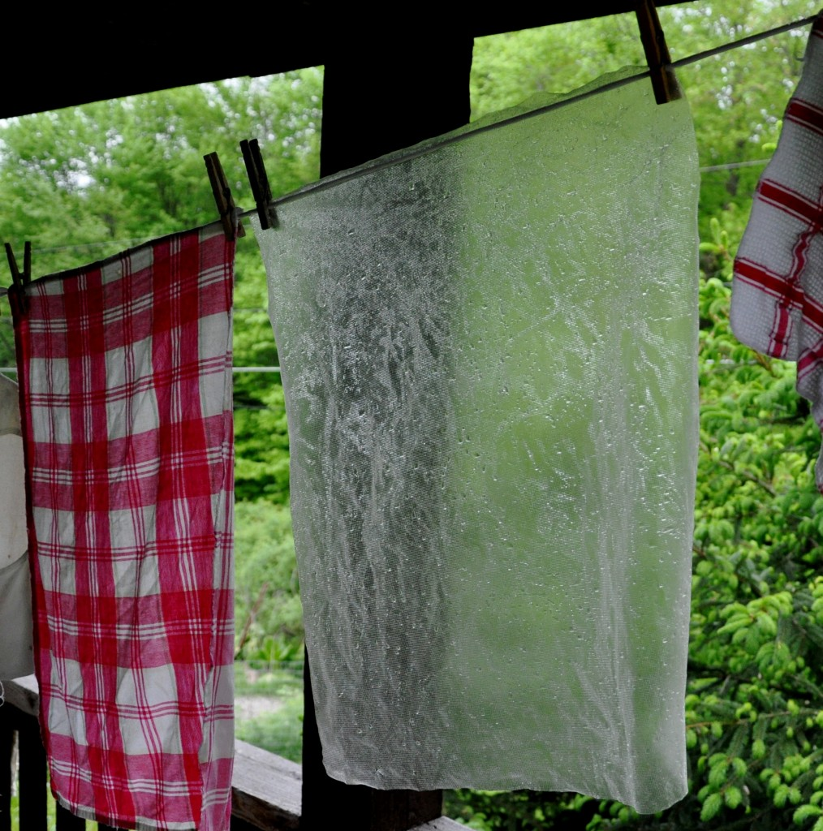
Plyban Hanging On Line To Dry

