PREPARE FOR NO ELECTRICITY
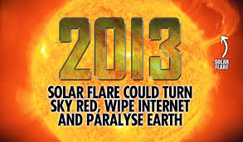
If the power goes out are you ready?
It could be solar flares, war, or the fact that our grid is in bad shape. And do not forget it can happen remember the storm of 1989 Click Here and the aftermath of this smaller scale storm.
As stated in my last post about EMP or EMF Click Here
I showed several ways to protect your electronics on a budget. Because this is something that has happened on small scales, from solar flares (which are going to be big in 2013). Which not only will take out your homes, but all electronics and cars may not work if it is big.
Nasa agrees that this is a possibility. And if recovery is possible it will be months even years to restore.
ARE YOU READY?
Why protect electronics?? As shown in my other post. Because those still can be ran on wind, solar, and pedal power. To watch a movie will be a treat. To run tools to create temporary living necessitys is a must. BUT only if they work.
Walk around your house....what electronics will still be needed??
Small TV, music, Fridge, space heaters, tools.
These are things you should have a plan for or even have the smaller things already stored in a farday cage (Click Here ).
NOW for power... In my pdf section I have put a few simple power ideas PRINT these if you are going to print anything.
•Solar
This is an instrucable that is worth looking at not in my price range but some good info Click Here
•Foot Power Click here (something we can all do for a little juice when needed)
•How to convert a gas engine to alcohol pdf Click Here Remember potatos and corn can be made into fuel along with many other crops and animal fats
• How to build a Cretan windmill pdf Click Here (I really like this one all made with hand tools),
• How windmills and wind motors pdf Click Here
• How to make peat fuel and how to use it pdf Click Here
• How to make and use a storage battery pdf Click Here
• How to make and use a gas engine! pdf Click Here
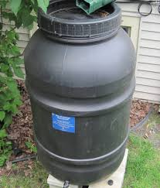

In Cold climates you really need to think about heat.
Pickle barrel - your rain barrels heat up during the day and can be brought in to take the nip out of a room. Click Here
soda can Click Here I have seen this one work with some kids that camped on our city green for the winter for occupy. And it works.
compost Click Here
fire place or stove.
And having alot of extra clothing gloves hats and coats stored. I also suggest to use the Safe room idea in this post Click Here to create a warming area in your home if you do not have a fireplace or stove. The pickle barrels and solar cans can keep a small area very comfortable for the 3 main months you would need to.
I have some supplies to make a wood grill stove for my house if it ever comes to it. Remember that the smoke is not safe so having some venting pipe and making a hole for it is a must and fire protecting the area you will place it is also a must.
*

