Our Three-Layered Approach to Prepping
by Sandy Hovatter
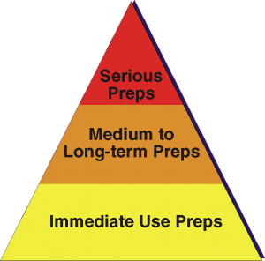
In just about every area of prepping, we like to use a three-layered approach, moving from simple and easily available preps to more serious long-term solutions. This approach keeps us from being overwhelmed by the enormity of purchases we need to make or knowledge and skills that we need to acquire. It also moves us forward in our preps in a logical and balanced way.
Our three-layered approach maps out like this:
- Preps for immediate use
- Preps for medium to long-term use
- Preps for when things really get bad
Preps for Immediate Use. Usually, the things that fall into the immediate use category are also the easiest to purchase and least expensive. For the most part, these first-level preps are the things that we are already using in our everyday lives. The only difference is that we have more of them on hand than what our current daily needs would require. For example, in the area of water, our immediate use water is store-bought bottled water. We use some bottled water on a routine basis, but we have a bit more than we really use stacked up under a work table in our basement for when special needs arise. You can easily build up this kind of water supply by purchasing a few cases when you go shopping over the next couple of months. We're in the process of building up to about a week’s supply of water in bottled water.
In an emergency or any unusual situation, this first layer of prepping buys you time to evaluate and adjust to your situation before you have to begin living in a way that you are not so familiar with. In a true emergency, everything changes. Anything you can do to add normalcy to your life brings a level of calm to your world. Grabbing a bottle of water is something we do every day. Having extra bottled water stored away allows me to continue living as I have been while I figure out how to live in a new way — and I don’t have to run out and buy anything because I already have it on hand.
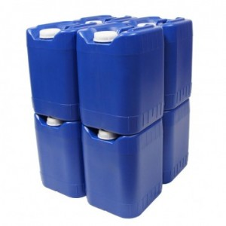
Preps for Medium to Long-term Use. This second level of preps are things that you don’t typically use every day under normal circumstances, but they can help you sustain a normal lifestyle when your normal lifestyle becomes disrupted for more than a few days. These types of prep generally require a bit of thought and planning to determine what your needs are and what your best approach is to meeting those needs, and they usually cost a little more than the things you buy for day-to-day use.
This is the level where prepping really starts to become an intentional lifestyle. Buying extra bottled water is a no-brainer for someone who typically uses bottled water as a convenience product, but this second level of prepping is where you start to acquire things that you won’t be using on a routine basis. These are things that you will have on hand in the event that you find yourself in a situation in which your normal way of life is disrupted and the stuff you keep in your cupboard isn’t enough to get you through it.
Sticking with water as our example, we have purchased a set of five-gallon, food-grade, stackable water containers that we fill and rotate regularly. We don’t drink from them during normal times. That’s not what we bought them for. These containers required a little more investment than the cases of water and it takes some time to fill them, but if we find ourselves in a second-level situation that requires more than just a couple of spare cases of bottled water to get us through it, we’ll be glad that we have this on hand ready to meet our hydration needs.
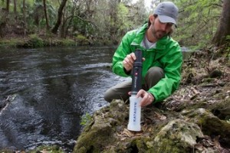
Preps for When Things Really Get Bad. Then there’s the third layer of preps – those we make for when things really get bad. Those preps are the ones that will sustain you for a longer time.
In the area of water, we recently invested in a small, portable Katadyn water filtration device that can purify up to 13,000 gallons of water to safe drinking standards. We’re talking about water from a stream or pond or rain barrel. This device is about the size of a tall thermos jug and could be easily carried in a backpack. 13,000 gallons of drinking water is enough to meet our needs for a great long while. We have plans for installing a rain barrel system on our house this coming spring that will provide free water for watering our garden and could help supply drinking water in the event of a level-three emergency.
I Love It When I Get To Use My Preps!
We recently experienced a boil alert in our community. The city put up signs at intersections in our neighborhood that told us they were working on the water lines and that we would need to boil our water to make it safe for drinking. That was an understatement if there ever was one! The stuff coming out of our pipes (I’m not sure I’d call it water) was brown and nasty looking. How brown was it? Think strong iced tea. Yeah, that kind of brown. Phil left for work shortly after we learned of the alert and noticed the alarming color of the water coming out of our tap. That left me home to deal with living with no water.
Intrepid prepper that I’ve become, my first reaction was to wonder what in the world was I going to do for water over the next indefinite period of time. All of a sudden, I wanted water. I don’t drink nearly as much of it as I should on a regular basis, but knowing I couldn’t have any really increased my desire for it. I mean I couldn’t drink Diet Coke exclusively for the next few days, so what was I going to do? Tea was my next option, but the water was so yucky I really didn’t want to drink any of it even if I had boiled it! Boiling this stuff wasn’t really going to make it clean and safe — just hot.
Yeah, I’m still new at this. My prepper instincts didn’t kick in right away.
But it wasn’t long before my newly minted prepper training kicked in. I remembered those cases of bottled water we have stored under the work table in our basement. For the three days that our water was questionable, I had all the water I could ever want available in those cases of bottled water. And if it went longer than those three day, I could refill the bottles of water from our five-gallon jugs. And if we started to run low on that, we could refill the five-gallon containers with water from our Katadyn water filter.
I went from being a bit worried to totally confident we could take care of ourselves. No running out to the store hoping they still had bottled water on the shelves. No rationing here. (Obviously, in a true emergency there would be rationing.)
This short-term inconvenience allowed me to use some of my first-level preps in a real-life (albeit non-emergency) situation. And it reinforced one of the main reasons we prep – so that we can take the “emergency” out of the emergency. My emotional state changed from nervous to totally calm and even confident – simply because I had stored water.
In a true emergency, knowing that you have what you need to survive allows you to remain calm and puts you in a position to help others. That’s why we prep.

