Marine Accessories for the Prepper
For someone raised far from the ocean, I have always loved the water. Perhaps it was the lack thereof… As a youth, I even managed to co-opt a planetarium operator to help me learn celestial navigation and of course I just had to have a Cassens and Plath sextant. I remember my first look at the USS Forrestal and thinking the anchor chain links was as big as my automobile. I have since sailed on a variety of platforms. My wife and I honeymooned on a Morgan 38 sailboat and fell in love with a Passport 42 http://www.yachtworld.com/boats/1984/Passport-42-2769723/Seattle/WA/United-States#.VQM45sZjM3Y blue water cruiser back when these boats were new. So what does all of this have to do with prepping? Small boats have minimal or no electrical power and if electric, usually 24 or 12 vdc from solar or wind generator charged storage batteries. Salt water is corrosive so items made for the blue water sailor are usually stainless steel or other non-corrodible materials (long life for land use). Few chandleries exist at sea so marine items are made durable and easy to repair which would be a boon in the event of an extended grid down condition.
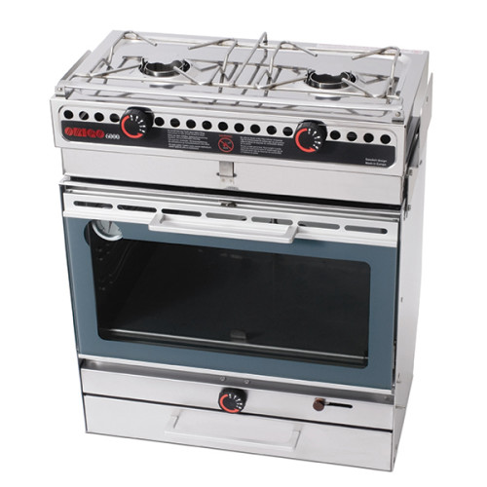
One of the first things marine that caught my attention was alcohol fueled cooking stoves. Many of these stoves use non-pressurized alcohol for use in below deck galleries. Once one has surplus food, a mechanism for making alcohol usually follows. With such a mechanism, non-smoke producing fuel for such a stove is readily at hand and requires no high technology. I submit one of these stoves would be a wonderful addition to that bug out location, especially in times where one wouldn’t want to advertise location by producing a smoke trail from wood. See: http://www.defender.com/product3.jsp?path=-1%7C2276204%7C2276205%7C2276206&id=60353. If you have a diesel bulk tank then you might want to consider diesel cook stove that is also intended to heat water. See: http://www.dickinsonmarine.com/stoves.php. Although not a marine unit, I have a Sopka Magnum wood fired cook stove in reserve. See: http://chesterchimney.com/products.php, and http://www.sopkainc.com/index.php/product/wcs/magnum.
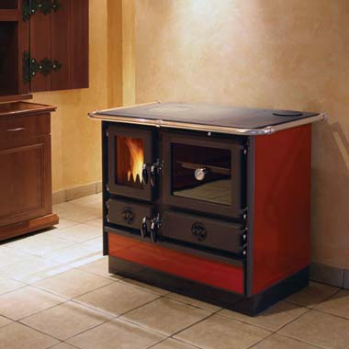
In the realm of galley appliances, there is a 12vdc blender by Waring. See: http://www.defender.com/product3.jsp?path=-1%7C2276204%7C2276245&id=2091736. Other items of interest include nesting stainless cookware http://www.defender.com/product.jsp?path=-1|2276204|2276236&id=323457; and even a pull type salad spinner: http://www.defender.com/product.jsp?path=-1|2276204|2276245&id=1527470.
If you peruse the various marine supply businesses and chandleries I suspect a variety of useful prepper products may be discovered.
Best wishes,
Panhandle Rancher

