Make a Secret Log Box
You already know I'm sort of obsessed with wood stumps so when my brother offered to show me how he was making wooden boxes out of small logs, I jumped at the chance. How fabulous to turn a little bit of wood into a beautiful giftbox or place to stash your emergency $20 bill? Vary the size a bit and you can use this in a lot of other ways too but lets just get down to the details.
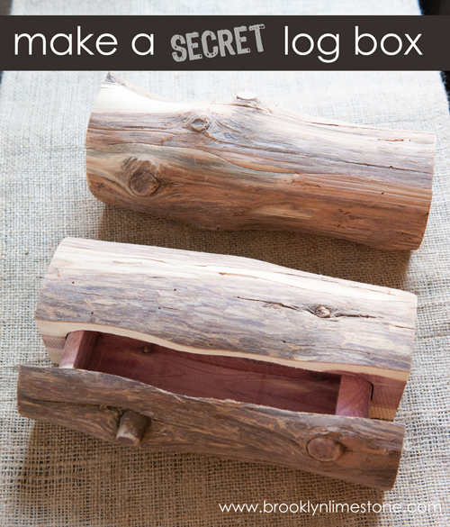
DO NOT BE SCARED OFF by the length of the instructions - there are a lot of steps but its a very simple concept. Once you have it figured out, its not at all difficult. All you need is bit of log, a band saw, wood glue, clamps and a pencil.
The gist of the project is that you cut slices off of 3 sides of the round log which gives you access to center. Then you cut out a piece for a drawer and glue it all back together again. Voila!
Detailed instructions (click the image above for a larger view)
1. Find a log, cut to desired finished size. (pic. 1-2)
2. Slice off 3 slides of the log, leaving one rounded edge. Mark + set aside slices. (3-7)
3. Draw a conversation box on log to mark drawer (8), cut (9-11)
4. Cut out a slice to make back of drawer (12), set aside.
5. Mark a rectangle on cut out to hollow out drawer (13), cut (14-15) + discard.
6. Glue back of drawer to hollowed out drawer base, clamp, allow to dry (16-18)
7. Glue sliced back to center of log, clamp, allow to dry (19-20)
8. Once clamped pieces have dried, glue & clamp drawer to drawer front (21-23)
9. Glue and clamp sliced base, allow to dry (24)
10. Slide completed drawer into the open space and sand any rough spots if necessary.
You now have a secret hidey hole for any of your tiny treasures. Now go out and get some stumps.
