Make Soap Without Using Lye
Did you know that your skin is the largest organ of your body? Makes sense when you think about it. That’s why it’s so important for me to stay away from chemical cleaners, and choose my personal care products wisely.
I’ve read quite a bit about making my own soap. The simplest recipes contain only 3 ingredients and are all natural. Unfortunately, lye is one of those ingredients–and because it is so caustic, I don’t want to use it or even have it around with kids in the house.
Am I being overly paranoid? Probably. But if I don’t have any lye in the house, there won’t be any spills, nobody will get chemical burns…you get the picture. I’ll sleep better at night.
There’s an answer for all of us scaredy-cat soapmakers! It’s called melt-and-pour soapmaking. With melt-and-pour, the lye work is already done and all that’s left is the fun part–crafting your own unique varieties of soap.
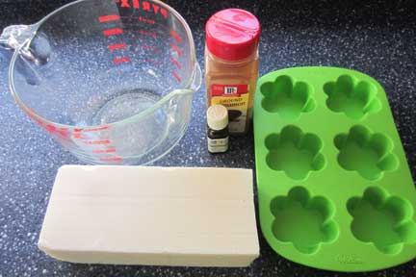

You will need:
Soap base
A large Pyrex
Herbs and/or essential oils
Silicone mold or a loaf pan lined with parchment paper
Soap base is your raw material. There are all different kinds–some contain glycerine, some goats’ milk, some aloe vera. Shop around and find the kind you like best.
Next, think about the qualities and/or fragrance you’d like your soap to have. Between herbs and essential oils, the possibilities are endless. Here are some combinations I like:
- Ground cinnamon and sweet orange essential oil
- Oatmeal (powdered in blender) and honey
- Ground rosemary and lavender essential oil
- Peppermint essential oil and rosemary essential oil
Measure out one pound of soap base. (Yep, that’s a postal scale. Why buy a cooking scale when this will do the trick?)
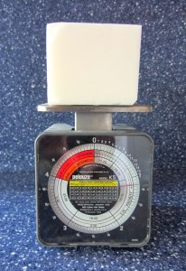
Chop it into large pieces. Put it in your Pyrex and melt it in the microwave or in a double boiler over low heat. Once melted, add your herbs and oils (at least 1/4 teaspoon essential oil and 1/2 teaspoon herbs per pound of soap base).
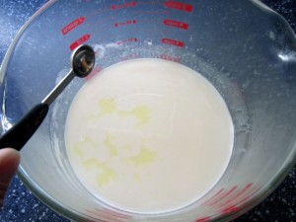
Mix thoroughly and pour into your mold. There may be some small bubbles or drips on the top, but that’s OK.
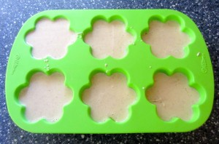
Allow to cool for several hours before unmolding. The silicone pan makes it easy, and the bars are already formed. If you’re using a loaf pan with parchment, you can cut the soap into bars with a sharp knife.
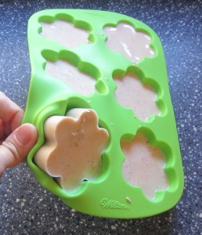
Your soap is ready to use now. It will last longer if you let it cure in a cool, dry place with plenty of air. I cure mine on a shelf in the linen closet, so it smells great when I open the door!

