LuminAID Solar Light
Item #: LUM-LL01

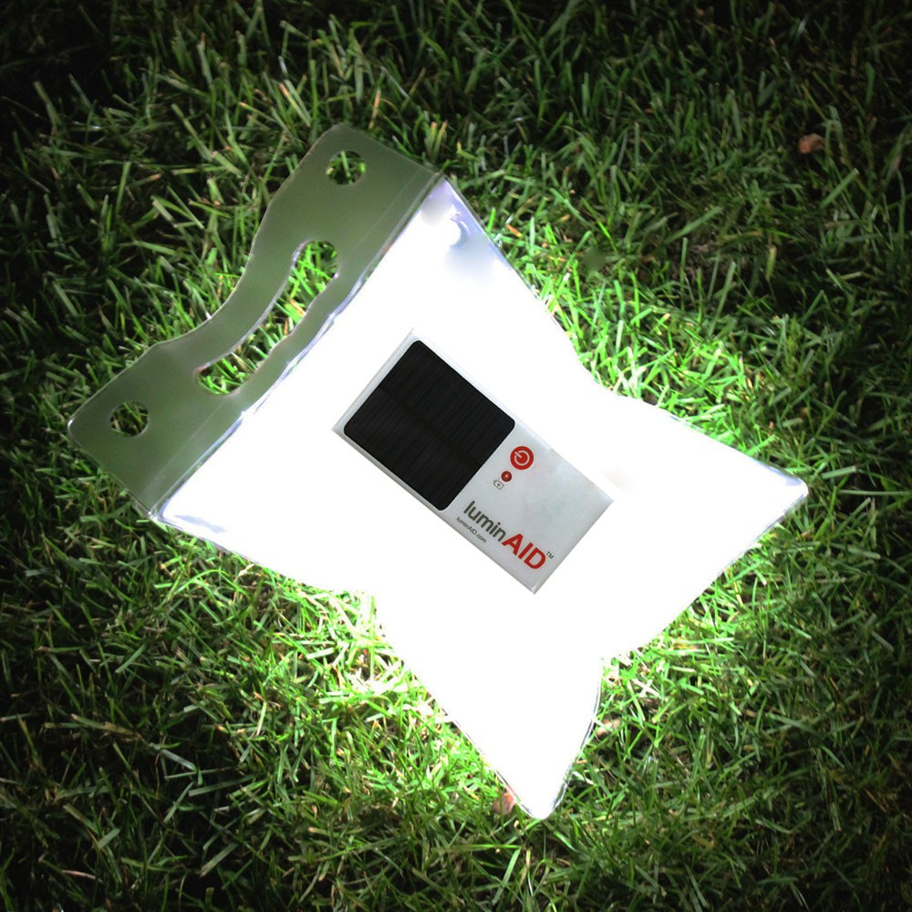
Our price: $19.95
The LuminAID is a solar powered, rechargeable, inflatable and lightweight lamp that provides up to sixteen hours of LED light. This portable and waterproof device is perfect for emergency situations and ideal for hiking, camping and travelling. read more

Details
The LuminAID solar powered lantern packs extremely light and provides up to 16 hours of diffused light when inflated. Initially designed to fulfill basic needs for light in disaster situations, the LuminAID is waterproof, can float, and is affordable. It is a valuable addition to any camping trip, adventure or home emergency kit.

Features & Benefits:
- Innovative solar light packs flat and inflates into a lantern
- Ultra-portable and lightweight at only 3 oz
- Snaps to your backpack for charging on the go
- Control light with high and low settings
- 8-10 hours light on high setting for reading and task work
- 14-16 hours light on low setting for safety or night light
- High-efficiency monocrystalline solar panel recharges in 6-7 hours of sunlight
- Floats and waterproof up to 1 meter deep (IPX-7)
- Operates on Lithium-Polymer Ion battery with 500 recharge cycles
- LED automatically shuts off to prevent battery drainage
- Maintains fully charged for up to 3 months when stored
- Made from semi-transparent, puncture-resistant TPU material (PVC-free, phthalate-free)
- Includes easy to follow illustrated instructions

