Learn How to Use Your Own Built In Night Vision
by admin

Using your own two eyes.
I see articles all the time about how important night vision devices are and I agree. The problem for most of us is the cost to get a really good set. Plus there are always problems with breakage and batteries. So what happens when they break or are just not available? You can increase your natural ability to see at night by applying the following four principals of night vision.
1. Dark adaptation: Before going outside at night, keep out of all light for at least one half hour. This will let your eyes become accustomed to the dark. A half a second’s exposure to light will destroy your night vision for minutes. If it is necessary to check your equipment or map use a red light bulb or keep one eye closed.
2. Scanning: You cannot scan an area at night like you scan during the day. At night, you move your eyes in short, jerky, abrupt movements over the area until you locate an objective. Then you use off-center vision to observe the object. Move your eyes in short jerky movements over and around the object, while concentrating your attention on the object.
3: Off-center vision: If you focus a little to one side of an object you can see it more clearly than if you look directly at it. This is especially true at night.
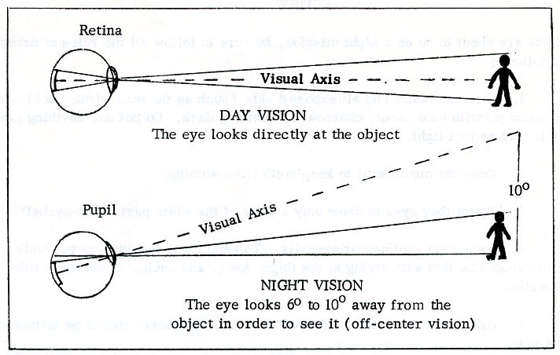
4: Confidence: Confidence is fully as important as dark-adaptation, off-center vision and scanning. You usually use your eyes where there is plenty of light, so your brain is used to images of sharp outlines and bright colors. In the darkness, your brain receives images that are faint, have no sharp outlines and little or no color. You must have confidence to believe what your eyes tell you. This confidence comes from practicing and using the principles of night vision.
In his 1996 book Bravo Two Zero about the first Iraq war a British SAS soldier named Andy McNabb described how they infiltrated behind enemy lines.
Mr McNabb explains that they travelled at night to avoid capture using only their own eyes to navigate. He says that none of the Special Forces soldiers took electronic night vision goggles, as they were too heavy and clumsy to carry around. After years of training at night, their own night-vision was almost as good.
The one serious problem that they encountered was that once you see a bright light, your eyes reacts and your eyes return to normal daylight vision again. To combat this he read his maps with one eye closed so that only one eye would lose night-vision.

