Key chain Carry-EDC
by John B
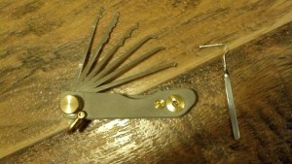
Usually if we leave the house, we have our wallet and our key chain. This got me thinking about an updated post on Key chain carry.

Key chain Carry
What do you have on your key chain (or key ring)? Keys? Is that all?
I’ll bet you have more than that on your key chain.
I like to carry a couple items on my key chain to give me an edge up if things go down.
Flashlight – I’ve been carrying the Nite Ize MLSA-M1-R7 Micro Light STS and love it. Since it’s “Swipe” activated, I find that it doesn’t come on by accident while in my pocket. 16 scorching Lumens of white light when I need it.
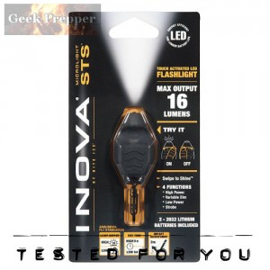
This is a great light and you can read more on it on my post, Micro Light for EDC KeyChain Carry
Mini Pry Bar Tool – The Gerber Shard has been my key chain companion for quite some time now and I’m surprised by how much I’ve used it. It’s handy because it’s right there, so I’m using it to pry, unscrew, tighten and many other uses.
Bottles of root beer are being popped open by this Gerber Shard as we speak…. that counts as an emergency use right?
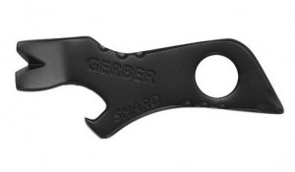
The Gerber Shard includes a small and medium flat driver; Philips head driver, wire stripper, pry bar, bottle opener, lanyard hole.
Jack Knife Lock Pick – This isn’t a tool for everyone. Most would benefit from a small key ring style Swiss Army Knife, but I ALWAYS have my Swiss Army Knife Hiker or my Leatherman Sidekick with me. Since I have the pocket knife and mult-itool option covered, I choose to carry a MadBobPicks Jack knife lock pick set.
Lock picks should never be used for evil or to pick locks that you don’t own. You’ve been warned! Here are the laws, concerning lock picks, for each state in the USA http://toool.us/laws.html. If you reside or travel outside the USA, please check the local laws.
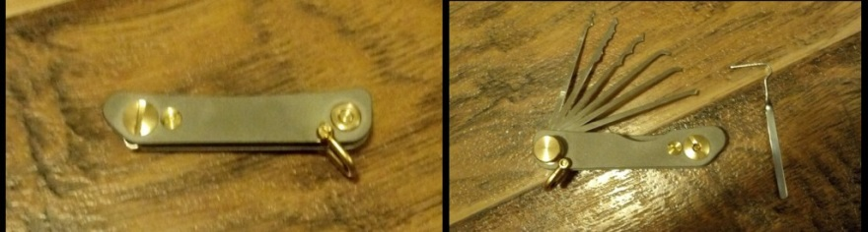
I do sometimes swap out the MadBobPicks Jack knife lock pick set for my Leatherman Squirt.
If I have to fly, I ditch the Leatherman Squirt and carry my Leatherman Style PS Multitool (No knife, but it does have pliers, wire cutters, scissors, file, regular and phillips screwdrivers, nail file, tweezers).
It’s good to take advantage of your key chain and add some tools to make life easier or to make survival easier. Take advantage of planning and do some form of Key chain Carry
Other EDC posts:
- Airport Carry On Get Home Kit
- Fresnel Lens – Fire Starting Secret Weapon
- EDC Survival Kit – Increasing the Odds of Survival

