Keeping Bees Using the Top-bar Beekeeping Method
Use this less expensive method to raise bees that will pollinate your crops and provide tasty honey fresh from the comb
By Phil Chandler

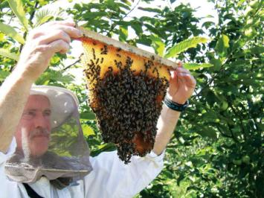
Beekeeping is a great hobby, whether you keep bees for pollination, honey, profit, medicinal uses or all of the above. But getting started with bees can be expensive if you use conventional hives. A basic setup with bees can cost more than $200, and building conventional hives and frames is time-consuming. But there’s a simpler, less-expensive and more natural option: top-bar hives. The top-bar method of beekeeping allows you to make simpler, inexpensive hives. Build them now and you can start keeping bees next spring.
In the top-bar system, you build simple box hives with slats (bars) of wood laid across the top, to which the bees attach their wax comb.
With growing concerns about colony collapse disorder and the resulting decline in the number of pollinators, gardeners might consider maintaining a top-bar hive of honeybees simply to increase vegetable and fruit yields through better pollination.
Top-bar beekeeping is for both urban and rural dwellers who want to keep bees on a modest scale, producing honey and beeswax. Above all, top-bar beekeeping is for people who love bees and understand and appreciate their role in the pollination of many wild and cultivated plants.
If your goal is to obtain the absolute maximum amount of honey regardless of all other considerations, top-bar beekeeping is not for you. This style of beekeeping can produce adequate amounts of honey, but the emphasis is on sustainability and keeping healthy bees rather than maximizing honey crops.

Natural vs. Industrial Beekeeping
Beekeeping does not have to be complicated. And you need none of the stuff in those glossy supply catalogs to keep healthy, happy and productive bees.
Nearly all conventional beehives in use in the United States and Europe are similar. They consist of rectangular wooden boxes containing removable wooden frames holding preformed “foundation” for the bees to build wax comb on, plus a floor and a roof. The queen bee lays eggs in this comb, and the bees store some pollen (their protein source) and honey in the comb. Other wooden boxes, called “supers,” with (usually) smaller frames, are stacked on top to store most of the honey crop.
In some ways, this box-and-frame hive is right for the job — at least from the beekeeper’s point of view. It’s a simple matter to lift individual frames out of the hive to see what the bees are doing and, if you have a strong back, it’s relatively easy to remove the honey crop. The uniform shape of the honeycomb in the frames makes it easier to extract the honey with a centrifuge.
For the bees, however, this conventional system has several disadvantages. Bees naturally build comb in deep, catenary curves (the shape made by a chain or rope suspended by its ends). But the use of preformed foundation inside rectangular frames forces bees to build comb according to our requirements, not theirs. Bees prefer to adjust the size of cells according to their needs.

