Is Bugging-In Death

I have a very hard time dealing with foolish people who are strident about their idiocy.
I don't suffer them well.
Recently, a discussion I was following examined what to do during #SHTF.
The obvious gist of it was to talk about when to bug-in versus when to bug-out.
A strident soul said: “If you plan on sheltering in place that's not a good idea. Those that move will survive.”
His words dripped with bravado.
I could smell the testosterone through the screen.
What he said was not true universally, but he was adamant about it.
I would learn that—to him--every #SHTF event was a bug-out trigger.

I replied: "'Those that move will survive' is an opinion. What to do is 100% dependent on the situation."
To which he restated: "Shelter in place is more like die in place...”
Being unable to resist I retorted: "Hey, if staying where you are is the safer choice and you want to bug out and get killed, give me your address so I can take your stuff.”

The fool said in reply: “All of my supplies are deployed so that only I know where they are."
¡Santa Madre de Dios, protéjanos de locura!
The poor soul will be one of the first to die.
Prepper zealots make me roll my eyes much too often.
They soak up all the prepper clichés and spew them as incontrovertible fact.
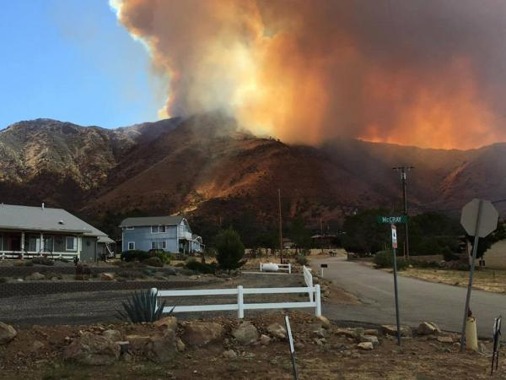

When the Erskine Fire happened above Bakersfield in Lake Isabella—bugging out was the answer.

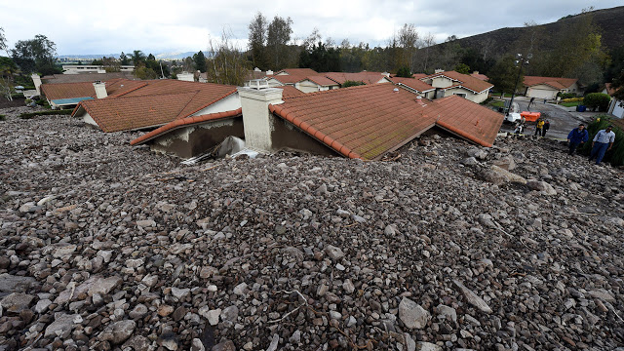

If a mudslide is heading for your house—a common occurrence in California when heavy rains happen—bugging out is the answer.

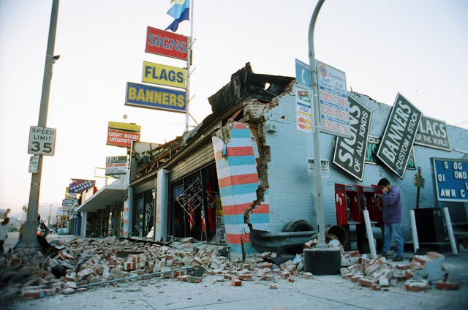

The Northridge earthquake two decades ago was definitely a #SHTF moment, but bugging out simply wasn’t possible.

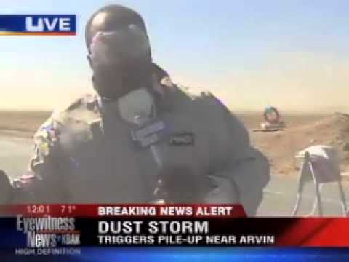

If there should be a killer dust storm—something that has also occurred before in California—bugging in would be the answer.

The trick to determining whether to bug in or to bug out is to assess what are the most likely threats to you and plan accordingly.

