How to properly prepare for disaster

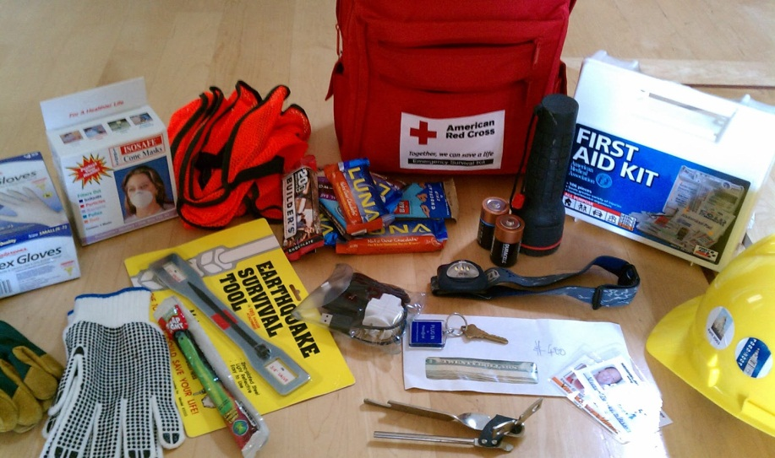
The world happens. And whether we want to face it or not, at one point or another, we will be faced with the task of recovering from a disaster. The important thing to do, next to trying to avoid it (which we can only do so much), is to know how to react if and when it strikes. From hurricanes to earthquakes, tornados, wildfires and blackouts, being ready for disaster can mean the difference between misfortune and devastation.

Calling for Help
In our modern times, very little is accomplished without the connectivity of our phones and the internet. Truth be told, if you are suddenly stranded without either, would you know how to contact help? Would you be able to? Much of our knowledge and ability is derived from technology, and if we find ourselves alone, the overwhelming feeling of being cut off is enough to cause immense panic. Without a doubt, part of your disaster recovery kit should include a satellite connection of some sort. Considering how much we rely on our smart phones and the internet, you will need it even more when your life and security depends on it.

What’s in Store
Being prepared for a massive event not only involves your safety during it, but your survival afterwards. Will you have enough food to subsist on? Without depending on outside sources or prepackaged goods, you should have the ability to support yourself and any loved ones for as long as possible following a disaster. Store your survival goods in a location safe from flood, military attack, high winds and other possible threats, but also keep it somewhat accessible if your environment (or health) is compromised.

Work on Contingency
No one can plan perfectly for disaster. Your strength lies is how well you can adapt when your plans do fall through. If your escape route out of town is suddenly washed away, will you have another option? If your storeroom burns down in a fast-approaching wildfire, do you have a separate supply in a different location? Adapting to changing circumstances and having hard, definitively outlined backup plans is key to your prosperity. And the rule of thumb: you can never have too many.

Safety in Numbers
It is very important to build a positive network of people you can depend upon in your time of need. Plan a meeting before an impending disaster to work out your recovery plans as a group, so everyone is on the same page, further strengthening your contingency plans. By combining assets, chance of a speedy recovery or a safe escape increase exponentially. In the event of a flood, your neighbor could help with his boat. If a blackout occurs, those with a generator will be called upon. Medical skills, physical strength, and leadership ability – all of these individual traits can be better served in a group setting if a larger amount of people rely on each other’s help.

For Better or Worse
It may be a grim topic, but it is certainly a necessary one. In light of recent devastation in the Philippines, and other intermittent events throughout the world, disaster recovery is an all-too-real need. Be prepared for the worst and hope for the best. In times of trouble, a little bit of advance planning can go a long way.

