How to Waterproof Your Boots
Any hiker, naturalist, or survivalist will tell you that your boots are one of the most important tools you will have when outdoors. If a person doesn’t have adequate footwear in extreme conditions, it can be a death sentence. If you have poor footwear, your ability to move, hunt, and retain heat are drastically affected and reduced.
In the old days, people didn’t need shoes, right? They were barefoot. Wrong. Shoes that helped society grow and expand date as far back as 500,000 BC. Strips of leather for early man, then then addition of studs and iron nails with the Romans as they marched.
Today, while some may follow fashion, the modern survivalist has other things to consider when selecting shoes and his needs for them. He also needs to know how to clean, protect, and extend the life of this valuable commodity.
As the area, terrain, environment, purpose, height, weight and sex can vary making selection a personal thing, we will not be going over brands in this article. We will be discussing how to protect, clean, and a few different ways to weatherize the boots you pick.
The main things to look for in a shoe for preppers:
- Thick soles for insulation and to resist slipping.
- Breathable layers and ability to take wear and tear.
- Comfort.
- Rugged construction.
- Reinforced toes.
- Good arch support.
- Puncture resistant soles
- Electric shock resistant materials.
- Shoes that can aid you in walking, climbing, crawling and running.

Making your boots more water resistant vs. waterproof
We have to clarify that to make your boots waterproof, you are only temporarily doing that. No amount of product or spray will make them permanently waterproof. If they are subjected to harsh weather and elements, you may need to apply waterproofing product quite often. When you waterproof you are building a seal on the boots to make them resistant to water and moisture.
There are a few ways of providing water resistance. Waterproofing is different than using shoe pastes or creams to soften and nourish the leather, as they usually are absorbed into the leather, but do not leave a seal to resist water.
Using the 4 types of water resistant compounds:
- Wax based polishes- may protect somewhat against light moisture and salt, but adding a shine is not the same. Although, afterwards, they may look the same with a nice sheen and luster.
- Specialty compounds for waterproofing- the main purpose of these is protection, and they do a pretty good job at it. They can be used with a polish to provide the best of both worlds in visual and functional applications.
- Spray-on compounds to waterproof- these rea better than nothing, but they lie on the surface and do not penetrate the leather. If it contains silicone, it may dry out natural materials like leather.
- Using natural products- I like to use beeswax or lanolin for natural protection. They may darken the leather, so test first.

How to Waterproof your boots
It is now time to waterproof your boots to help extend their life and functionality as tools that you can rely on to do their job. I am using lanolin (the melted more liquid golden oil) and store bought 100% beeswax to show your how we waterproof our boots and the before and after. There is a section below on melting beeswax that is in chunks (usually when you buy it from the local community garden).
STEP 1 Select a product to use. Water based is good for all leathers, oil based should only be used for full grains leathers. Oil based may darken your leather.
If you can find out what kind of leather the shoes are made from, there are specialty products for suede, nubuck, and split. If you are going to dye the leather, do it now.
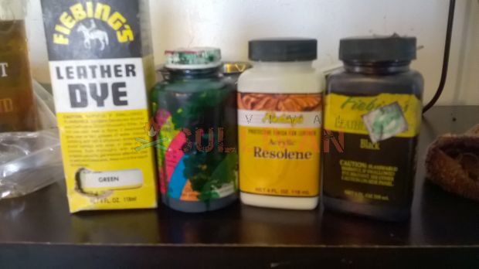
STEP 2 Clean them with leather soap and a toothbrush to get all dirt and debris out of the cracks and seams, but do not let them dry completely. Leather opens up when it’s wet and we want the pores open. You want them to be damp, when water has penetrated the leather will be cold and darker.
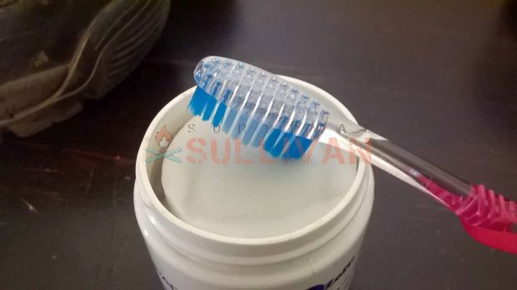
STEP 3 Apply your product. Commercial products will have directions, put most spray or wipe on. For beeswax or lanolin, see our other DIY directions. Use a lint free cloth, we use socks or old t-shirts.
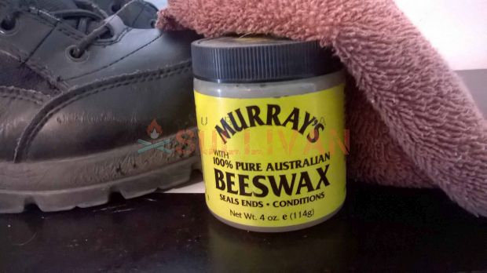
STEP 4 Wipe on the surface, and pay attention to get it in any joints, cracks, or seams. These will be your points of entry for water. This boot needs some love here.
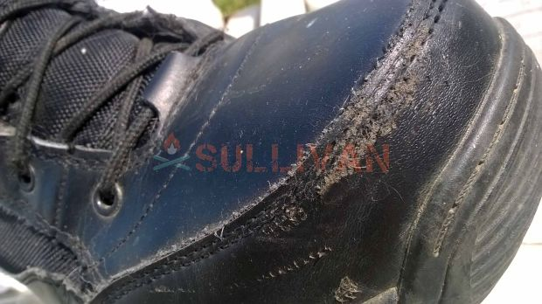
STEP 5 You do not need to apply any product to rubber soles or rubber parts. For the seams that are plastic, or bottom heels etc. I work in some wax or use a fabric bonding agent (pictured below) to fill a crack.
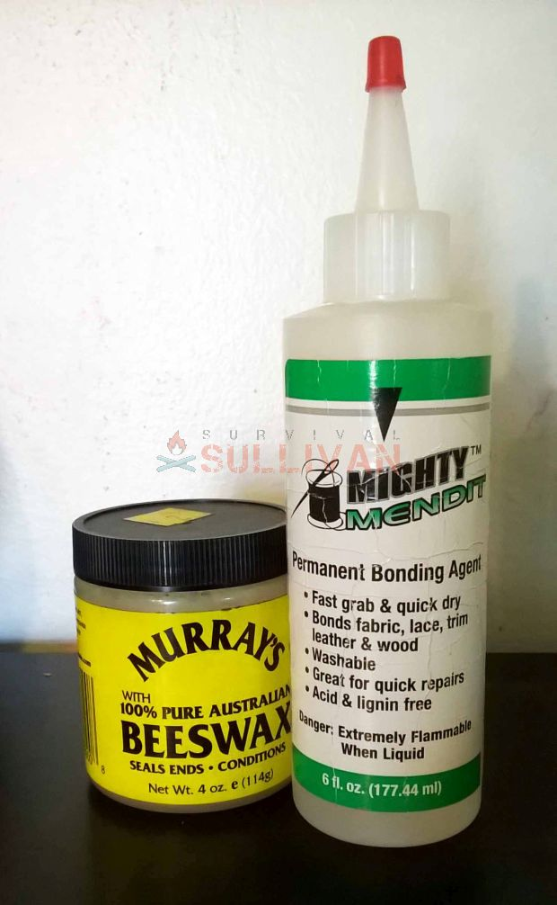
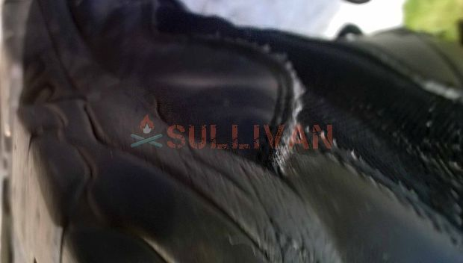
STEP 6 After letting everything soak in, use a clean cloth to wipe away the excess.
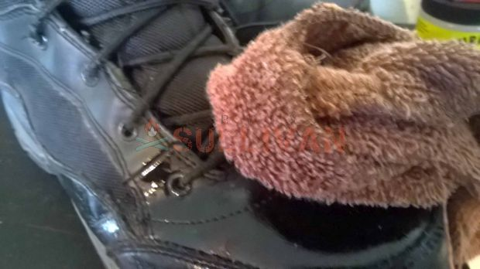
STEP 7 Let the boots dry at room temperature. I put these on the porch as it’s nice today.
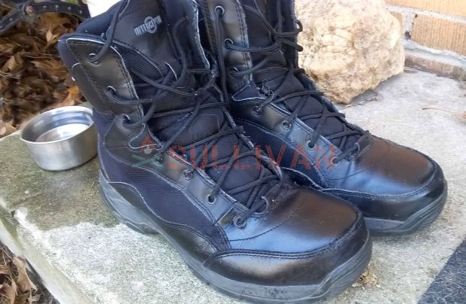

DIY Using pure beeswax to waterproof your boots naturally
To use an all-natural product, my husband uses beeswax and has for many years on his boots. He uses a brand that uses Australian beeswax and is ready from the jar- it does say it’s a “stiff wax” and can be sued for dreadlocks too. I use beeswax from our local hive master, and it takes an extra step or 2. I think mine comes out shinier, but his is thicker and does give a nice gleam. He also treks a lot more, hunts in varying terrain, and is out in the rain more. So, he likes the function. He reapplies whenever he is planning to be out for a day that requires a lot of foot action. Unless he ran into wet conditions, heavy weeds and undergrowth that would scrape it off, or heavy marshy mud, about once a month he reapplies. I do mine a fee times a season.
STEP 1 Melt your wax.
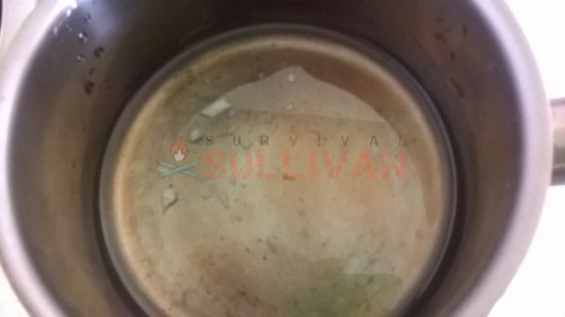
STEP 2 Use a soft lint free cloth or cotton swab to apply it, as it cools it will turn white. That’s normal. Try to get it into the cracks and seems when molten for the best penetration.
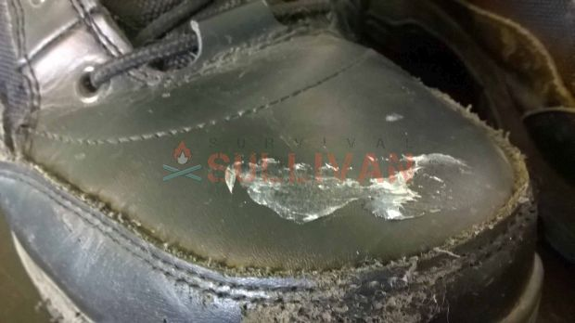
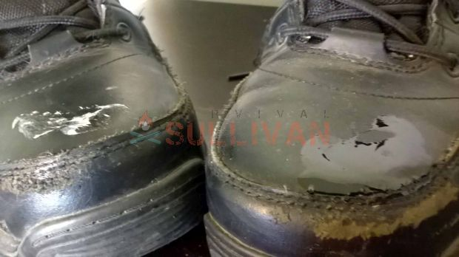
Using the melted local beeswax, use a smaller application piece of material so you don’t soak up your waterproofing compound.
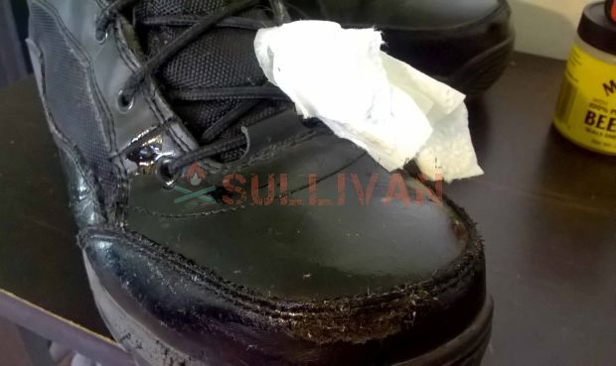
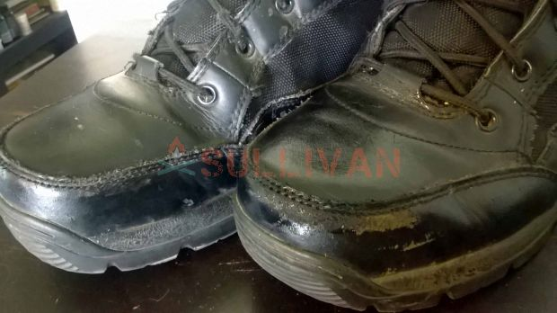
STEP 3 He then uses a heat source to re-melt the beeswax to make it sink in better. You can use a heat source like a heat gun, but he just put them in front of the space heater.
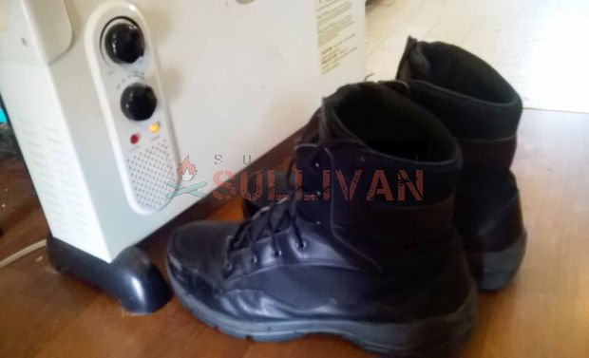
STEP 4 After buffing, you will have a nice sheen. In this picture below, store bought beeswax is on the left, and natural local beeswax is on the right. This is just applied to the toes.
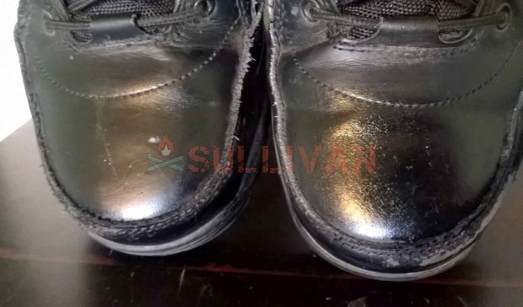Photo: waterproof beeswax vs lanolin shine
STEP 5 (optional) For the beeswax and natural products, if it looks dull, buff with a soft cloth. These are after the whole boot has been treated.
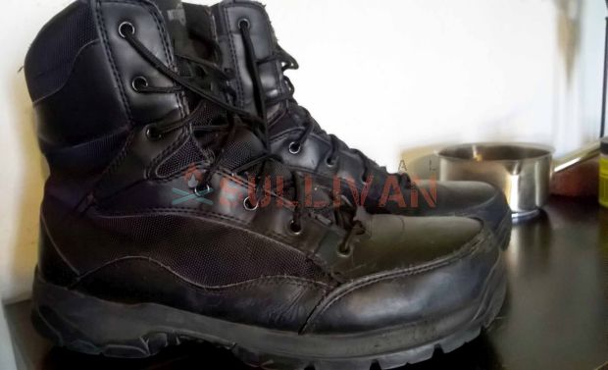

Organic waterproofing using lanolin
The most economical way to use an all-natural product if you can’t find beeswax is using lanolin. You can get cosmetic grade lanolin for about $1 in health food stores. Many of the store bought products do have petroleum jelly in them, so this is a chemical free way to waterproof. You would use exactly the same method as above for beeswax, beeswax is a little thicker so lanolin is a tad shinier.
A video showing how effective lanolin can be:

Survival waterproofing
I heard of a tip for waterproofing your boots in a post collapse situation or when you have no access to stores, etc. like when you are in remote areas or in rugged terrain. You can find a wax ring, the kind they use in toilets pretty cheap for a few bucks and warm that wax and rub it in, much like beeswax. This is heavy duty wax and I can see it working like a thicker beeswax. If you will be spending time in very wet conditions, heavy snow and slush, or trekking through unknown areas without access to supplies, you may want to use this method. Wet feet can mean death in conditions such as these, so for a few bucks it worth a try.
Using wax to waterproof boots video:
https://www.youtube.com/watch?v=yBSrc26Xec4

Maintaining hiking boots
While it is expected, footwear will break down, there are a few things you can do to prolong its life. To ensure your hiking boots remain supportive, comfortable and waterproof here are some tips.
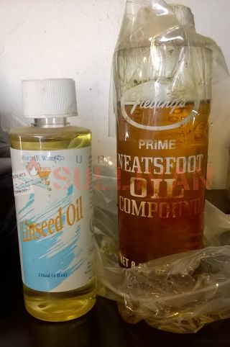
Photo: Don’t sit on it and crush the bottom, or you’ll need to store it in a baggie.

These are good oils for softening your boots. The neatsfoot oil I use for my leather carving leathers also.
- Break in your new boots by wearing them for a week or so before you intend on using them. Nothing is worse than hiking in new boots and getting those blisters as your shoes haven’t been broken in yet.
- Use leather conditioner and oils to keep the leather soft (right).
- New boots need waterproofing before you go on any major walks or hikes. Do this before you leave the house. Check for the laces and D-rings to be in good shape. Make sure all the stitching is intact.
- Clean during your hike, with any use, or at the day’s end. Tap them to loosen any debris and dirt, and then brush the surfaces to knock off sand and grit.
- Use a stuck or knife to pick out stones and mud from the soles.
- If they are wet, stuff newspapers, or dried leaves inside to soak up the moisture. Do not dry in direct sunlight or too close to a fire or heater- you can crack the seals and melt the glue allowing water to get in and sacrificing the integrity of the build. Change the newspaper hourly, or when they become dark and damp.
- Don’t let them freeze, this too can crack them.
- If you can take several pairs of socks, rotate them throughout the day to keep moisture at a minimum.
- As I lived in AZ with tiny scorpions that fit everywhere and it was a daily ritual, but anywhere can have tiny critters like black widows, so shake out your shoes first thing. LOOK before you put them on.

Getting the smell out of well used boots
If you plan on waterproofing and protecting your boots to make them usable for quite a while on the outside, we need to make sure to take care of the inside. Specifically, freshening and keeping them odor free. Bacteria is what smells when you smell any odors on your body or clothing, so thinking about it that way is the best way to eliminate odors. Kill the smell producing entities.
- Wash them you may have picked up somethings on the outside. Wash, condition, and then waterproof. For inside, these days most soles can be taken out and washed. Wipe the boot out with a damp cloth and allow them to completely dry.
- Use baking powder. Baking powder should be sprinkled liberally, tap the boot to get it in the cracks. In the morning, dump out the extra. If you have it, kitty litter absorbs moisture so throw some in too.
- Disinfect. Use a spray disinfectant, or make your own. Spray inside and out, then let them dry completely.
- DYI Boot Spray and wipe
  - Use alcohol or Vinegar if it is a strong smell
  - Add a few drops of essential oils to freshen, many have antiseptic properties
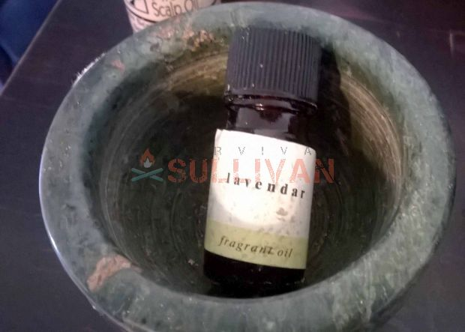
- DYI boot disinfectant 2. Dab a few drops of peppermint, rosemary or tea tree oil on a cotton swab or piece of cloth, wipe inside the boot. Many essential oils are antimicrobial and are a great alternative to hand soap, deodorant, or even perfumes.
A cheap way to get them, as they are expensive, is to use extracts. The ingredients say alcohol and orange oil, lemon oil, etc. So, there is some oil in there, so they will do the trick and they smell nice.

- Leave a dryer sheet in them overnight
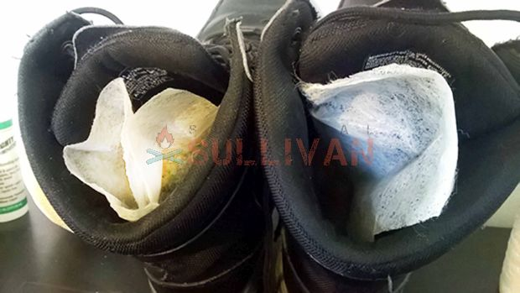
- Make a pouch to stuff in the boots over night with the ingredients above, or use fresh tea leaves. Place in the boots nightly.

