How to Waterproof Fabric
Waterproof Fabric With Waterproofing Spray and Seam SealerWaterproof Fabric Using Laundry Detergent and AlumWaterproof Fabric with Turpentine and Soybean OilPreparing to Waterproof Fabric
Whether you've purchased a new tent or want to protect the canvas cover on your boat, you will want to waterproof fabric to extend its luster and lifespan. This article will teach you how to waterproof fabric using either a commercial spray or a homemade mixture made of household products.

Method 1 of 4: Waterproof Fabric With Waterproofing Spray and Seam Sealer
- 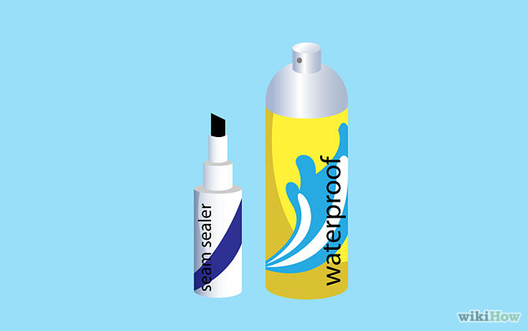
1
Use waterproofing spray and seam sealer on silnylon, canvas and leather. You can purchase your supplies at an outdoor or camping supply store.
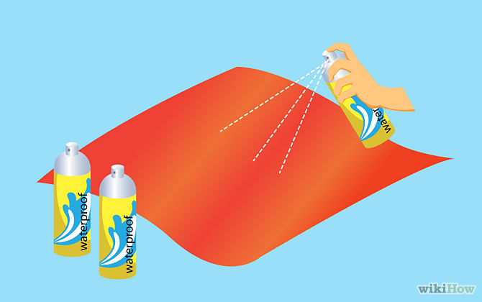
2
Spray the entire surface of the fabric with waterproofing spray. You may need several cans of spray to cover a large amount of fabric.

3
Apply seam sealer to all of the seams. Seam sealer usually comes in a small bottle with an applicator on top, which you can roll over the seams while squeezing gently on the bottle.

Method 2 of 4: Waterproof Fabric Using Laundry Detergent and Alum
- 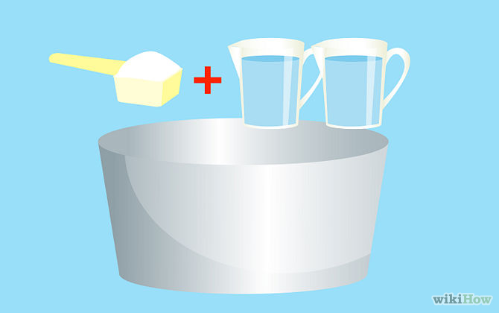
1
Mix 1 pound (0.45 kg) of laundry detergent with 2 gallons (7.5 L) of hot water in a large container. You want the container to be large enough so that you can soak all of your fabric in the detergent mixture.
- 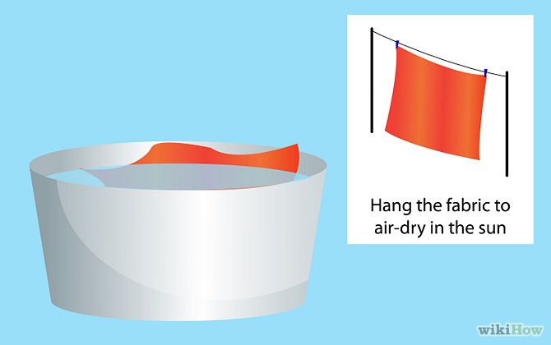
2
Soak the fabric in the mixture until it is completely saturated. Hang the fabric to air-dry in the sun.
- 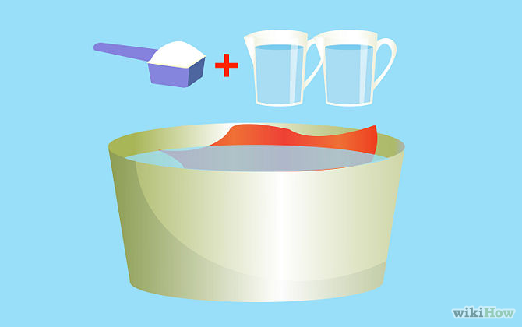
3
Combine 1/2 pound (0.25 kg) of alum with 2 gallons (7.5 L) of hot water in a second container. After the fabric has dried out from the laundry detergent soak, steep the fabric in this mixture for at least 2 hours.
- 
4
Hang the fabric in the sun to air-dry completely.

Method 3 of 4: Waterproof Fabric with Turpentine and Soybean Oil
- 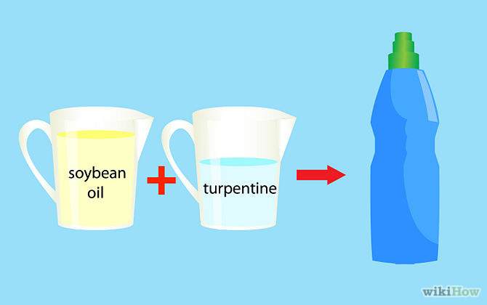
1
Mix 1 cup (237 ml) of soybean oil with 4 ounces (118 ml) of turpentine inside a durable plastic spray bottle. Stir the mixture with a wooden paint stirrer.
- 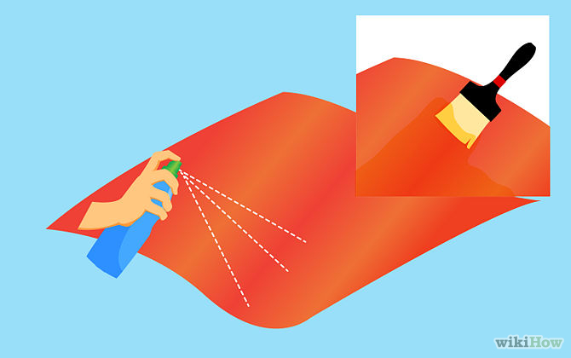
2
Spray the mixture onto the fabric with the spray bottle. Alternatively, if you are covering a large piece of fabric with the turpentine and soybean oil mixture, then you can pour the mixture into an empty bucket and paint it on with a paintbrush.
- 
3
Lay the fabric flat to dry completely.

Method 4 of 4: Preparing to Waterproof Fabric
- 
1
Clean the fabric. For dusty or lightly soiled fabrics, use a vacuum or a brush. For heavily soiled fabrics, use a fabric cleaner.
- 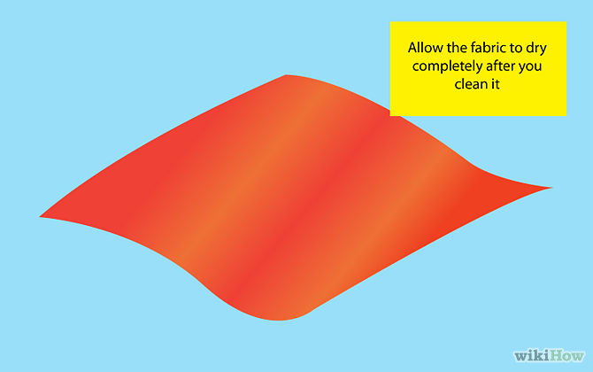
2
Allow the fabric to dry completely after you clean it.
- 
3
Transfer the fabric to a well-ventilated area when possible. For additional protection, wear safety goggles and gloves.
- 
4
Waterproof fabric on a dry day. If you use a chemical method, then make sure to cover your lawn or any nearby plants with a tarp or with plastic sheeting.
- 
5
Lay the fabric on a flat surface when possible for maximum coverage. Set a tent up in an obstacle-free area that gets plenty of airflow.

