How to Survive an Apocalypse
What will happen if society collapses? What would you do if there's no one to help you or your family? You're almost excited for this moment, aren't you? You've been stockpiling up Twinkies for years (now that was good thinking!)! You're probably just wondering if there's anything you've forgotten, really. Well, read on.

Method 1 of 2: If You Have Time To Prepare (Because Obviously the Internet is Still Working)
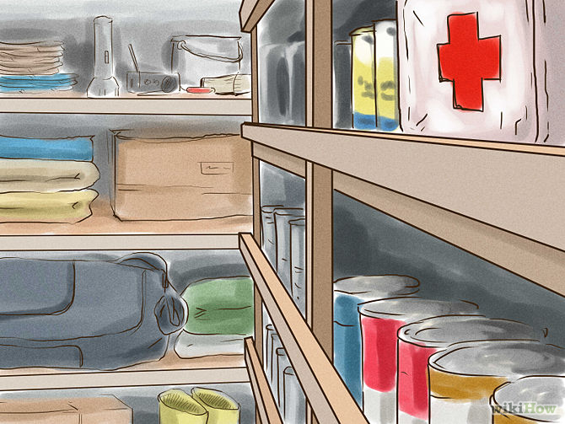

1 Store supplies for 90 days. It's not going to be short term since the entire country or the world is falling apart; there's no two ways around it. But hopefully having three months of supplies will get you settled and going with your new insular habits. The more time you have dedicated to form a plan when disaster does strike, the better. Think in two categories: basic survival and getting by.
  - For basic survival (the most important), consider storing the following:
    - Jugs of water
    - Canned goods
    - A few packaged, vacuum-sealed goods
    - Blanket and pillow
    - Medications
    - A weapon
    - A knife (in addition to a weapon)
    - Warm clothing (if your climate requires it)
    - Carrying bag (for moving and/or fleeing)
  - For just getting by, think about having these items at your disposal:
    - Batteries
    - Flashlights
    - Matches
    - Pot (for cooking or boiling water)
    - Eating ware (plate, mug, spoon, fork)
    - Rope or twine
    - Map
    - Permanent markers
    - Change of clothes
    - Can opener
    - Lighters
    - Camp stove and propane
    - Hatchet or ax
    - First aid book
    - Sunglasses
    - Duct tape
    - Glow sticks
    - Boots
    - Radio and/or walkie-talkies
    - Other comfort items
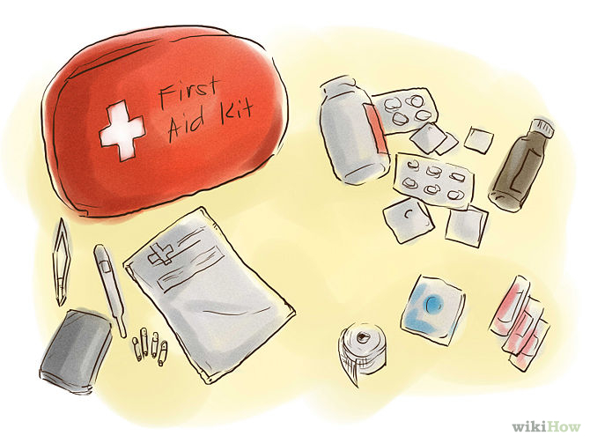
2
Prepare an emergency kit. Whether you're on the lookout from cannibals, flesh-eating super-bacteria, zombies, or a meteor, you'll need to think about your health. Here's a list for what you need to put in your emergency kit:^{[1]}
  - Band Aids
  - Gauze
  - Medical tape
  - Ibuprofen
  - Acetaminophen
  - Antihistamine
  - Aspirin
  - Laxative
  - Iodine
  - Hand sanitizer
  - Tweezers
  - Safety Pins
  - Thermometer
  - Superglue
  - Toothpicks/Needles
    - Remember, you've gotta keep yourself healthy against everything. You'll be dealing with everything from cuts to dysentery. Hospitals will cease existing and simple problems will seem a lot more daunting. If you or a family member has a specific ailment, stockpile medications for that, too.
- 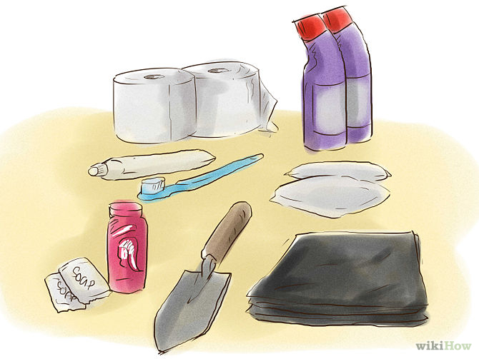

3
Plan how to prepare for the messier sides of the long-term. That's a nice way of saying, "Everybody poops." To keep hygiene from being an issue on top of everything else, pack the following (you'll be glad you did):^{[1]}
  - Toilet paper (a couple rolls will suffice)
  - Menstrual products
  - Toothbrush and toothpaste
  - Plastic garbage bags and ties
  - Shovel or trowel
  - Bleach
  - Soap and shampoo (those hotel samples are finally useful!)
- 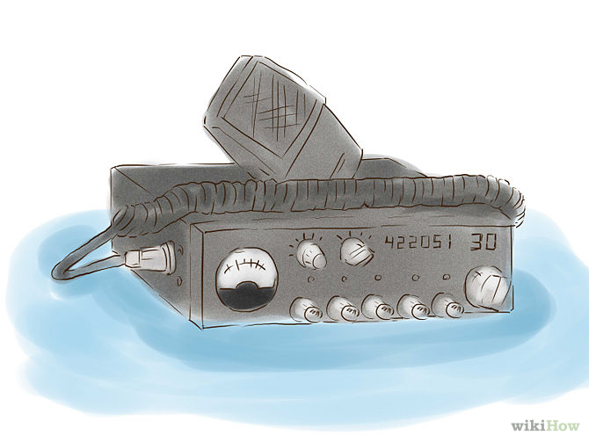
4
Set up a communication system. Since you and your friends obviously all have radios or walkie-talkies, agree on a specific channel or frequency. When the blow comes, you'll know how to find each other.
  - Keep batteries with your radio. The last thing you want is to presume you're prepared when you're really not. And if you have a loved one you're taking care of, make sure they have a radio and you're not keeping both of them for the two of you.
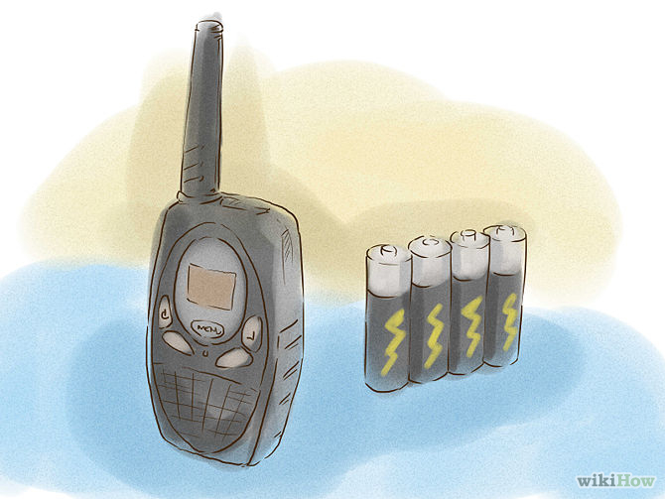
  - When all else fails, work out how you will contact each other. This is when your permanent markers will come in handy. If the apocalypse strikes and you have left the house (why would you do that?!), write where you are going, when you left, and if/when you'll be back on the wall, on a rock, on a nearby car, wherever you can find.
- 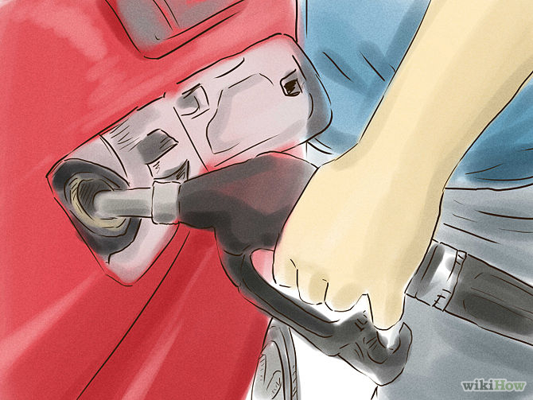
5
Use diesel-powered vehicles. Hoarding gasoline won't work; the chemicals that once kept it fresh will degrade it in time. After a year or so, it goes bad. Chances are gas stations will run out of gasoline but there could be some Diesel left. In addition, all military diesel's can run on other fuels as well, from rotten kerosene to fermented leaves. So invest in something that can handle the harder fuels.
  - In said vehicle, it's equally as likely that you'll be there when all hell breaks loose, so pack a survival kit in your car as well. Is there such a thing as being too prepared?
  - If this isn't an option, make sure you have a bicycle laying around somewhere that's fully functioning. There will be a point when you need to cover large distances in a short amount of time.
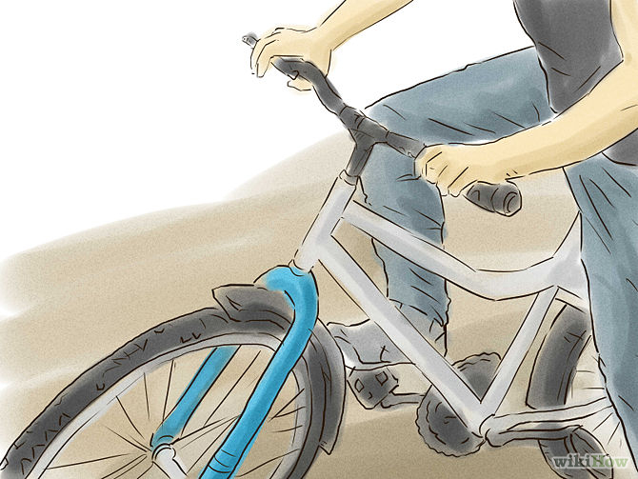
- 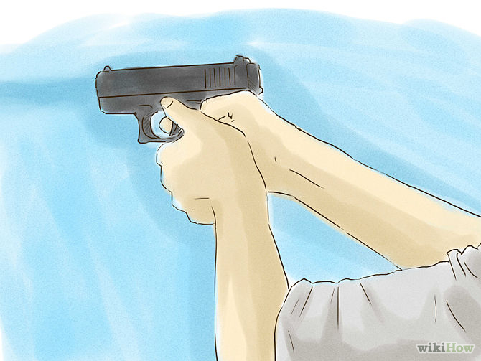
6
Become a good shot. Let's be honest, knowing how to work a gun is gonna keep you from either dying or being voted off the island. So get over your hippie all-the-world-needs-is-love mantra and load 'er up. And while you're at it, buy a couple (if you haven't already).
  - Regardless of who or what you'll be facing, this is probably a good idea. Zombies will attack you, starving or untrusting humans will attack you, robots will do whatever they damn well please with you, aliens will probe you, and the Kardashians just need to be kept far, far away. Whatever or whoever your enemy, shooting them will probably increase your chances of not being attacked, eaten, being made a robot playtoy, probed, or questioning your will to live.
    - Unless the apocalypse is due to some bacteria that's floating around in the air. Can't really shoot that, huh? In that case, get a gas mask. Actually, get both. The people/zombies/Kardashians will probably still see you as an enemy.
- 
7
Learn how to hunt. Face it: This is the Hunger Games. There will be an economic crisis, societal unrest, and you'll be forced to jump the fence to kill squirrels to feed your family's rumbling tummies. How are you going to do it? Gonna waste bullets on squirrels? Don't think so.
  - Master the art of the snare trap. If you're really scrappy with it, you need nothing but what nature provides you (provided that nuclear blast hasn't wiped out everything green).
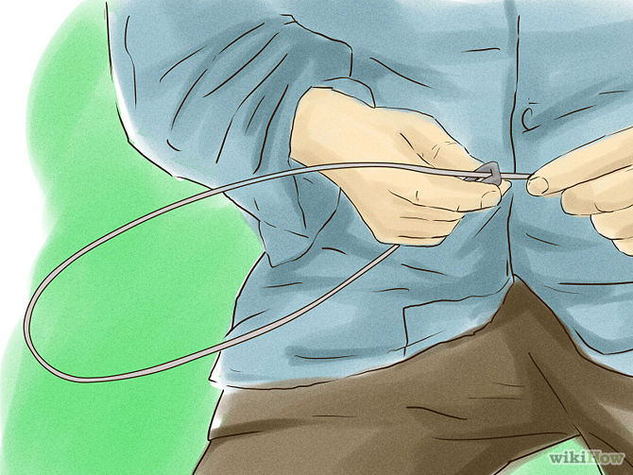
  - If you're on the ocean or near a body of water, get to fishing or fly fishing. Your stock of Bush's baked beans and Spaghetti O's certainly isn't going to start spawning miraculously.
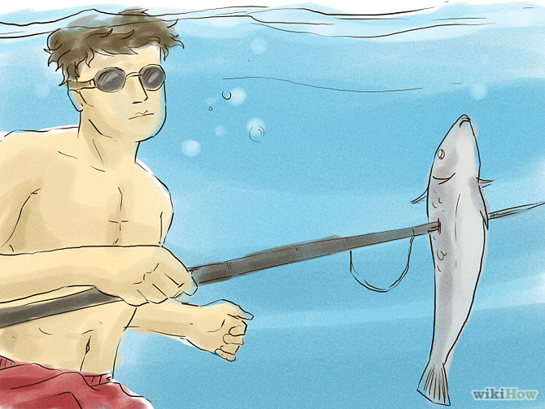
  - Take a hint from Katniss and start honing your archery skills. Once you've got a reason, learn how to make your own bow.
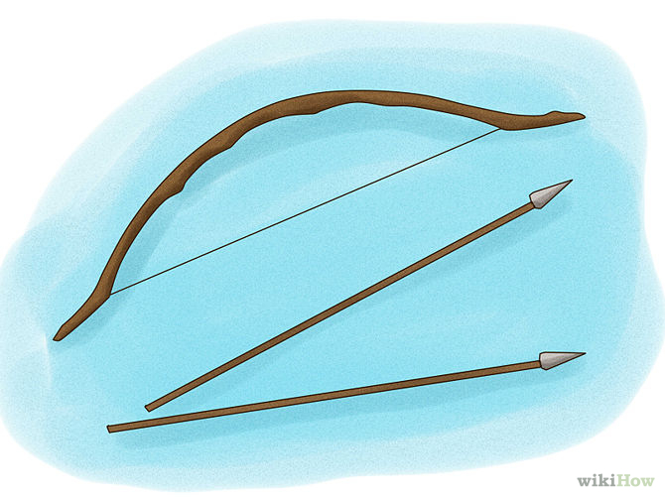
    - Really, you should just be spending loads of time on wikiHow's disaster preparedness section.
- 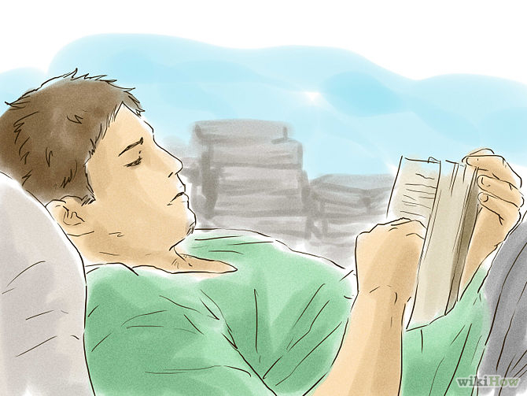
8
Read every novel on every version of apocalypse you can. Even though they are "fiction" reading on how they scavenged for food, retained water, and found shelter might just be the thing to save your life. However, DO NOT rely on these as your only preparation.
  - The Road by Cormac McCarthy, Lucifer's Hammer by Larry Niven, Alas, Babylon by Pat Frank, Earth Abides by George R. Stewart, Stephen King's The Stand, and The Day of the Triffids by John Wyndham are all great places to start (even if the apocalypse doesn't end up coming anytime soon). You've already read The Hunger Games, right?
- 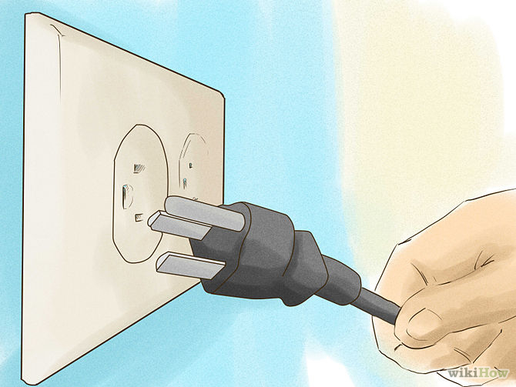
9
Become less dependent. If we're all honest with ourselves, what kind of world could we recreate without others? The Internet is just a series of tubes maintained by underground elves, right? In the event that you and your family are alone, how would you end up living? With the knowledge you have, what familiarities of the world could you give them?
  - For most of us, not much. We flip light switches like it ain't no thang. We complain when Netflix is buffering. So if you want to really and truly prepare yourself, you're going to have to either cut yourself off from these luxuries or learn how to recreate them yourself. Can you make a battery from a lemon? Or a potato clock? Lowering the bar...how are you at tying knots? Start lining up the reruns of Gilligan's Island and MacGyver now, huh
- 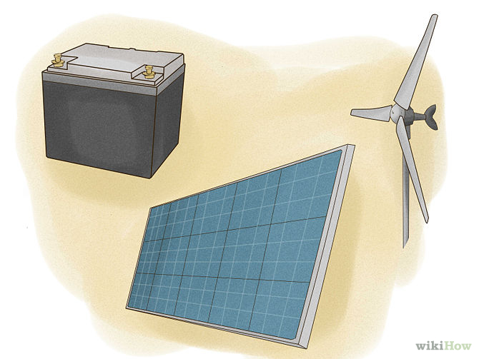
10
Find a way to generate your own electricity. Taking car batteries and daisy chaining them will act as an energy storage device, but you're going to need to generate power. A generator running on wood, gas or a diesel engine where you can make your own fuel is good, but the real payoff is using renewable energy by making your own wind turbine out of PVC pipes and a car alternator or scavenging some solar panels near a highway. When the events do take a turn for the worst, at least you'll be able to be productive at night and have some of the luxuries of your former life.
  - Having electricity in your safe house will keep the lights on and keep electronics running. Electricity is important (not to run a PlayStation 3 or X-Box 360 (no one cares how good you are at halo anymore)) to run power tools, welders, water/fuel pumps, radio equipment as well as charge any portable item or comfort item you may wish to use. It'll be a surprising source for morale, too.

Method 2 of 2: With No Time to Spare (Apart from Reading this Page)
- 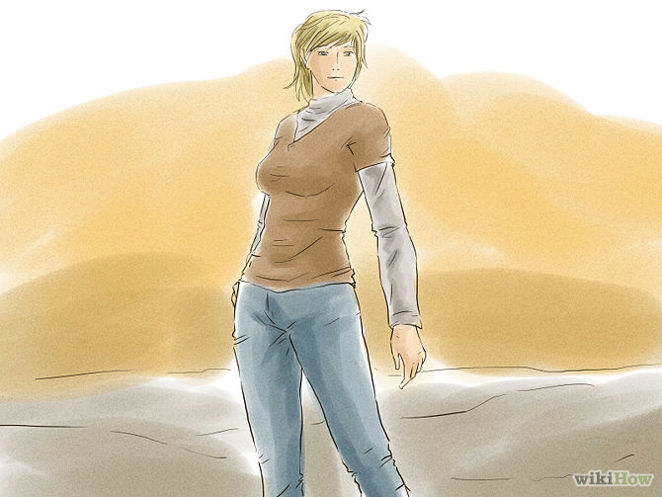
1
Grab a long-sleeved shirt and some pants. If you were out lounging on your pool deck with nothing but earbuds on and iPhone in hand (how else would you be reading this?), you're going to want to put on some layers. Even if the meteor looming on the horizon will send a blast of heat from here to Fargo, you'll be glad you did.
  - Pretty much any cause for an apocalypse requires long, comfortable clothing.^{[2]} You want a long-sleeved shirt and pants to protect your skin from predators, yes, but also from the sun and treacherous terrain. The apocalypse is no time to work on your tan.
  - If you have time, grab a pair of boots. If you don't have boots nearby, go for tennis shoes. You may have to break into a dead sprint at anytime. If you have the luxury, make sure you're comfortable enough in your clothes and shoes to flee.
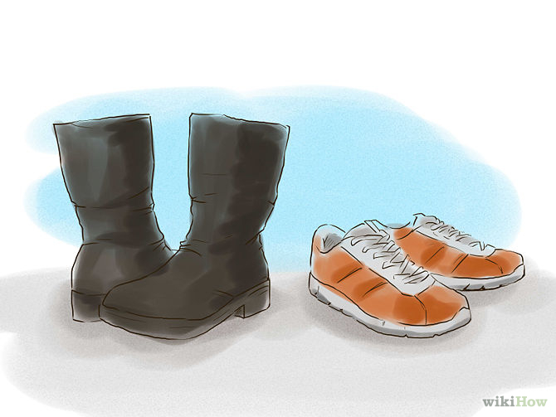
- 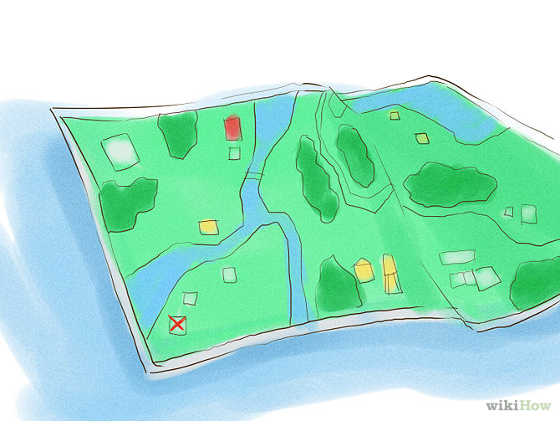
2
Come up with an escape plan. If for some odd reason your house isn't safe to stay in, you'll need to get out as soon as possible. With your map in hand, get out and get out now. Would you do best in the forest? Near water? Are you concerned with privacy and hiding from others or is there not another soul in sight? Your specific situation will determine where you should go.
  - Again, if you can stay in your house, you should. Shelter is best and friends and family will know how to find you. Make an assessment of your situation. Be as logical and rational as possible. You may want to stay, but is it best for you and your family?
- 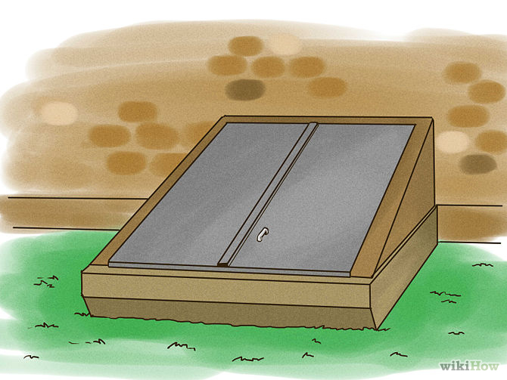
3
Seek shelter. Even if it's not nuclear, you'll be better off escaping the perils of weather and being exposed to predators by getting and staying inside. But if it's a blast that is putting down the human race, it's doubly imperative that you shield yourself from the radiation as quickly as you can.
  - Basements are a good place to start. 16 inches of solid brick can keep it away from you, so you should be pretty set there -- not to mention amongst your own things. 5 inches of steel will do it too, but you probably don't live on the Enterprise.^{[2]}
- 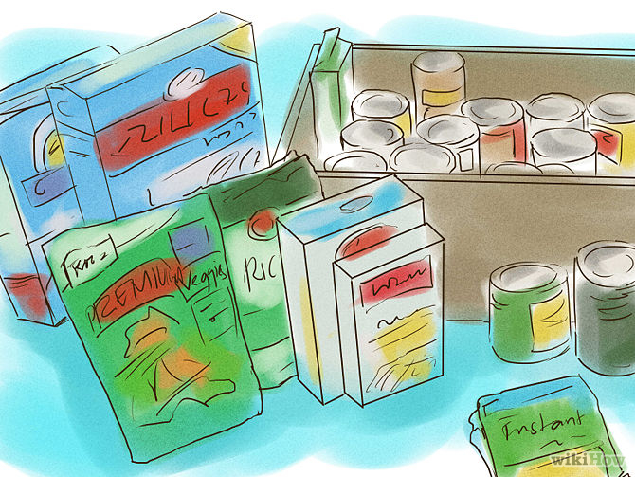
4
Find a food source. You'll probably want this to be from a remnant of your soon-to-be past and not a raspberry bush or particularly lively pond. A grocery store or even recently-deserted houses are your best bet. As you're scrounging, get a candy bar and chow it down. The last thing you want to think about right now is hunger.
  - And stock up. Don't think in terms of days; think in weeks. Grab a few bags and start scrumping. What can you carry that'll last the longest? Think in volume and weight in addition to preservation. Cans are good, but they're heavy. But if everything is already picked over, don't get fussy; take what you can get.
  - Water. Get loads and loads and loads of water. Or else you'll be drinking your pee in no time.
- 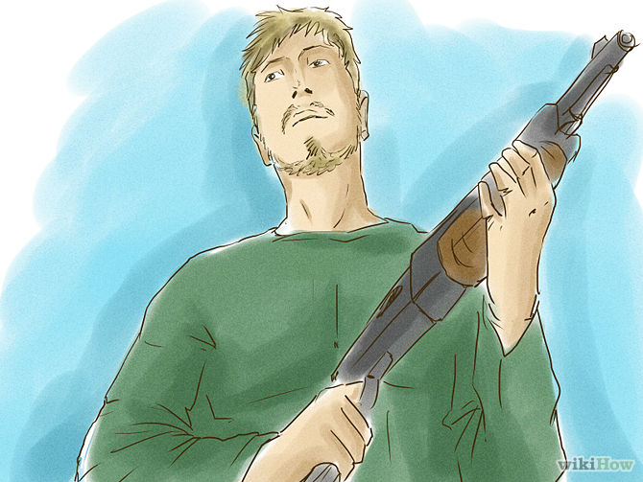
5
Go on the defensive. It's pretty safe to assume at this juncture that whatever is out there is not your friend. Find a weapon that you can actually use and start watching your six. When it comes to humans, there is no place for intelligence and culture now -- you do what you need to do.
  - Don't flash your gun like you do your BMW. Conceal your weapons.^{[3]} You know that scene in Die Hard where Bruce had those guns taped to his back (despite the fact that tape doesn't adhere easily to pools of sweat) and pulled a one-over on that German villain either played by Jeremy Irons or Alan Rickman? That's gonna be you. No one's gonna pull the wool over your eyes. You're a weapon yourself.
- 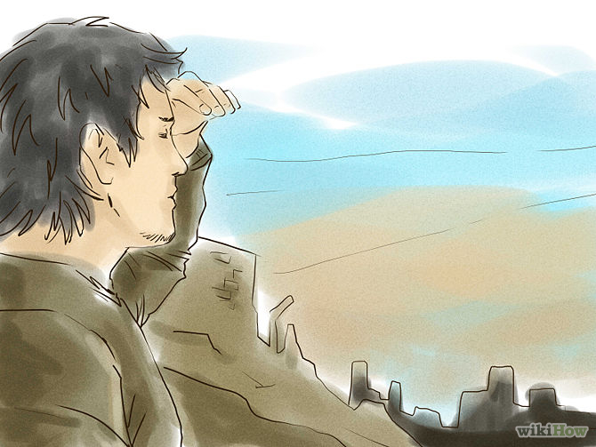
6
Find other survivors. You've got your food, you've got your weapons, and you've staked out a place to stay. Now it's time to assemble a team a la The Walking Dead. Except for unlike that show, you want a team that is actually useful. When you consider taking on others (they're mouths to feed, after all), assess what they can do for you. Do they know plants? Are they a wizard with a javelin? Are they carrying their own stockpile of food?
  - Okay, okay, you'll probably want friends so you shouldn't be too picky. If you're not going to assess them for their goods, at least consider their character. Does your gut tell you they're trustworthy?
  - If you're all alone, keep a look out for lights and fires at night time. If you see one or more, consider venturing out yourself to make new best friends, but only if you think the end would justify the means. How far away is the light? How quickly could you get there? What would you be risking by leaving? Are there predators or obstacles in your path? You may be better off being alone...for now.
- 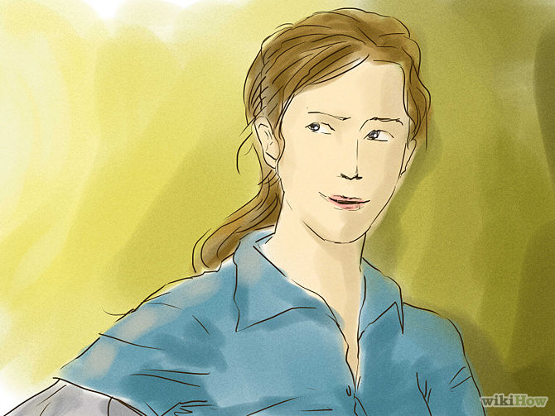
7
Stay positive. This will arguably be the hardest thing, especially if you're alone or wounded. But ultimately this hardship will be easier to handle if you remain optimistic about it. And if there are children with you, all the more reason.
  - Do not let your ethics stand in the way of your identity. The rules are different now. Just because you decided someone isn't pulling their slack and the team should therefore cut their losses doesn't mean you've turned into an animal. Assess your moralities as you see fit, but understand that the world is a much different place now and you must adapt to it to stay alive and fruitful.
Ad

Tips
- Never trust your own species. People are going to be hungry and thirsty and cannot be trusted. When you first meet them, they are either going to mug you for what you have or, even worse, kill you. Be prepared when meeting other humans, if you run into them - you run into them on your own terms.
- Stick to less travel grounds. Looters and raiders will expect people to travel on the Pre-Disaster Roads, which they will tackle them, kill them, strip their kill of whatever they have, and leave the corpse to rot. Stick to less traveled routes like rail lines for instance, unless there isn't a compass available, try to avoid main routes altogether.
- Print out this article. If society were to collapse, try printing out this article for use as a reference. The internet will shut down and the power will be next, so having this article on paper will improve your odds on survival greatly and to inexperienced people as well.
- Get a second citizenship. Having a second citizenship and passport will get you out of a collapsing country and into a stable one; a nation may not let you in if you have a citizenship that bars you from it but you can still get in with another citizenship you picked up before hand.
- There is strength in numbers. If you are alone, you may wish to seek out others. Assess the situation at hand.
- Always suspect you're being watched. If you're moving spritely, your likelihood of being attacked by anything gets diminished. Always be on the watch for enemies on two legs, four legs, or no legs at all.
- Stay hidden and out of sight. Never reveal your shelter by putting a big SOS sign on it. If possible, keep it looking deserted to avoid attracting attention.
- Living on a farm will give you great advantage; an isolated area will protect you from most looters and raiders. Preparing a Survival Retreat before-hand and having a few extra hands around will help you survive the aftermath of Armageddon for years.
- Never let your guard down until you know you are safe.
- Even though most of us don't like it, fruit cake will last for over 100 years without refrigeration or even in plastic storage bags.

Warnings
- Rivers and lakes will be polluted with human fecal matter coming from the water treatment plants and overflowing sewers. Diseases like Typhoid and Cholera will strike with vengeance.
- People will form gangs in order to retrieve the resources they need to survive, resulting in safety with numbers. Know this and recognize this mob mentality.
- Law enforcement officers either real or fake cannot be trusted in an apocalypse.
- Expect individuals to practice cannibalism due to the lack of food.
- The criminal element that was once housed in local and federal prisons will be loose all over the countryside. It's best to assume the worst of humans at this juncture.
- Never advertise your preparedness plans to co-workers, friends, and extended members of your family. They will likely not be prepared and once their survival instincts kick in, they will turn to you or worse, turn ON you for your supplies.

Things You'll Need
Jugs of water
Canned goods
A few packaged, vacuum-sealed goods
Blanket and pillow
Medications
A weapon
A knife (in addition to a weapon)
Warm clothing (if your climate requires it)
Carrying bag (for moving and/or fleeing)
Batteries
Flashlights
Matches
Pot (for cooking or boiling water)
Eating ware (plate, mug, spoon, fork)
Map
Permanent markers
Change of clothes (skin covering and comfortable)
Can opener
Camp stove and propane
Hatchet or ax
First aid book
Duct tape
Glow sticks
Radio and/or walkie-talkies
Lighters
Hatchet or Ax
Water (30 to 90 days)
Food (30 to 90 days)
Duct Tape
First Aid Kit (list above)
Survival reference books (1 or 2)
Signal Mirror (CD or camping mirror)
Rope (20ft/ 7Yds)
Sunglasses
Hiking boots
Bulletproof vest
Identification documents
A backpack, duffel bag, Hiking pack, etc.
"Gift" items to give to unfriendly people you encounter
Toilet paper (a couple rolls will suffice)
Menstrual products
Toothbrush and toothpaste
Plastic garbage bags and ties
Shovel or trowel
Bleach
Soap and shampoo
Comfort items
A bow or crossbow (for hunting and fighting)
Compass and/or GPS

