How to Repair Small Engines
by Fix-It Club
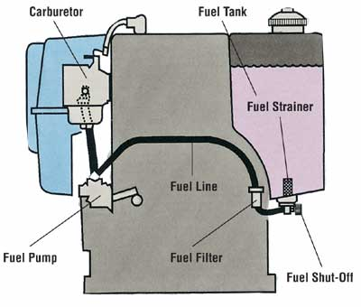
Small Engine Image Gallery

©2006 Publications International, Ltd. This drawing reviews the typical components of a fuel system on a two-stroke engine.
Small gas engines serve us in many ways. They power lawn mowers, tillers, cultivators, trimmers, edgers, snowblowers, chain saws, pumps, generators, air compressors, and other useful home tools. They also power our fun: outboard boats, snowmobiles, motorcycles, all-terrain vehicles, ultralight aircraft, and other toys. To keep them operating efficiently, an owner of these tools and toys should know about small engines: how they work and what to do when they don't.
Small gas engines are made up of individual systems that work together to produce power. Each system has many components. Internal combustion gasoline-powered engines require six systems: fuel, exhaust, ignition, combustion, cooling, and lubrication. In this article, we will discuss the systems and components that make small engines work.

Fuel and Exhaust
The fuel and exhaust systems are critical to operation. They furnish the fuel for combustion and remove exhaust gases. The following are components of a fuel and exhaust system.
Gasoline: Gasoline is a combustible liquid that burns relatively slowly. However, when sprayed as a mist and mixed with air, it is quite explosive. All it needs is a spark. Two-stroke engines require that oil be mixed with the gasoline to lubricate internal parts. Four-stroke engines use a fuel-air mixture.
Fuel Tank: The fuel tank stores fuel in preparation for mixing by the carburetor and use by the engine. Some fuel tanks are pressurized with air to help deliver fuel to the carburetor. Other tanks are non-pressurized and depend on a fuel pump to deliver fuel to the carburetor.
Fuel Line: Fuel is moved from the tank to the pump and/or carburetor through a fuel line. Pressurized fuel systems often have a squeeze bulb in the fuel line for building pressure.
Filter: A carburetor jet has a small opening that can easily become clogged. A fuel filter traps dirt and sediment from the gas before it is delivered to the carburetor.
Pump: A fuel pump produces a vacuum that pulls the fuel from an unpressurized tank, then delivers it to the carburetor.
Carburetor: The carburetor has one job: to mix the correct proportion of gasoline and air for the engine. Too much gasoline in the mixture makes it rich; too little gas makes it lean.
Throttle: The throttle controls the amount of fuel-air mixture that enters the engine from the carburetor. The throttle thus controls the speed of the engine.
Primer: A primer injects a small amount of gasoline into the carburetor throat to make the initial fuel-air mixture rich. A primer is used to help start a cold engine.
Choke: Some engines control the richness of the fuel-air mixture at startup by controlling the air rather than the fuel. A choke reduces the amount of air in the fuel-air mixture.
Governor: A governor is a device that automatically opens the engine's throttle when more power is needed and closes it when the load is light.
Muffler: Small gas engines, especially two-stroke engines, are noisy when they operate. A muffler reduces the sound of the exhaust gases by passing them through baffles.
Spark Arrestor: A spark can exit the exhaust port of a small gas engine, potentially starting a fire on nearby combustibles. A spark arrestor on the exhaust port can reduce the chances of such a fire. Spark arrestors are especially important on chain saws, motorcycles, and all-terrain vehicles operated in dry woodlands.

Ignition
The ignition is a primary system within all small gas engines. It produces and delivers the high-voltage spark that ignites the fuel-air mixture to cause combustion. No spark means no combustion, which means your engine doesn't run. Below are the components found in small engine ignition systems. Some systems will include breaker point ignitions while others depend on solid-state ignitions.
Magneto-Powered Ignition System: A magneto uses magnetism to supply electricity in ignitions where there is no battery. The magneto is turned by the crankshaft, which rotates when the manual recoil starter is pulled. The three types of magneto ignition systems are mechanical-breaker, capacitor-discharge, and transistor-controlled.
Battery-Powered Ignition System: If your small engine includes a battery for starting, the ignition coil will also use it to supply spark to the spark plugs. A battery stores electrical energy until needed. Battery ignition systems also use mechanical-breaker, capacitor-discharge, and transistor-controlled ignitions.
Mechanical-Breaker Ignitions: High-voltage electricity must be sent to the spark plug at the appropriate time. In mechanical-breaker ignitions, this job is performed through the contact points and a condenser.
Points: As the crankshaft rotates, a cam opens and closes a set of contact points. These points function as an on/off switch: Closed is on, and open is off.
Condenser: Because the spark moving across points can damage their surfaces, the condenser stores voltage to reduce arcing between points.
Capacitor-Discharge Ignitions (CDI): A capacitor is a large condenser. A CDI stores and delivers voltage to the coil using magnets, diodes, and a capacitor
Transistor-Controlled Ignitions (TCI): Transistors are electronic controllers. A TCI uses transistors, resistors, and diodes to control the timing of the spark.
Coil: An ignition coil is simply two coils of wire wrapped around an iron core. The coil changes low voltage (6 or 12 volts) into the high voltage (15,000 to 30,000 volts) needed by the spark plug.
Spark Plug: A spark plug is an insulated electrode that is screwed into the top of the engine cylinder. High-voltage timed electricity from the magneto travels by wire to the spark plug. The base of the plug has an air gap of about 0.030 inch (30 thousandths of an inch), which the current must jump.
Wires: The primary wire from the coil to the breaker point and secondary wire from the coil to the spark plug(s) deliver electricity to the ignition components.
Distributor: A distributor is an ignition system for engines with more than one cylinder and spark plug. It distributes the spark to the appropriate cylinder using a rotor, cap, and individual spark plug wires.

Combustion
The combustion system of a small gas engine is where the work gets done. Components of the combustion system include the cylinder block, cylinder head, camshaft, valves, piston, connecting rod, crankshaft, timing gears, and flywheel. To better understand small gas engines, let's look at how this vital system works.
Cylinder Block: The largest single part in a small gas engine is the cylinder block. It is a piece of metal in which the cylinder hole is bored or placed.
Cylinder Head: The cylinder head is the top, or ceiling, of the cylinder and is attached to the block with bolts. Depending on the type of engine, the head may or may not include valves.
Piston: A piston is the movable floor in the combustion chamber. Its upward movement compresses the fuel-air mixture. After combustion, its downward movement rotates the crankshaft.
Crankshaft: An engine's crankshaft is a metal shaft with an offset section onto which the connecting rod is attached. Rotation of the crankshaft moves the piston up in the cylinder. Movement of the piston down in the cylinder then rotates the crankshaft.
Connecting Rod: Between the piston and the crankshaft is a connecting rod. At the larger end of the connecting rod is a bearing that allows rotation around the moving crankshaft. The small end is attached to the piston pin.
Valves: Valves simply open and close passages. A reed valve in a two-stroke engine is activated by changes in air pressure.
Flywheel: At the end of the crankshaft is a circular weighted wheel called a flywheel. The flywheel delivers the engine's power to devices (wheels, blades, etc.) and helps keep the crankshaft turning smoothly.
Small Engine Image Gallery
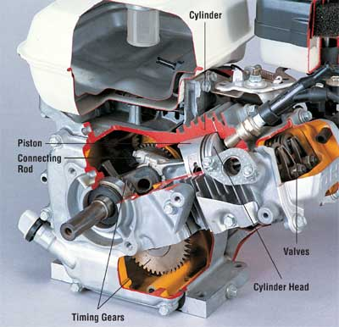
©2006 Publications International, Ltd. Here are some of the components of a two-stroke engine's combustion system. See more pictures of small engines.
Cooling and Lubrication
Combustion and friction produce heat. Heat and friction -- if not controlled -- can quickly damage an engine's components. Small gas engines are typically cooled by air. Friction is reduced using movable bearings and lubricants.
Air-Cooling Fins: For simplicity, most smaller gas engines are cooled by air. Metal fins around the outside of the combustion chamber help dissipate the internal heat.
Friction: Friction is resistance that occurs when one surface rubs against another. Friction causes wear. In an engine with many moving parts, friction is reduced with bearings and lubricants.
Bearings: A bearing is a replaceable part that takes the brunt of the friction. A friction bearing relies on lubricants to minimize friction. A nonfriction bearing uses hard steel rollers or balls to prevent wear, though it too requires some lubrication.
Lubricants: Lubricants such as oil and grease reduce surface friction by coating parts with a film. Lubricants in two-stroke engines are applied to surfaces by mixing oil with fuel.
Viscosity: An oil's viscosity is its resistance to flow. The thicker a lubricating oil or grease is, the higher its viscosity number.
Filters: Friction happens. Moving parts wear, even with the best lubricants. The resulting metal as well as carbon from the combustion process must be cleaned from the oil to ensure long lubrication. Some small engines use oil filters to remove contaminants from the circulating oil.
Regularly servicing your small engine will ultimately save you money and time. In the next section, we'll review how, where, and when to service this engine.

The Benefits of Regular Small-Engine Maintenance
Purchasing a small engine-driven implement can make a dent in your budget. Tools and toys powered by small engines can cost anywhere from $100 to $10,000. That's why it's a good idea to invest in periodic servicing of your small engine. Replacing an engine every couple of years is an annoying and needless expense. Below we will review detailed information on how to service two-stroke gas engines. Following these procedures could help you put more money in the bank and less into your mechanic's pocket.

Benefits of Regular Service
Servicing your small engine tool or toy on a regular basis offers many advantages over the Wait-Until-It-Breaks Maintenance Program.
- By establishing a service schedule, you will gain confidence that whenever you need the unit it will be ready for use.
- By performing a number of service functions together, you will save time. You can pick up all needed parts and lubricants in one trip to the parts store. Then you need to disassemble a component only once to perform numerous service procedures rather than taking it apart many times.
- Regular service gives you a chance to visually inspect the entire engine and related components for damage, wear, and other potential problems.
How, Where, and When to ServiceKnowing how to service is as important as knowing when. Some service procedures can be performed wherever you store your tool or toy: in a garage, storage shed, or tool shed. If the unit is heavy, you can build a ramp up to a sturdy table that is at a handy height for working. Or you can use a ratchet winch to lift the engine. Units weighing less than 40 pounds may be lifted to a workbench or table as long as you lift with your legs rather than with your back. Get help if you need it, and make sure that the unit will remain sturdily in place as you service it. Remember to always put safety first!Servicing a small engine is easy once you know what to do and when to do it. A service chart can help you determine common service requirements as well as track what service has been done. Your engine-powered unit may have a service chart in the owner's manual or service manual. Typical recommendations include changing engine oil every 25 hours of use and tuning up the engine at least once a year.The purpose of ongoing service, also known as preventive maintenance, is to keep your engine-driven tool or toy in good operating condition. Ongoing service procedures include air cleaner service, crankcase breather service, cooling system service, muffler service, lubrication, and tune-up.Lubrication service means making sure that all moving parts have sufficient lubrication (oil and/or grease) to minimize wear. Lubrication service procedures include mixing oil with fuel in two-stroke engines, and lubricating other moving parts.A tune-up consists of the adjustment and/or replacement of parts critical to smooth and efficient engine operation. Those parts include components in all engine systems: fuel, exhaust, ignition, combustion, cooling, and lubrication. Ignition tune-ups are more important for mechanical-breaker ignitions than they are for self-contained solid-state ignitions. Regular tune-ups will keep your small engine running smoothly and reduce the need for repairs.In addition, you should check other systems and make adjustments as needed to keep them operating smoothly. This includes adjusting the throttle, choke, and governor linkage, and cleaning off debris.Engine-driven tools and toys usually come with an owner's manual. While some manufacturers' manuals are more complete and better written than others, most manuals include basic information on safe operation and service. Unfortunately, product manuals are often written to reduce the manufacturer's liability for accidental misuse rather than to help the owner service the product. In addition, manuals for engine-driven products typically show how to service the nonengine components: the grass catcher, wheel adjustments, blades, chains, and other parts. Service information for the engine may be minimal or nonexistent in the owner's manual.
What can you do about this lack of information? Fortunately, there are numerous after-market publishers of service manuals for specific models of small engines. If you don't have an owner's manual, you can contact the manufacturer directly to purchase one; manufacturers also sell service manuals. Most manufacturers keep product manuals for up to 20 years. If they only have one original copy left, you can often request a photocopy for a small charge.
Knowing how to service the fuel system is an important part of caring for a small engine. Learn how to care for fuel filters, carburetors, and other major fuel system parts in the next section.
•
• Page
• 1
Small Engine Basics
• 2
The Benefits of Regular Small-Engine Maintenance
• 3
How to Repair a Small-Engine Fuel System
• 4
How to Repair a Small-Engine Ignition System
•
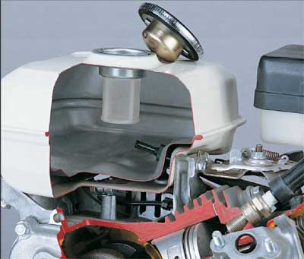
©2006 Publications International, Ltd. This fuel tank has two filters: one at the opening and one at the entry to the fuel line.

How to Repair a Small-Engine Fuel System
The function of a small engine fuel system is to store and deliver fuel to the combustion chamber. Maintaining a fuel system includes servicing the fuel filter, air cleaner, fuel tank, and fuel lines; adjusting the carburetor; and adjusting the governor. Of course, not all small engines have all of these components.

Servicing Fuel Filters
Some small engines have a fuel strainer in the bottom of the fuel tank. Others have a removable fuel strainer in the fuel line. Still other small engines use disposable in-line fuel filters made of pleated paper. To clean sediment from a tank:
Step 1: Drain or siphon all fuel from the tank.
Step 2: With a flashlight, find the lowest point in the tank: the sediment reservoir. Clean all sediment from the reservoir indentation.
Step 3: Wipe sediment from the end of the filter element.
Step 4: Wipe the inside of the tank with a clean rag.
Step 5: Refill the fuel tank.
Here is how to clean sediment from a fuel strainer:
Step 1: Find and close the shutoff valve on the fuel line.
Step 2: Loosen the lock nut on the bowl retainer and remove the sediment bowl.
Step 3: Empty and clean the sediment bowl. Clean the filter screen. Refill the sediment bowl with fresh fuel.
Step 4: Reinstall the sediment bowl and bowl retainer, tightening the lock nut.
Step 5: Open the shutoff valve.
Here is how to replace an in-line fuel filter:
Step 1: Find and close the shutoff valve on the fuel line or use a clothespin to pinch the fuel line closed.
Step 2: Disconnect the fuel filter from the fuel line.
Step 3: Replace the in-line fuel filter with an exact replacement part.
Step 4: Open the shutoff valve.

Servicing Air Cleaners
The purpose of an air cleaner on a small engine is to keep large particles in the air from clogging the carburetor. The two types of air cleaners used on small engines are oil bath and dry. Hereis how to service an air cleaner:
Step 1: Remove the cover of the air cleaner, typically by unscrewing a nut on top of the cleaner.
Step 2: If it's an oil cleaner, remove all oil and contaminants from the center channel of the cleaner, wipe it clean, then replace oil to the indicated level. A dry cleaner cannot be cleaned and therefore must be replaced.
Step 3: Replace the air cleaner cover and make sure all fasteners are securely tightened.

Servicing Fuel Tanks and Lines
Fuel systems with pumps use nonpressurized fuel tanks. Outboard engines typically use pressurized tanks. Fuel lines are usually made of neoprene. Here's how to service a fuel tank and line:
Step 1: Remove the cap from the fuel tank.
Step 2: Using a flashlight, check for sediment in the fuel tank. If sediment is found, clean the tank and replace the fuel. Replace the fuel cap when done.
Step 3: Check the fuel line and siphon bulb, if there is one, by squeezing them and inspecting for cracks. If damaged, replace with a line or a bulb of the same inside diameter. Make sure it is approved for use with fuel.

Adjusting Carburetors
A carburetor mixes fuel and air in the correct proportion for use by the engine. The three types of carburetors commonly used in small engines are natural draft, updraft, and downdraft. These names describe the direction that air flows from the inlet to the engine manifold. To maintain your small engine, you will want to make sure the carburetor's speed and mixture are correctly adjusted.
There are many types and models of carburetors used on small gas engines. Some have more available adjustments than others. Depending on the design, some carburetors are set at the factory and don't include adjusting screws. For example, a carburetor may allow adjustment of high speed, idle speed, and idle mixture while another only allows high and idle speed adjustments. Here's how to adjust the typical three-adjustment carburetor:
Step 1: With the engine running, open the throttle wide. Turn the high-speed adjustment needle forward and backward until the highest speed setting is found.
Step 2: Move the throttle to the slowest running speed. Adjust the idle-speed needle until the recommended idle speed is found.
Step 3: Once the idle speed has been set, adjust the idle mixture until the engine runs smoothly.
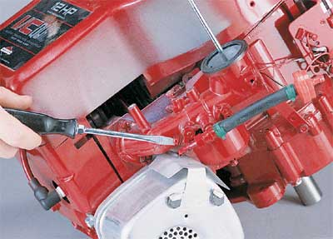
©2006 Publications International, Ltd. To set the correct idle speed, turn the idle adjustment screw with a screwdriver.

Adjusting Governors
A governor is a device that controls the speed of the engine as the load changes. As the load slows the engine down, the governor opens the throttle to return the engine to a set speed. Governors are commonly used on engine-powered electrical generators where constant speed is important. Two types of governors are installed on small engines: mechanical and air-vane.
Caution: An incorrectly adjusted governor can cause the small engine to operate at excessively high speeds and damage or destroy it.
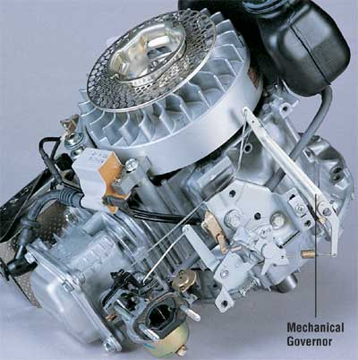
©2006 Publications International, Ltd. A mechanical governor responds to the centrifugal force created by the engine's revolution.
Unfortunately, there is no universal adjustment sequence for small engine governors. Much depends on the type of governor, whether the crankshaft is horizontal or vertical, the complexity and pivot points of the linkage, and the intended operating range. Because of these factors, refer to an owner's manual or service manual for your specific engine and application to adjust the governor.
In the next section, learn how the ignition system needs to be routinely serviced so it can deliver a high-voltage spark to help start a small engine.
•
• Page
• 3
How to Repair a Small-Engine Fuel System
• 4
How to Repair a Small-Engine Ignition System
• 5
How to Repair a Small-Engine Lubrication System
• 6
How to Repair a Small-Engine Cooling, Exhaust, and Control Systems
•
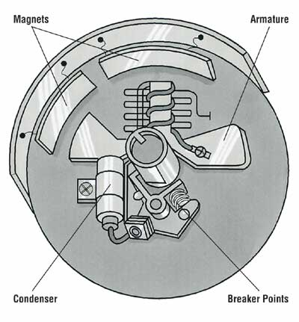
©2006 Publications International, Ltd. Here are the parts of a typical flywheel magneto.

How to Repair a Small-Engine Ignition System
An ignition system in a small engine produces and delivers the high-voltage spark that ignites the fuel-air mixture to cause the combustion. Some small engines require a battery to supply electrical power and the ignition spark. Others develop the ignition spark using a magneto.
A small engine ignition includes the ignition controller (mechanical-breaker, capacitor-discharge, or transistor-controlled), spark plugs, flywheel, and wiring. Servicing the ignition system of your small engine depends on which types of components it has. Below are step-by-step instructions for servicing ignition systems found in modern small engines.

Servicing Nonbattery Ignition Systems
A magneto applies magnetism to supply electricity in ignitions where there is no battery. The magneto is turned by the crankshaft, which rotates when the manual recoil starter is pulled. Here's how to service a non-battery ignition system:
Step 1: Service magneto.
Step 2: Service ignition controller.
Step 3: Service spark plug(s).
Step 4: Service flywheel.
If you need to service a magneto, use the following directions:
Step 1: Remove the magneto cap and clean surfaces with a small, clean paintbrush. Wipe any excess oil away.
Step 2: Service the ignition controller (mechanical-breaker, capacitor-discharge, or transistor-controlled) as described at the bottom of this page.

Servicing Battery Ignition Systems
A battery is a device containing electrical cells that produce and store direct current. Batteries used to start and operate small engines typically store 6 volts or 12 volts. Here's how to service a battery ignition system:
Step 1: Service battery and charging system.
Step 2: Service ignition controller.
Step 3: Service spark plug(s).
Step 4: Service flywheel.
If you are interested in servicing a battery and charging system, here's how:
Step 1: Use a voltage tester to verify that the battery is storing sufficient voltage. Each cell develops approximately 2 volts (1.9 to 2.1 volts). A 6-volt battery testing lower than 5.7 volts or a 12-volt battery lower than 11.4 volts should be recharged to rated voltage or higher.
Step 2: If the battery is conventional (has three or six caps on top), use a hydrometer to check the density of the liquid electrolyte in each cell. The density or specific gravity should be between 1.26 and 1.28 at room temperature.
If it's below 1.25, recharge the battery. The difference in specific gravity between any two cells should be no more than 0.05. Note that a sealed maintenance-free battery cannot be tested in this way.
Step 3: Clean battery terminals using a small amount of baking soda and a stiff wire brush. Clean battery cables the same way.
Step 4: Inspect the cable insulation for corrosion and breaks; replace as needed.

Servicing Mechanical-Breaker Ignitions
For many years, mechanical-breaker ignition systems were the most popular of all ignition systems. The high voltage electricity from the coil is turned on and off using contact points and a condenser. The spark must be correctly timed to reach the spark plug at the exact moment when the piston is at the top of its travel and the fuel-air mixture is fully compressed. Here's how to service a mechanical-breaker ignition:
Step 1: Remove the cover from the stator plate to expose the breaker points and condenser.
Step 2: Manually turn the crankshaft until the high point of the cam lobe opens the contact points. Inspect the points for uneven wear or damage. If necessary, replace the breaker points and condenser.
Step 3: Slightly loosen the points setscrew and place the appropriate thickness gauge between the two contacts. (Check your owner's or service manual for the correct gap.) Move the points setscrew until the thickness gauge is touching both contacts but can be withdrawn without moving them.
Step 4: Tighten the points setscrew.
Step 5: Check the points gap with the thickness gauge again. Tightening the setscrew may have changed the gap.
Step 6: Clean the points with lint-free paper to remove any oil left by the thickness gauge.
Note: Some mechanical-breaker ignitions can be set using a dwell meter. If you have a dwell meter, refer to the unit's operating instructions and the ignition specifications to determine what dwell angle setting is correct and how to set it.
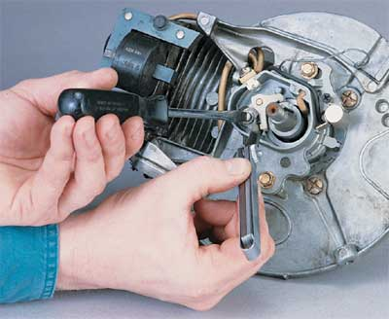
©2006 Publications International, Ltd. To adjust a mechanical-breaker ignition, loosen the points setscrew and use a thickness gauge to check the gap between the breaker contacts.

Timing Mechanical-Breaker Ignitions
To work efficiently, the spark must be delivered to the combustion chamber at the exact moment that the piston is at or near TDC (top dead center). Here's how to time the ignition spark:
Step 1: Loosen the adjustment nut(s) on the stator so it can be turned.
Step 2: Disconnect the coil lead wire from the points.
Step 3: Connect a lead of the continuity tester light or ohmmeter to the breaker point terminal and the other to the housing or a ground location.
Step 4: Rotate the stator until the light or ohmmeter indicates that the points have opened the circuit (light off or resistance high).
Step 5: Tighten the adjustment nut(s) on the stator without moving it.
Step 6: Reconnect the coil lead wire to the points.

Servicing Capacitor-Discharge Ignitions
Capacitor-discharge ignitions (CDIs) store and deliver voltage to the coil by way of magnets, diodes, and a capacitor. The mechanical points of a breaker point ignition are replaced with electronics. The only moving parts are the magnets on the flywheel. That's why this system is sometimes called a breakerless ignition.
Because there are no breaker points on this system, there is no requirement for timing. However, the trigger module performs the same function as points. There must be a specific gap between the trigger module and the flywheel projection. Refer to your owner's or service manual for specific steps to setting this gap. The typical steps to setting the trigger module gap on a CDI system are the following:
Step 1: Remove the lead from the spark plug to prevent starting. Ground the spark plug lead by attaching it to the shroud.
Step 2: Rotate the flywheel so the projection is aligned with the trigger module.
Step 3: Loosen the trigger module adjustment screw(s) and insert a thickness gauge of the correct thickness (typically 0.005 to 0.015 inch) in the gap.
Step 4: Move the trigger module until it touches the thickness gauge, making sure the projection and module surfaces are parallel.
Step 5: Tighten the trigger module adjustment screw(s) and replace the spark plug lead.
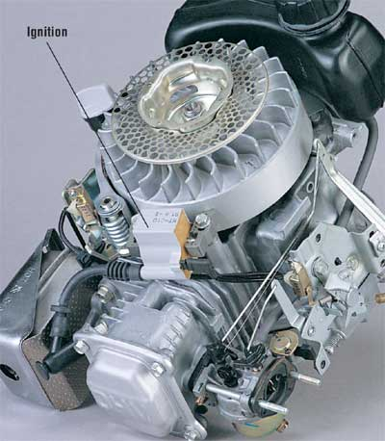
©2006 Publications International, Ltd. Capacitor-discharge ignitions and transistor-controlled ignitions look the same. Check the engine's owner's manual for specific information on servicing and repair.

Servicing Transistor-Controlled Ignitions
A transistor-controlled ignition (TCI) uses transistors, resistors, and diodes to control the timing of the spark to the engine. Because it has no moving parts, it too is called a breakerless or solid-state ignition. Most TCIs require no service. However, to ensure long-term performance, perform the following inspection on a regular basis.
The TCI controls a voltage of up to 30,000 volts for delivery to the spark plug. Be extremely careful when working around the TCI, as you can injure yourself or the ignition system with high voltage. Use the following steps to service a transistor-controlled ignition unit:
Step 1: Remove the lead from the spark plug to prevent starting. Ground the spark plug lead by attaching it to the shroud.
Step 2: Check the TCI unit to make sure it has not been damaged. Sensitive electronic components are mounted on a printed circuit board within the box and can be damaged by force or by excessive heat.
Step 3: Check all leads to and from the TCI unit to make sure they are tightly connected and that insulation is not cut or frayed.
Step 4: Visually inspect the magnet and ignition coil mounted next to the flywheel. Look for damage to the end of the magnet or the edge of the flywheel.

Servicing Spark Plugs
The spark plug in a small gas engine must withstand high voltage, high heat, and millions of ignitions during its life. A new spark plug requires about 5,000 volts of electricity to jump the gap. A used spark plug may require twice as much voltage to function. So servicing the spark plug is important to your engine's operation. Here's how to service a spark plug:
Step 1: Disconnect the lead wire from the top of the spark plug.
Step 2: Using the appropriate spark plug wrench, loosen the plug from the cylinder head. Before removing the plug, clean debris from around the spark plug base.
Step 3: Note the electrode's appearance. Excessive buildup can mean incorrect fuel-air mixture, incorrect carburetor adjustment, weak spark voltage, or poor air cleaner maintenance, among other causes.
Step 4: Clean the spark plug surface with a soft cloth and the electrode with a wire brush or spark plug cleaning unit. If the electrode is worn or damaged, replace the spark plug with one of the same size and heat range to avoid any damage to the engine.
Step 5: Using a feeler gauge, set the gap on the spark plug electrode to the manufacturer's recommendations.

Servicing Flywheels
The flywheel on a small gas engine is a simple part that requires little service. The most important part of servicing a flywheel is to inspect it for damage periodically. Here's how to service a flywheel:
Step 1: Remove the lead from the spark plug (to ensure that the engine doesn't start), then rotate the flywheel by hand and inspect it for wobble and obvious damage. Check edges and cooling fins, looking for cracks and missing pieces that can make the flywheel -- and the engine -- rotate out of balance.
Step 2: To inspect the inside of the flywheel, use a flywheel puller or a knock-off tool to remove the flywheel from the end of the crankshaft.
Step 3: Inspect the magnets on the inside of the flywheel, if so equipped. Wipe all surfaces clean, removing rust, oil, and debris.
Moving parts of a small engine can wear out prematurely if they aren't lubricated. Learn tips about how to lubricate the engine, using oils and additives, in the next section.
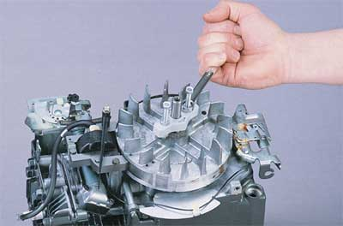
©2006 Publications International, Ltd. You may need a special tool called a flywheel puller to remove the flywheel.

How to Repair a Small-Engine Lubrication System
Friction causes wear; it's a law of physics. Small gas engines can wear out prematurely if moving parts aren't lubricated. We'll discuss how to reduce wear on your small engine and increase its useful life by servicing the lubrication system. Topics include the fuel-oil mixture for two-stroke engines and performing other lubrication services.
Always use the type and viscosity grade of oil recommended by the engine manufacturer. Lubricating oils and additives designed for four-stroke engines are not suitable for two-stroke engines.

Mixing Fuel-Oil for Two-Stroke Engines
Two-stroke engines are efficient. They only require a single rotation of the crankshaft to develop power. This simplicity requires economy in all engine systems, including lubrication. A two-stroke engine is lubricated by mixing oil with the gasoline. This fuel-oil mixture can be purchased as such, or you can mix it yourself. Here's how to make a two-stroke engine fuel-oil mixture:
Step 1: Check the manufacturer's recommendations for the specific ratio and grade of oil and fuel to be mixed.
Step 2: In a vented gas can used only for mixing, pour a specified amount and type of gasoline.
Step 3: Add the correct amount of recommended oil for the fuel-oil ratio. A gallon contains 128 ounces. A fuel-oil ratio of 50:1 means 50 ounces of fuel should have 1 ounce of oil added, or you should add about 2.5 ounces of recommended lubricating oil to every gallon of recommended gasoline. A 25:1 fuel-oil ratio requires about 5 ounces of oil per gallon of fuel. Also pour in any additives recommended by the manufacturer.
Step 4: Make sure all caps are securely fastened to the mixing gas can, and shake it to thoroughly mix the fuel and oil.
Step 5: Carefully pour the resulting fuel-oil mixture into the engine's fuel tank.
Step 6: Whether you purchase fuel-oil mixed or mix it yourself, rotate the fuel tank in a circle a few times to remix the fuel and oil before each use.

Lubrication Service
Some small engines require additional lubrication, depending on their design and the tasks they perform. A riding lawn mower, for example, may require lubrication of the axles and steering box. Though this article can't cover all possible lubrication service procedures, it can offer procedures that are easily adaptable to most small engines.
Lubrication service is the application of lubricating greases. Greases are simply petroleum products with higher viscosity or thickness than oils. A lubricating grease may have a grade as low as 60 (about twice as thick as 30 grade oil) to over 100. Common viscosities for lubricating greases are 80 and 90 grade. At these viscosities, lubricants have the density of toothpaste. Special tools called lube guns are used to apply lubricating greases. Professional repair shops use pressurized lube guns; the engine owner can apply lubricating greases with a ratchet lube gun. The greases are sold in tubes that fit into the lube gun. Here's how to apply lubricating grease to small engine components:
Step 1: Check the owner's manual for specific information on lubrication: where and with what.
Step 2: Apply the recommended grade of lubricating grease. Some components have fittings to which the end of the lube gun is attached. Others require that the top of a reservoir is opened and fluid added to a specific FULL point. Still other components require that a lubricant such as white grease be spread on the part by hand.
Caution: Make sure that lubricating greases do not touch electrical parts. Lubricants can conduct electricity, shorting out the system and potentially causing a fire.
A defective cooling system can ruin a small engine. Learn how to properly maintain and service a cooling system in the next section.
•
• Page
• 3
How to Repair a Small-Engine Fuel System
• 4
How to Repair a Small-Engine Ignition System
• 5
How to Repair a Small-Engine Lubrication System
• 6
How to Repair a Small-Engine Cooling, Exhaust, and Control Systems
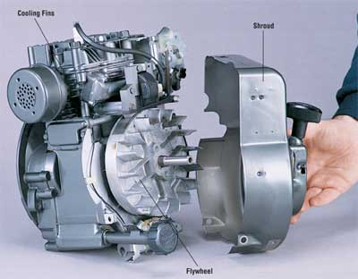
©2006 Publications International, Ltd. On an air-cooled engine, the shroud directs the airflow from the flywheel across the cylinder and head to keep them cool.

How to Repair a Small-Engine Cooling, Exhaust, and Control Systems
An internal combustion engine can develop an internal temperature as high as 4500 degrees Farenheit (2200 degrees Celsius) during the power stroke. Obviously, a small engine's cooling system is critical to smooth operation as well as long engine life.
A defective cooling system can ruin an otherwise good engine in minutes. Fortunately, small engines have simple cooling systems that require little maintenance to operate for many years. A small two-stroke engine is typically air-cooled.

Servicing Air-Cooled Engines
Most small, single-cylinder engines are cooled by a stream of air developed by fan blades on the flywheel. The air stream is deflected around the cylinder and cylinder head by a metal or plastic cover called a shroud. Additional engine heat is dissipated through cooling fins around the cylinder. Servicing air-cooled systems is generally very easy. Here's how to service an air-cooled system:
Step 1: Periodically remove the shroud from around the engine flywheel and inspect the inside for debris.
Step 2: With the shroud removed, visually inspect the flywheel blades for debris and damage.
Step 3: Visually inspect cooling fins on the cylinder and cylinder head. Use a wooden stick or clean paintbrush to clear away any debris. When the engine is cool, wipe the surfaces of the cooling fins, cylinder, and cylinder head with a cloth. Remember that even the tip of a cooling fin can have a surface temperature of over 100 degrees Farenheit (38 degrees Celsius).
Step 4: Replace the shroud over the flywheel and cylinder. Make sure the flywheel blades aren't striking the shroud.

Servicing Small-Engine Exhaust Systems
Exhaust systems require little maintenance. The function of an exhaust system is to get rid of the exhaust gases from the internal combustion process going on in the engine. Depending on what type of implement the small engine is powering, the exhaust system may have a spark arrestor or a muffler that requires periodic service.

Servicing Spark Arrestors
A spark arrestor on a small engine does just that: It arrests -- or stops -- sparks from leaving the combustion chamber and entering the outside atmosphere. Spark arrestors are especially important on equipment, such as chain saws and trail bikes, that is used around combustible trees and brush. In fact, spark arrestors are required equipment on some small engines in many states.
A spark arrestor is simply a screen on the exhaust port of a small engine. It is designed to stop sparks from exiting the engine. Use the following steps to service a spark arrestor:
Step 1: Make sure the engine is fully cooled and the ignition switch is off.
Step 2: Find the spark arrestor on the side of the engine. It is a screen or a short tube located wherever the exhaust gases exit the engine. Visually inspect the spark arrestor for blockage or damage. If any is found, remove the spark arrestor and clean or replace it.
Step 3: Tighten all nuts on the spark arrestor bracket and the exhaust system.
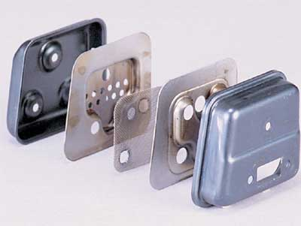
©2006 Publications International, Ltd. A spark arrestor consists of a screen inside the engine's muffler. Some spark arrestors are separate units outside the muffler.

Servicing Mufflers
Mufflers are designed to reduce noise levels on small gas engines. Operating a small engine for any length of time without a muffler will sell you on the value of this device!
Fortunately, exhaust mufflers require no regular servicing beyond a visual inspection. Here's how to service a muffler:
Step 1: Make sure the engine is fully cooled and the ignition switch is off.
Step 2: Find the muffler on the side of the engine where the exhaust gases exit. Use the end of a screwdriver to lightly strike the muffler at various locations, checking for rust damage or loose nuts. Also check the end of the muffler to ensure that there is no obstruction to exiting gases.
Step 3: Tighten all nuts on the muffler bracket and the exhaust system.
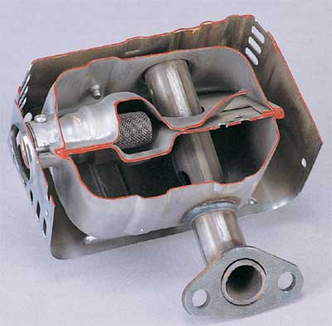
©2006 Publications International, Ltd. This cross section shows the internal construction of a muffler, including the baffles that reduce the engine's noise.

Servicing Small-Engine Controls
Small engines are used to power a wide variety of tools and toys. Controls make engines and their driven devices go faster or slower, turn on or off, change gearing, and make other operating adjustments. Servicing small engines requires servicing these controls as well.
In most cases, servicing controls means adjusting or lubricating them. Some controls are electrical (switches) while others are mechanical (throttles and gear selectors).

Adjusting Controls
Adjusting controls on a small engine typically requires the owner's manual or a service manual for the specific model. That's because control adjustments are frequently unique to that model. However, if you don't have an owner's manual, mechanical controls can be adjusted following commonsense procedures. Here's how to adjust a throttle control:
Step 1: Make sure the engine is off and cooled before working on it.
Step 2: Inspect the control cable for kinks, bare spots, or other visible damage. At the same time, wipe oils and debris from the control cable and lever.
Step 3: Inspect both ends of the control cable, checking the connection to the throttle lever as well as to the carburetor or governor. Make sure both ends are securely fastened.
Step 4: Move the throttle lever back and forth as you watch the movement of the carburetor connection. If full lever movement doesn't fully move the carburetor throttle, adjust the cable as required. In some cases, a fastener on or near the carburetor holds the throttle casing in place while allowing the throttle wire to move. Move the casing as needed and tighten the fastener.
Step 5: Lubricate the control before reassembly.

Lubricating Controls
Mechanical controls on engine-driven devices require periodic lubrication to minimize binding and wear. Here's how to lubricate a cable control:
Step 1: Disconnect one end of the control wire to allow free movement within the cable. Apply spray or grease lubricant to the wire, making sure lubricant doesn't reach other parts. Wipe away excess lubricant.
Step 2: Check the control for correct action. If adjustment is required, follow the procedures for adjusting controls.
By using the service guidelines mentioned in this article, you can keep your small engine working properly and save yourself time and money.

