How to Potty Train Your Puppy Using a Bell
by Flickety
Teaching your puppy to use a bell to tell you when he needs to eliminate saves lots of time, energy and stress compared to other forms of housebreaking. It also provides experience training your dog in the early stages of development.

Steps
- 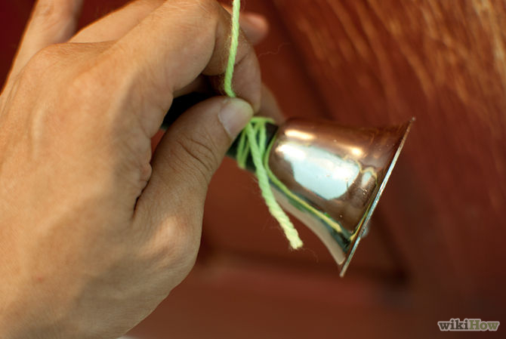
1
Hang a bell on the door leading to the outside of your house. Using a hook or tack, hang it on the door jam closest to the opening side and low enough for your puppy to reach with his paw and nose. Bells can also be hung from the doorknob using a shoelace or string.
  - Show your puppy the bells as soon as you hang them. Familiarize him with the bells by holding out some treats next to the bells and ringing them at the same time.
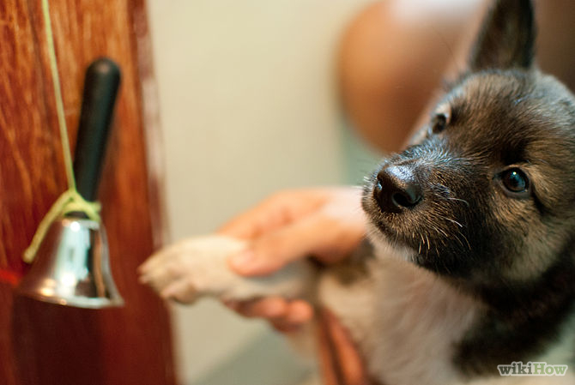
2
Every time you take your puppy out, encourage him to ring the bells. Show him the bells every time he goes out the door. Use a command like "Bells!" or "Ring!" to help him associate the bells with being able to go outside and potty. Gently take his paw and touch it to the bell. Shake his paw to make the noise and say your phrase or word. Immediately open the door upon ringing the bell.
  - Make sure the bells are rung, even if you are doing the ringing.
- 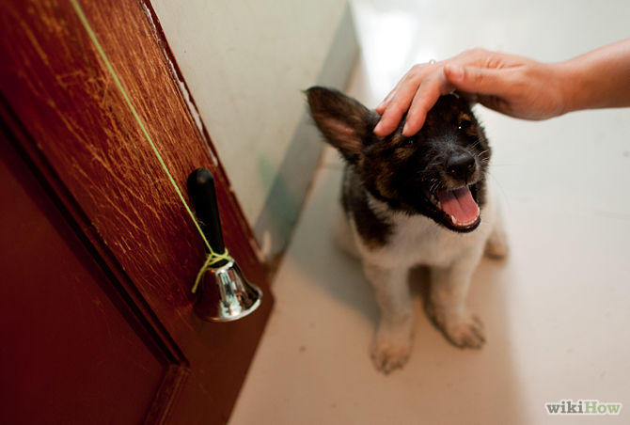
3
Be consistent. Within a few days, you should hear your puppy ringing the bell and find him sitting patiently by the door.
If your puppy doesn't figure this out, try this alternative method:
  - Smear a little cheese (or other treat) onto the bell. If your puppy touches the bell, even if it doesn't ring at first, immediately give the puppy a tasty treat.
  - Repeat so the puppy knows that a treat follows the bell touching, then bell ringing.
  - Finally, open the door with the puppy watching, and drop tasty treats on the floor on the other side of the door, so your puppy knows the treats are there.
  - Close the door. Encourage the puppy to ring the bell, and then immediately reward the puppy by allowing the puppy to go through the door to eat the treats on the other side. Now your puppy knows how to get you to open the door and take him outside.
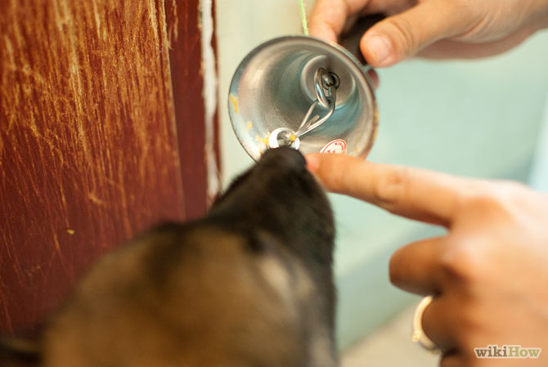
- 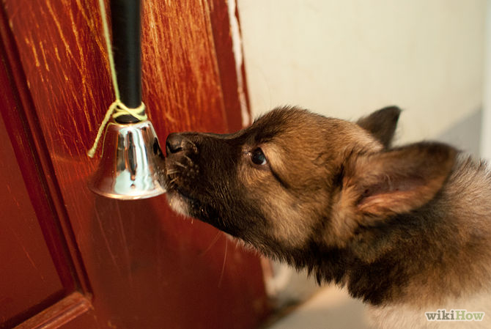
5
Practice makes perfect. Keep the routine consistent. And, be sure to use the same consistent phrase for the cue to go potty (such as "Go potty!") upon noticing your puppy's signs of needing to go once he's outside. After he has finished, praise him with fine words and a treat.

