How to Live off the Grid
It is estimated that 200,000 people live off the electrical grid in the United States. It also includes living outside of power and sewer grids. For most people, this is a choice to reduce energy consumption and live in a more natural setting. You can find out how to live off the grid by considering the home and lifestyle choices below.

Part 1 of 3: Location
- 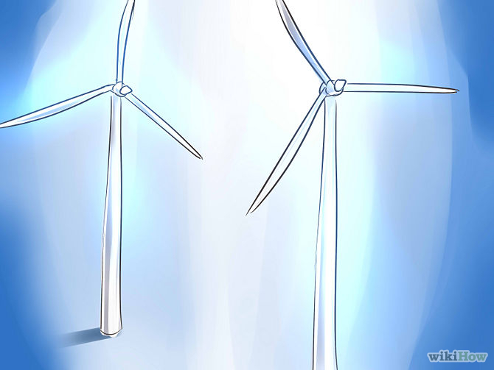

1
Choose a place to live that can provide wind or solar energy. If you plan to use any energy in your home, then you will need a power source. Choosing a sunny or windy location is essential before you choose an off-the-grid home.
  - If you can find a place that can provide both sources, you will be even better suited for the task.

2
Come up with your initial investment. Most off the grid living requires you to build your own energy efficient home or buy into a place that already has independent energy sources. You can add $10,000 or more for just the initial energy investment of a home with independent electricity.
- 
3
Choose an off-the-grid community. If you cannot find land that fits the requirements for solar and wind power, then choose 1 of pre-made communities catering to this type of living.
  - Consider living in Oregon. Three Rivers Recreation Area near Bend has a gated off the grid community. Breitenbush is another area with very few residents near Salem.
  - Research income-sharing communities. These include Dancing Rabbit in Missouri, Twin Oaks in Virginia or Earthhaven in North Carolina. These communities do income-sharing, off the grid living.
  - Consider Greater World Community near Taos New Mexico. Their Earthship houses are built entirely from natural and recycled materials. Properties cost between $75,000 and $350,000. Arcosanti Ecovillage in Arizona uses natural building methods as well.
  - The Possibility Alliance in Missouri aims to live a stripped down lifestyle, where community members do shared work, farm the land and cook with sunlight. While most people in the community live here only a portion of the year, a small percentage call it home all year.
- 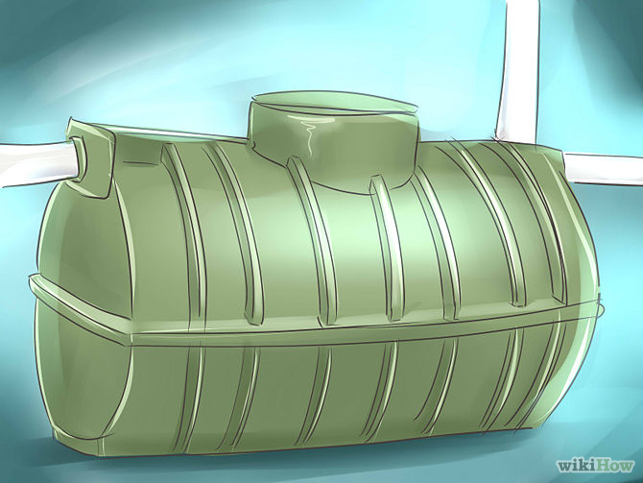
4
Buy land where you can get water from a well and install a septic tank. These are essential for water and waste management.

Part 2 of 3: Home Building
- 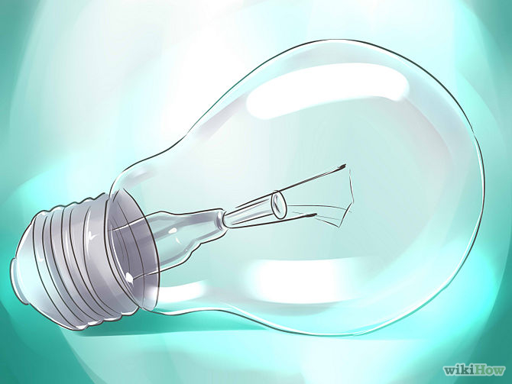
1
Invest in a plan to produce 10,000 kilowatt hours of electricity per year. This is the energy required for a typical American household. Research solar panels, wind energy and other electricity storage options.
- 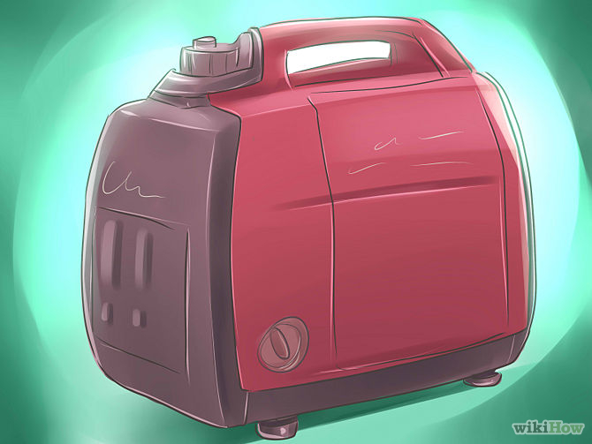
2
Invest in generators and other storage devices. You need to store the energy you harness. You also need to have back up systems, such as propane generators.
- 
3
Drill a well. You will need to use well water for household uses, but you may also choose to buy cisterns to collect rainwater, especially if you plan to grow crops. Initial investments range between $3,000 and $15,000 for the drilling and pump.
- 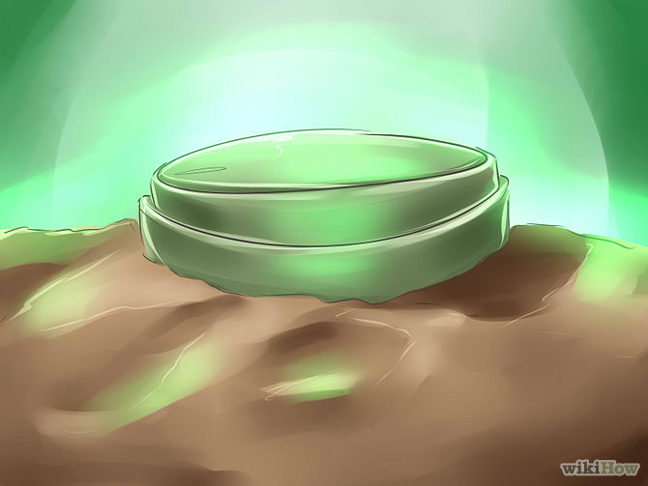
4
Install a septic tank. You will need an initial investment of several thousand dollars for this device that is buried underground.
- 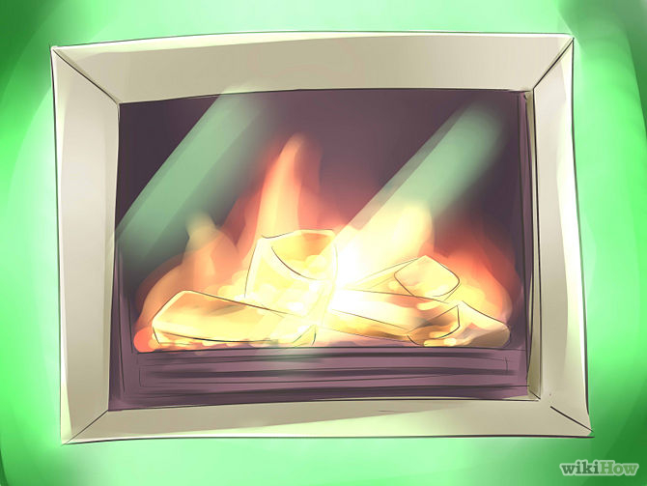
5
Build your home or refurbish it with heat in mind. If you live anywhere that gets cold in the winter, you should consider fireplaces and insulation. Some building companies specialize in using efficient and green building materials.

Part 3 of 3: Lifestyle Changes
- 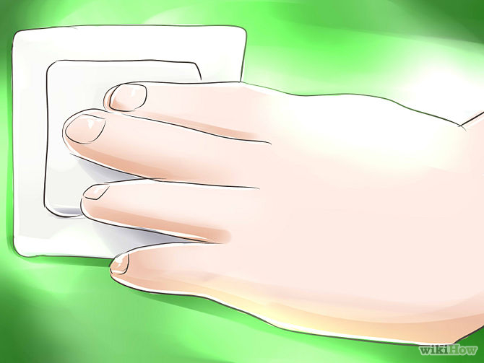
1
Decide if you can reduce your overall electricity consumption. If your livelihood relies on electronics, then installing energy backups like generators is essential.
- 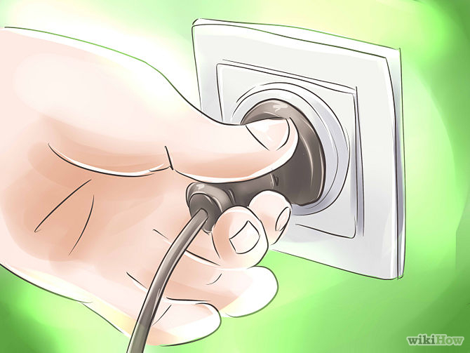
2
Limit the number of electrical appliances in your home. Get rid of blow dryers, clothes dryers, microwaves, video game consoles and anything else that is not essential.
- 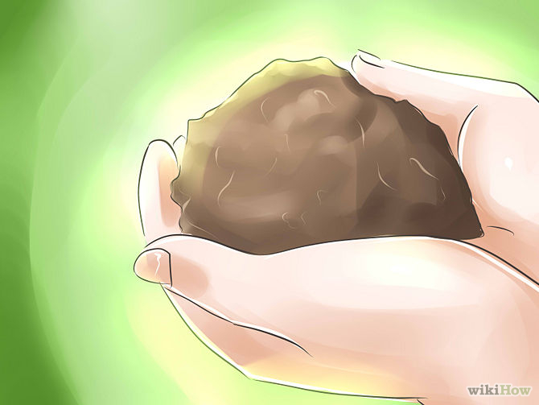
3
Start composting. Living away from the grid means providing your own garbage service. Composting and recycling can get rid of the majority of waste, and you will need to take the rest to a local dump.
- 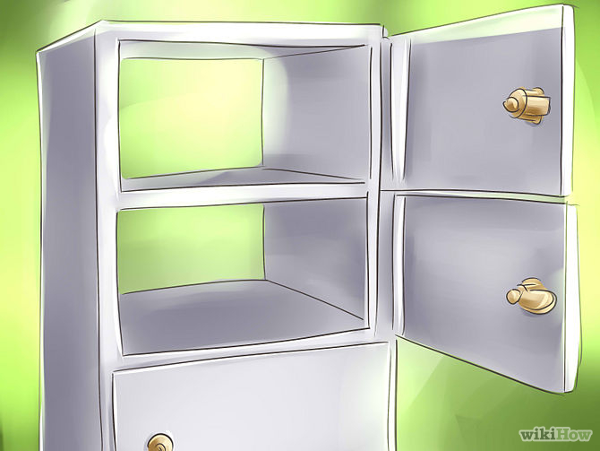
4
Rent a PO Box in a nearby town. Since you will likely be off the postal service grid, you should arrange for a way to get mail when you go to town.
- 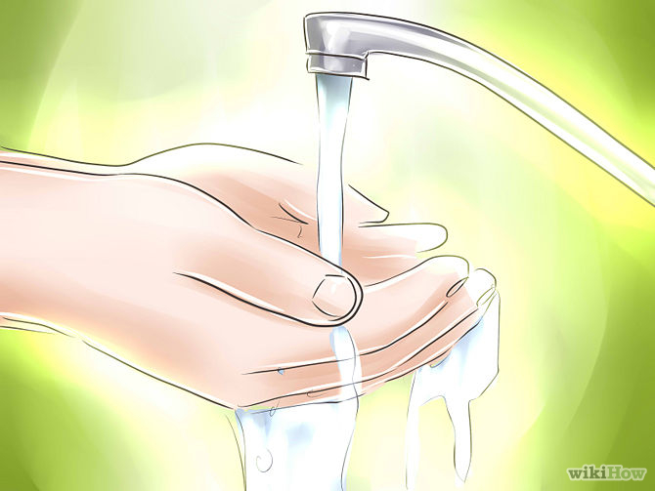
5
Be ready to adjust water usage. During times of low sunlight or wind, you may need to flush, use the shower or wash clothing less frequently.
- 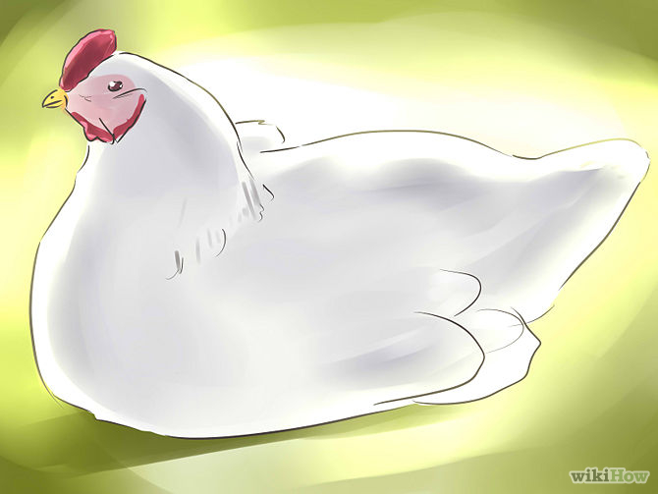
6
Consider becoming a farmer. Planting your own crops and preserving food can help you avoid going into town for groceries. It is also cost efficient and rewarding.
  - You may also want to keep a cow, goat or chickens for protein sources.

Things You'll Need
- 
$25,000 to $100,000 initial investment
Location with solar/wind energy
Off the grid community
Well
Septic tank
Propane generators
Insulation
Green building materials
Engineers/builders
Compost/recycling
Post office box
Farm plots
Domesticated animals (cows, goats, chickens)

Sources and Citations
- http://science.howstuffworks.com/environmental/green-science/living-off-the-grid.htm
- http://realestate.msn.com/best-places-to-live-off-the-grid
- http://www.mnn.com/lifestyle/responsible-living/stories/going-off-the-grid-why-more-people-are-choosing-to-live-life-un
- http://www.motherearthnews.com/nature-and-environment/living-off-the-grid-forever.aspx?PageId=2#ArticleContent
- http://www.mint.com/blog/trends/a-beginners-guide-to-going-off-the-grid-052012/

